Noro’s story.
Last October we went to visit the Homeless people that used to live in the terrible Star Compound near our hotel in Fianarantsoa. We had initiated a Project with Feedback Madagascar to see what we could do to alleviate the plight of so many homeless women and children and street children who lived in plastic shelters right outside our hotel. Families living in bags. Bruce, our elder statesman, would simply “Not let it go” and so, over a period of 3 years and much agonizing, we finally managed to rehouse 10 families and their children with a new start at a small settlement 5 Km outside town. We had seen the kids, 29 of them, in school for the first time and now wanted to see how we could continue to improve their lives through work opportunities, some start-up funding, education and empowerment classes and support and with initiatives on clean water, small farming etc. Really just to go and sit with them and say “Hi, how can we help?”
The day was bright and we arrived to dancing and singing and the usual welcome you find between friends. We have an on-going list of improvements in water storage and housing and now have another 10 families and 55 more children in school.
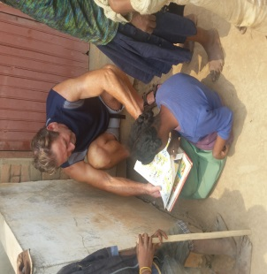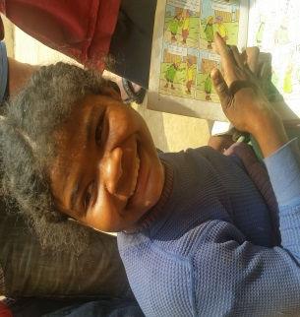
Just as we were about to leave I noticed a girl at the end of the village sitting on the ground in a corner just looking at the wall while paging through an old comic book. We sat with her for a while and realised she was both physically and mentally disabled but what was more chilling was that she would not look up at me. I took a photo of her on my phone and showed it to her and her immediate smile was like the sun breaking through clouds for the first time in Spring.
Over the next 6 months we decided to see what could be done to help. Her parents are split up and only her grandmother minds her now and she has a lot of physical issues and has had little or no stimulation or teaching to date. Her story is one of loneliness and rejection.
Pere Emeric sorted out a wheelchair for her and Sam from Feedback got it kitted out. I raised funds in Ireland from some wonderful friends and a dear friend’s 7 year old daughter gave up her comic books at Christmas which have now arrived.
So we now have a new Starfish and the hope is to build a new bridge across a nearby river so she can be wheeled to school at the far side and start full education with other children. In the meantime Samantha from Feedback Madagascar just sent a few photographs of Noro in her new wheelchair (Or Claire as we called her until we knew her real name) and the pictures say it all. Much to do.
Pat O’Brien. Trustee. March 2017
Update from Samantha. Feb 2017

NEW WHEELCHAIR & BOOKS FOR NORO (CLAIRE). Noro was overjoyed to receive the kind gift of a wheelchair and a parcel of books from Pat and the TASC team – as the photos show, she was brimming with delight. This will be a life changer for her – as she is unable to walk or travel at all, but is in great need of mental stimulation and contact with other people. Noro’s grandmother was thrilled and asked to transmit her sincere thanks to TASC and everyone who contributed to this gift. The wheelchair given from our dear friend and inspiration Pere Emeric was delivered to Noro in February 2017.

