REPORT ON THE TB HOSPITAL AT TANJOMOHA (Tsaraivotra) JANUARY 2017
Background
Before TASC was established a number of the now TASC trustees were shown the facilities for the treatment of TB at Tanjomoha in 2001 . These were rudimentary to say the least and consisted of 2-3 wooden huts in the grounds, each of which housed several cases of TB. Whilst the medicines were available free from WHO, the huts offered no more than a rush floor and bowls for the sick to eat (mainly rice) in their fingers.

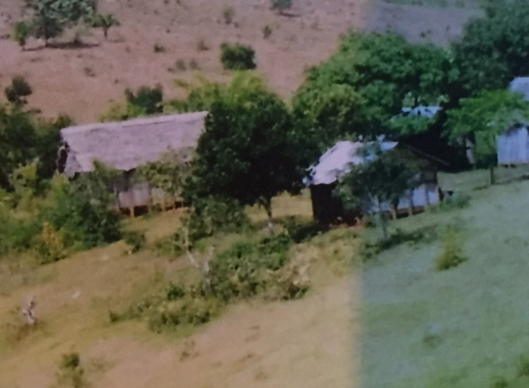
The old hutted TB facility in the woods, 2001
This made a lasting impression and we resolved to try and help provide something more suitable, as for TB to be successfully treated basics such as a warm, secure and comfortable environment offering some dignity, together with a better diet (to include protein) is essential.
Once TASC was conceived and established after a second visit in 2006, we were fortunate to have sufficient funds, matched by a sizeable donation from the Irish Missionary Fund, to allow the construction of a hospital area which met these needs within Tanjomoha at a cost of 85,000E.
This hospital provided 65 in patient beds together with its own kitchen to provide the extra nutrition so important for successful treatment of TB. It is called Tsaraivotra.
This facility was opened in 2006 and approved by the then Minister of Public Health. Its purpose was to diagnose and treat tuberculosis by providing not only the necessary medications but also a safe, hygienic and dignified environment.
It has 20 x 4 bed rooms and 2 x 7 bed rooms, so in all 94 beds. Additionally it has a dedicated kitchen providing 3 meals a day with an enhanced chicken ration to provide more protein. There is a TV lounge which has helped very much with keeping patients on site. It has its own washing facilities and a central gazebo in the garden to encourage fraternisation.

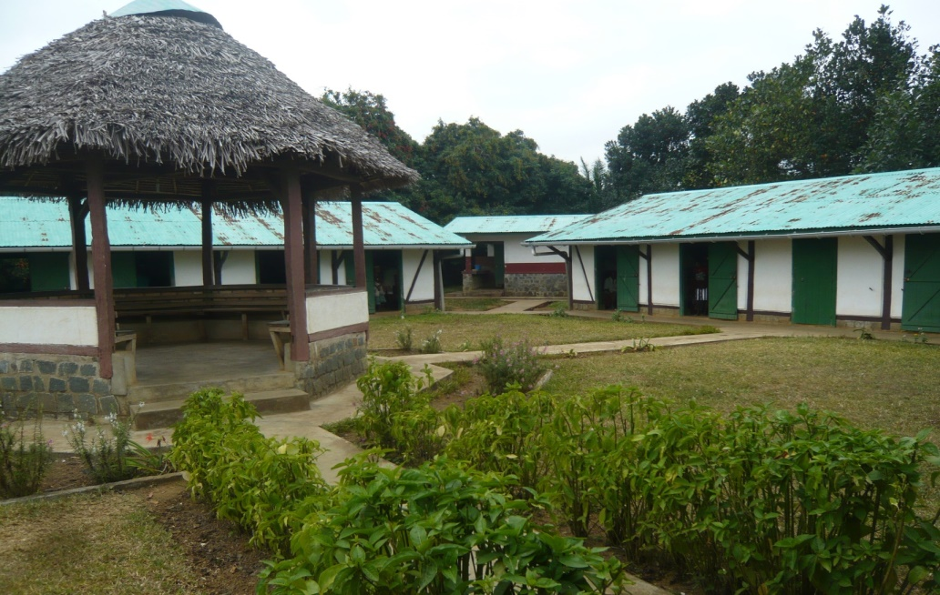
The new TB hospital at Tanjomoha, Tsaraivotra, 2016
It is staffed by visits from the resident doctor at Tanjomoha, Dr Eric, although he does not feel expert with TB . A doctor from the public hospital visits most days for this purpose. There is a nursing sister who does most of the day to day care and documents the cases, assisted by other less skilled staff, 2 cooks and an odd job man/groundsman. Drugs are dispensed daily to the patients under the direction of the nursing sister. These drugs are provided free by WHO and are the same medicines used to treat TB worldwide.

Tuberculosis(TB)
Tuberculosis is as old as mankind and has been a leading cause of premature death worldwide. In the Western world it was rife until the late 19th century when improvements in overcrowding and nutrition resulting from an increased standard of living consequent on the greater wealth of the working classes and poor resulted in dramatic falls in its incidence.
It is an infection spread by inhalation of infected droplets which contain the TB bacteria, spread in aerosol form when individuals with the illness cough. It primarily affects the lungs, causing weight loss, cough and death over usually a number of years. It affected all classes and resulted in the death of well known individuals such as Mendelsson, the Bronte sisters and George Orwell to name but a few. However the overcrowding and malnutrition prevalent in the working classes before the Industrial revolution resulted in it being much more common in the poor, conditions we saw so clearly still present in Madagascar.
No treatment other than rest and fresh air, provided by numerous remote sanatoria, was available until the discovery of streptomycin in 1946. The widespread availability of this and subsequent antibiotics mean that it is possible to cure TB, although it is still crucial to pay attention in particular to nutrition as those suffering from the disease are typically very thin. This weakens the body’s immunity and ability to overcome the infection, even when the drugs needed to treat it are given.
One third of the world’s population is said to have been infected with TB but the overwhelming majority of such people never develop the disease, rather the healthy body’s immune system contains the few bacteria. However the presence of malnourishment and other disease (especially HIV) cause the immune system to weaken and thereby allows the TB to awaken from its dormant state and became active, resulting in the development of the illness.
Although an infectious disease, it is quite hard for healthy well-nourished individuals to contract TB. For example, even the partners of cases in the UK who live in the same house and sleep in the same bed have a < 5% chance of becoming infected and developing TB. These statistics are far worse when there is overcrowding, malnourishment and often other illness which weakens the immune system, factors all present in Madagascar. These combine to make TB hundreds of times commoner than in the West.
It is possible to give the BCG vaccine to reduce the chances of an individual developing TB, but this only offers partial protection for a number of years.
BCG is now given at about 3 months to many but not all those born in Madagascar. Its efficacy is much reduced when there is malnourishment.
Diagnosis
In the developed world, the diagnosis is made by chest radiology and sputum examination and cases are divided into sputum +ve (where TB germs are seen in the sputum,, and sputum –ve when they are not after special staining in the lab) (?insert CXR and sputum smears). In the West, the sputum samples are also cultured so that the bacteria are grown in a laboratory. Sometimes the results of cultures become positive, confirming the presence of TB, even when the sputum when examined in the lab is negative for TB.

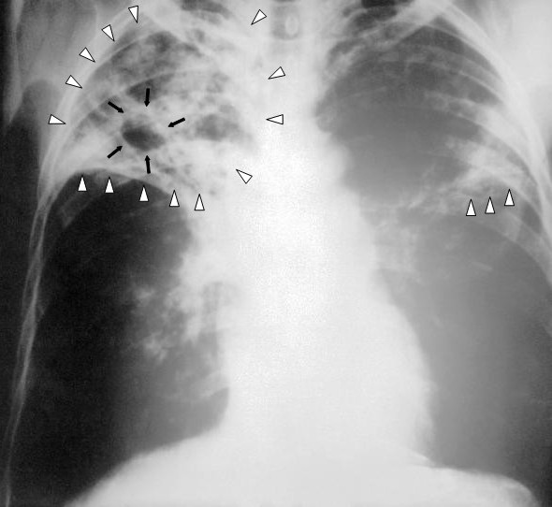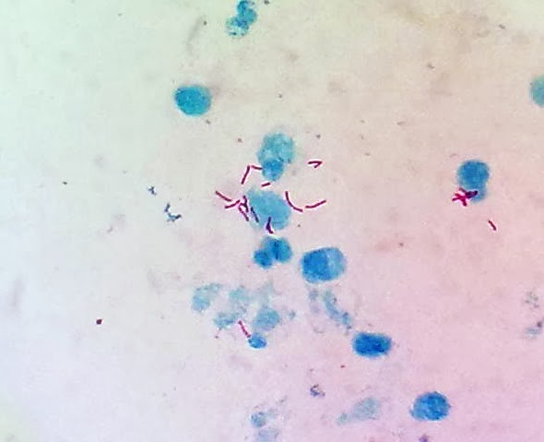

Chest xray (left panel showing Sputum sample showing TB germs (red)
Disease in the left lung (arrowed) when viewed under the microscope
At Tanjomoha, sputum is examined in the lab at the local public hospital by microscopy once stained with specific chemicals which highlight TB bacilli (Ziehl-Nielsen staining, still used in the UK).
Extracts from annual report of Tsaraivotra, prepared by Pere Emeric
Detailed records have been kept for every year of the hospital since its opening . There are no accurate records of numbers or outcomes before this time.
In 2015, 418 individuals were diagnosed with TB in the Vohipeno area. This compares with:
2008 578
2009 550
2010 427
2011 519
2012 571
2013 411
2014 448
There may thus be signs of a reduction in TB in the area, very possibly because of the success of Tsaraivotra. This is likely to be even more marked because it is probable that whilst the number coming just from the immediate Vohipeno area have significantly reduced, more people are coming from further afield as the word of the hospital and its success spreads. Pere Emeric does not have data from before this year as to how many do so.
In 2015, of the 418 cases of TB diagnosed on the Vohipeno district, 199 received treatment in Tsararivotra, the rest elsewhere. Of these 199, 159 (80%) were sputum smear +ve, when TB germs are seen in the sputum, the remainder smear –ve, when TB germs are not seen in the sputum sample. 19/199 (10%) were aged <15 yrs, and 55% male.

Population served
There is no accurate information concerning the size of the population from whom cases are drawn; Vohipeno itself has a population of c. 15000 but in 2015 , only166/418 (40%) cases treated were from Vohipeno itself, the rest (60%) were from within a roughly 50km radius, the nearest other treatment centre being at Farafangana.
166 cases from a Vohipeno population of c. 15000 gives an incidence of >1000/100000 population. By comparison, we treat about 5 patients /year in Somerset from a catchment population of 370,000 so TB is hundreds of times commoner in Madagascar.
Practicalities of treatment
Patients are admitted to and remain at Tsaraivotra normally for 2 months receiving daily medications and frequent medical assessment. They are then allowed home for the remainder of the 6 months treatment, returning at 4 and 6 months for reassessment and to collect further supplies of medicines. Any that are particularly weak, usually representing more advanced disease at diagnosis may remain in patients for longer.
The families of the sickest patients are encouraged to stay at Tsaraivotra to help with their care. Very few patients fail to re-attend at 4 and 6 months , only 2 failed to do so in 2015 although another 4 were lost between 4 and 6 months.
Mortality
14/199 (7%) patients died in 2015. Usually this because they presented late, very weak and with advanced disease and sometimes other underlying illness. This compares very favourably with the UK where 10% of patients die, usually within the first month of treatment.
Contact tracing
In the western world, close contact tracing of patients forms an important part of the overall control of TB, but there is no mechanism for this in Madagascar. However, any close, usually family, contact of a TB case is encouraged to attend Tsaraivotra for testing if they are unwell or have a cough of more than 2 weeks duration.
Costs associated with treatment of TB at Tsararivotra
Drugs are free (WHO)
In 2015, E13,500 was spent on transport and food for patients, of which E9,500 was for food. This equates to E0.35/day for food per person
HIV
HIV is a huge problem in much of mainland Africa with up to half of adults positive a number of years ago. By weakening selective parts of the immune system, HIV is particularly bad for TB, increasing greatly its prevalance.
Fortunately, when all the patients were recently HIV tested in the Vohipeno district in 1 year, only 1 tested positive for HIV so it is not a problem.
Comments
1. These are very reassuring statistics and indicate that Tsaraivotra has been very successful in treating TB in the Vohipeno region. The patients have comfortable accommodation and receive a good diet integral to their recovery.
2. Pere Emeric is to be congratulated on what has been achieved. The importance of having the first 2 months of treatment at Tsararivotra is recognised and remarkably few patients seem to default on treatment with every effort made to find the few that do. This is important in order to prevent partially treated patients remaining potentially infectious to others.
3. The outcome of treatment at Tsaraivotra, in terms of mortality and treatment completion, compares very favourably with that seen in the UK, which is testament to the care and attention the patients receive.
There are some concerns:
- Some people who do not have TB germs seen in their sputum may be being missed, because the sputum samples cannot be cultured in the region, but at least such patients are of low infectivity compared to those with TB germs seen in their sputum.
- The inability of an infrastructure for contact tracing will also miss a few cases, or result in them presenting with more advanced disease later on.
- There are clearly occasional deficiencies in the provision of technician time for examining sputum samples at Vohipeno hospital which will result in some cases having a delayed diagnosis. There is only a single trained technician at Vohipeno hospital, who is not always available, so there is sometimes no service in which case the samples are sent to Manakara. In this case it can be several weeks until a result is obtained (this should be an almost same day service ideally).
- Xray is available in the public hospital but is used in < 10% of cases, most probably if the situation is unclear from sputum examination. Xray is relatively expensive at 3E /examination. There is in theory no absolute need to perform Xray if the diagnosis is evident from sputum examination, unless there are special features or poor response to treatment, in which case it is available.
- The roof is rusting and needs repainting which we can arrange and fund.

The two medically qualified trustees will discuss these technical issues with their co-trustees, but they are relatively minor when seen against the quite outstanding overall success of the Tsaraivotra TB project.

CRS January 2017

.

