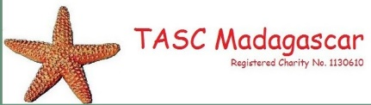
Borehole Programme
Post-Project Report

VOHIPENO MUNICIPALITY
- OVERVIEW
Vohipeno town is located in Vohipeno District, Vatovavy Fito Vinany Region of Madagascar. The town benefitted from clean drinking water infrastructure after receiving support from the Adsum Foundation and TASC Madagascar for the installation of 6 boreholes and hand-pumps in March 2016, as well as the repairing of another hand-pump.
- BENEFICIARIES IN VOHIPENO MUNICIPALITY
VILLAGE | BENEFICIARIES
MANGARIVOTRA NORD, Soafiadana | 146
MANGARIVOTRA SUD | 130
VATOMASY SUD | 123 households
TANJOMOHA | 393
VATOMASY EST | 35 households
MAROMBY | 115

- TIMELINE OF PROJECT ACTIVITIES
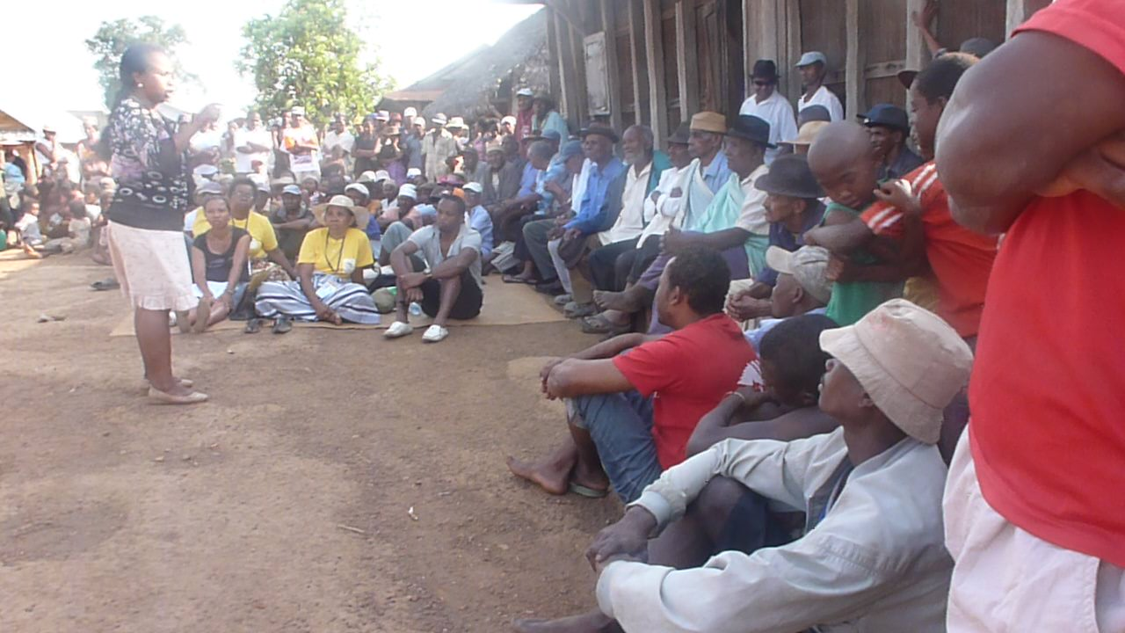
Village meeting
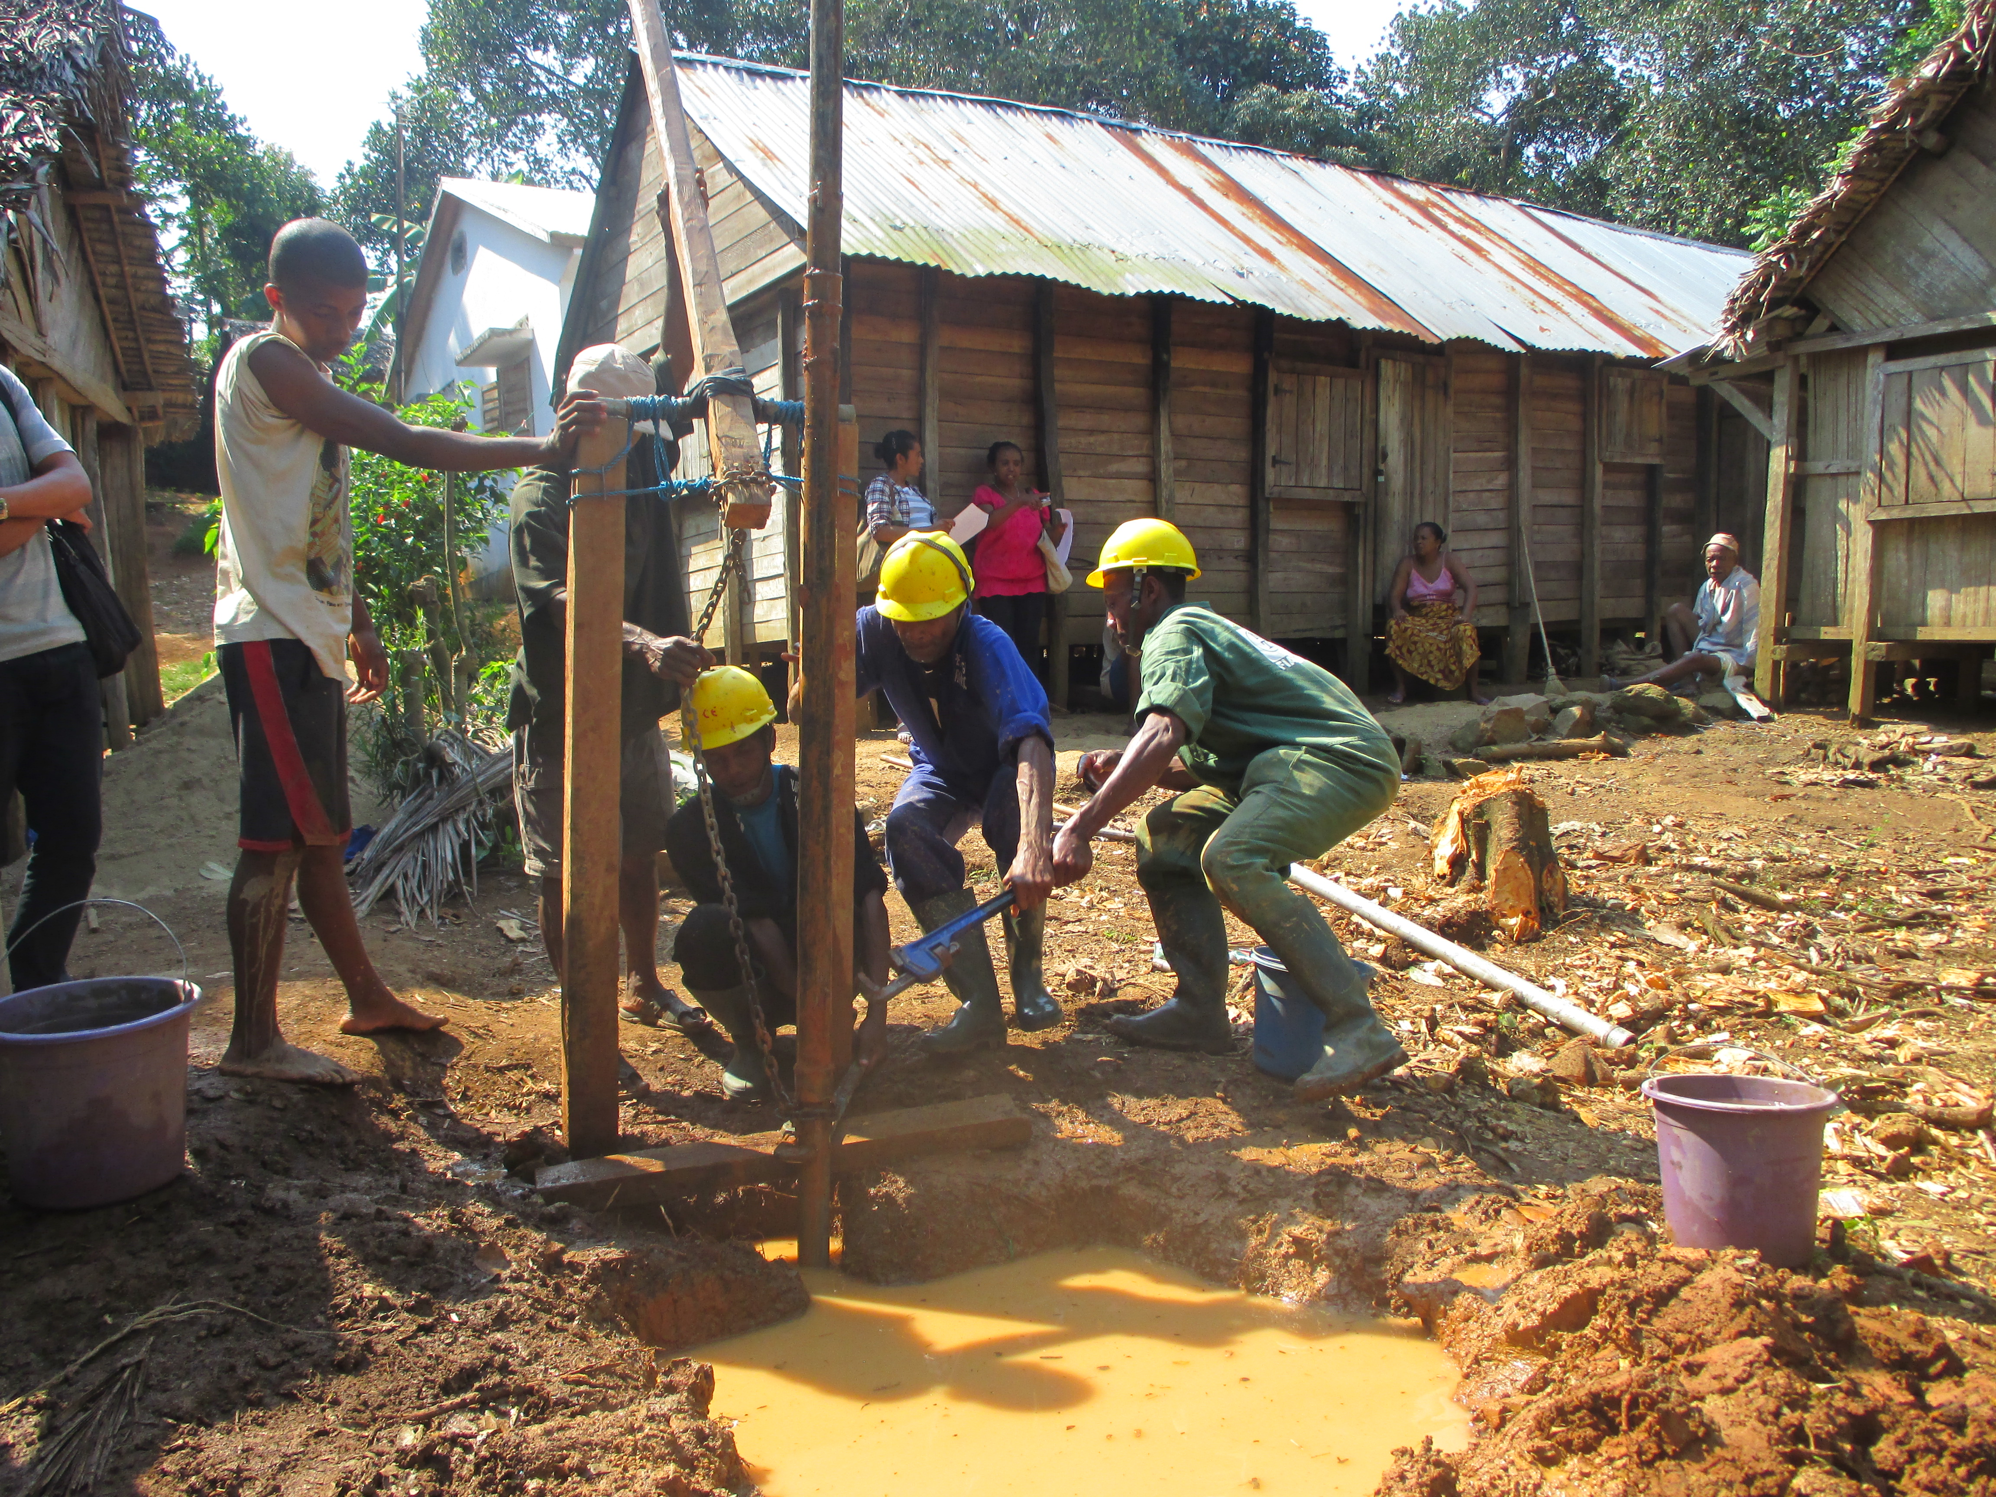
Start of drilling work
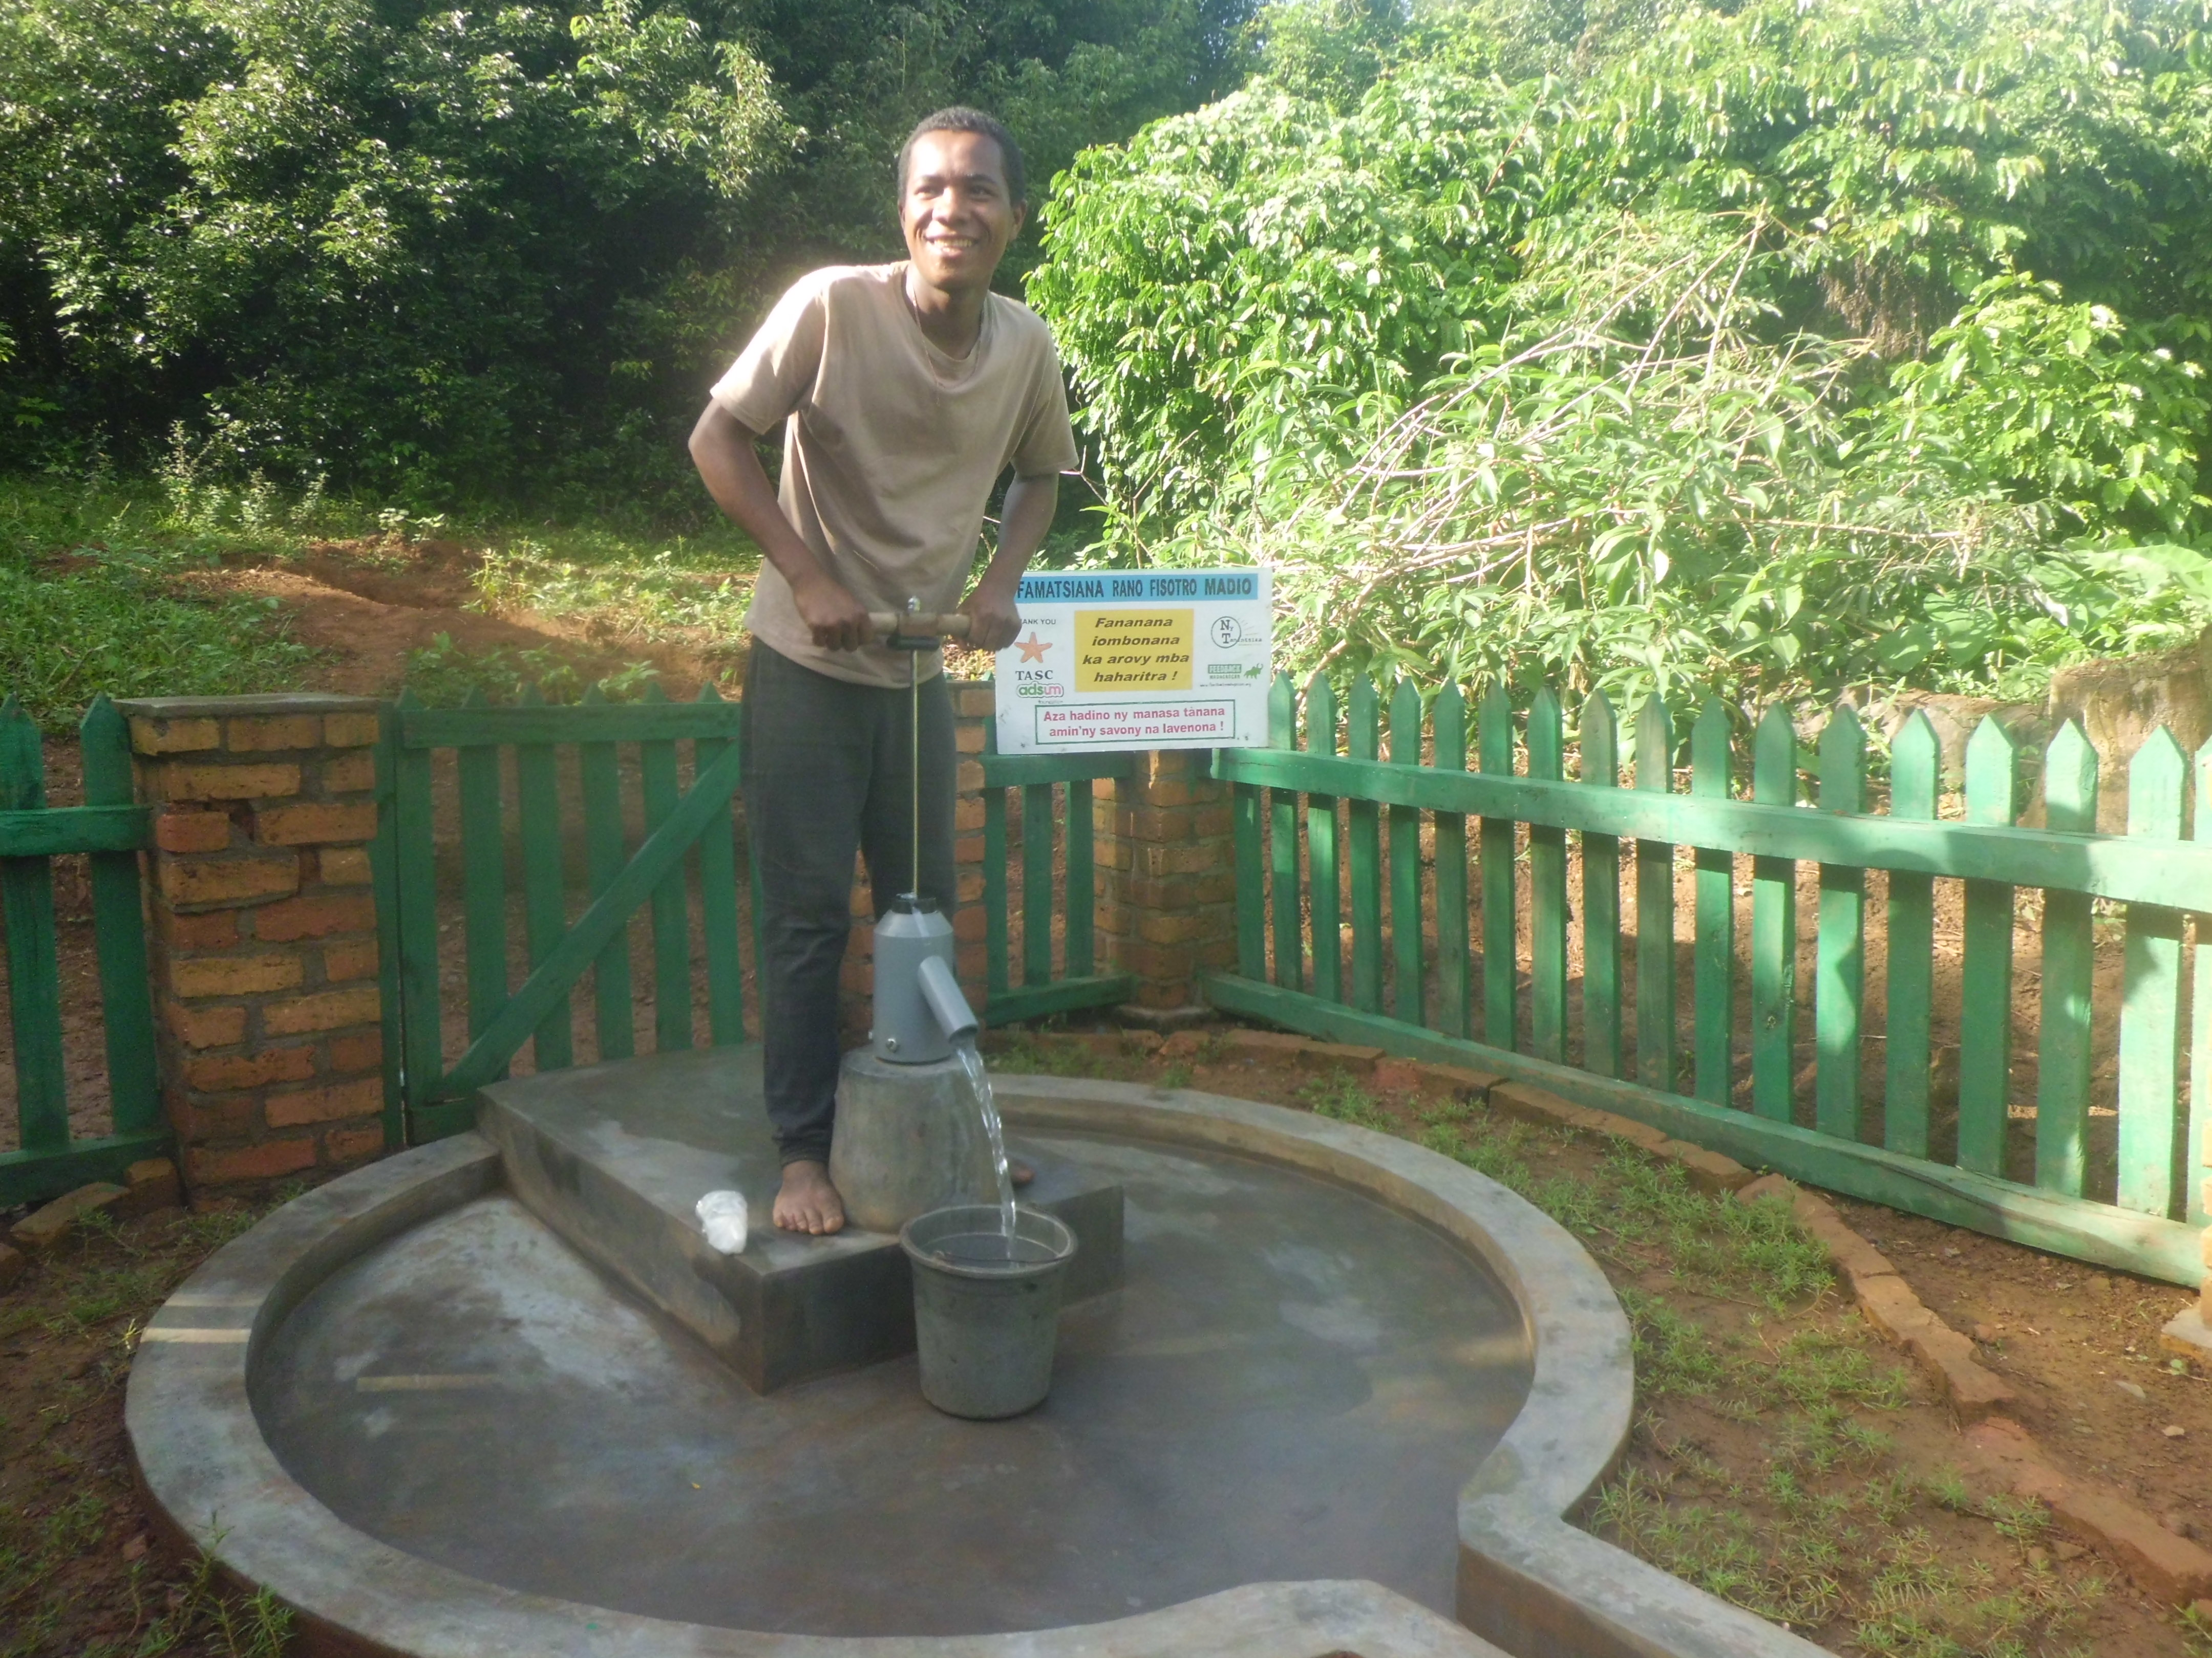
Clean drinking water!

- DETAILS OF EACH PHASE
- PREPARATION PHASE: JULY-AUGUST 2015:
- SITE VISIT AND FEASIBILITY STUDY:
A trip was made to the Vohipeno area the 28th - 29th July 2015 to conduct site visits and feasibility studies in each planned borehole site. Specifically, this was to:
- Identify 3 suitable locations for each borehole in each of the 6 sites in the different areas of town, carrying out environmental risk assessments and getting written authorisation from the landowners for well installation for community use.
- Study the site feasibility.
- Confirm readiness regarding community contributions required for the project.
- Assess the current situation with regard to donors or projects active in the water sector in this area.
- Carry out a survey of the project beneficiaries.
Information gathered on Vohipeno: Fianarantsoa – Vohipeno: 315 km by car
DISTANCE | PREVIOUS WATER SOURCE | FEASABILITY SITUATION | BOREHOLE DEPTH ESTIMATION | SOIL TYPE
Vohipeno office municipality to Vatomasy Nord : 300m | Spring and traditional well | Feasible | 6-7m | Sandy and rocky
Vohipeno office municipality to Vatomasy Nord : 400m | Spring and traditional well | Feasible | 6-7m | Sandy and rocky
Tanjomoha to Vohipeno Office municipality : 2.1 km | Traditional well and pump | Feasible | 5-7m | Sandy
Mangarivotra North to Vohipeno municipality: 2 km | Spring | Feasible | 5m | Sandy and rocky
Mangarivotra South to Vohipeno municipality : | Vohipeno river | Feasible | 5m | Sandy
Maromby to Vohipeno municipality: 1km | Vohipeno river | Feasible | 5-7m | Sandy and rocky
- FIRST MEETING WITH PROJECT BENEFICIARIES
A meeting was held with households from Maromby, Mangarivotra on the 17th August 2015.
- Meeting agenda
- Presentation of Feedback Madagascar / Ny Tanintsika and their partnership with the Adsum Foundation and TASC;
- Presentation of the Borehole Programme;
- Project activities in Vohipeno;
- Technical explanation of boreholes;
- Discussion about beneficiaries’ contributions to the project;
- Election of the local committee in charge of overseeing preparations for the project and progress;
- Election of 2 local maintenance technicians per borehole; responsible for repairs and maintenance of the wells (to be trained during the work);
- Logistical arrangements (e.g. purchases of local materials required, housing for drilling teams, identifying a stock house, etc.).

ACTIVITY | PARTICIPANTS | DETAILS / RESULTS
First meeting with beneficiaries in Mangarivotra, Maromby at the Tanjomoha Centre
Awareness-raising about the 3 key WASH messages (Water-Sanitation-Hygiene) | - Mayor of Ambohibary municipality  - Headmaster of Andoharanovelona  - Fokontany (neighbourhood) Chief  - Village chief  - 30 households present | 18 households informed of the 3 key WASH messages and the importance of the following actions in diarrhoea disease prevention:  - Building and use (hygienic) latrines  - Hand-washing with soap or ash  - Drinking safe water  Awareness-raising about borehole use for households.
Explanation of the borehole technology and design |  | Active participation of participants, with many questions asked by project beneficiaries.  A photo of a completed borehole was shown to illustrate the technology.
Presentation of Project Workplan for Vohipeno sites |  | Discussion about community contributions:  - Providing somewhere secure for the drilling teams to stay during their work in the village, and someone to prepare their food.  - Providing somewhere secure to store the equipment and materials until the end of work.  - Fetching water throughout drilling work.  - Collecting and transporting sand.  - Transporting any materials by foot where transport is impossible to the point of drilling.  - A minimal financial contribution of 125,000 MGA per borehole.  - The community accepted these contributions having asked different questions to clarify everything.
Choosing the building committee (in charge of overseeing preparations for the project and progress) |  | The following people lead this committee:  Mangarivotra: Ledoux: 034 40 377 27, Nirina Bruno: 033 23 638 74, Mme Irene : 034 48 785 07  Maromby: Rakoto Joel: 033 47 856 80, Mr Zaria

- DECISION MADE:

During the first meeting at the Tanjomoha Centre on the 17th September 2015, the beneficiaries from Mangarivotra and Maromby were thrilled to accept the installation of a borehole and hand-pump for clean drinking water.
Likewise, beneficiaries at the second meeting in Vatomasy areas in Vohipeno in December 2015 were delighted to accept the project.

- CHOOSING LOCAL MAINTENANCE TECHNICIANS:

The villagers chosen to follow the practical training with the drillers during borehole installation were:
Village | NAME | AGE
Mangarivotra North | CONSTANT Robert | 56
 | BOTO Mahavatotsara | 49
Mangarivotra South | RANDRIANAMBININA Felix | 52
Vatomasy North EAST | RAHERISON Jean Tokiniaina Albro | 26
 | RAZAFITSARATSIRY Adamah | 43
Foyer Tanjomoha | COSTANT ROBERT | 56
 | GASIPARA
Maromby | RANDRIAMIRADO | 27
 | RAMANANTENA Alfred | 46
Vatomasy South East | TSIAFARANDAHY Martino | ND
 | RANDRIAMAHEFA Nestor | ND

Note: CONSTANT Robert also assists the maintenance technician in Mangarivotra South.

- VISIT TO THE REGIONAL ADMINISTRATION FOR WATER, SANITATION AND HYGIENE IN MANAKARA:

A curtesy and coordination visit was made to the regional department of the Ministry of Water, Sanitation and Hygiene in Manakara on the 18th August 2015. A meeting was held with the Director of Vatovavy Fito Vinany Region, Mr Luc RANDRIANARIVELO. Discussion centred on FBM/NT’s project sites in partnership with Adsum Foundation and TASC, to clarify the site situation and the partnership with other organisations.
Other organisations working in Vatovavy Fito Vinany region on water and sanitation are Water Aid (working in the South of Vohipeno), as well as GRET and FIKRIFAMA.
The Director is keen for FBM/NT to install many boreholes in Vatovavy Fito Vinany Region because just 36% of the population has access to safe water. He insisted about the Government’s important role in assessing the project – that the Director from Manakara should visit the project for monitoring purposes and to help FBM/NT resolve any problems with the community. They are also the officials who validate the work after borehole installation.

- DRILLING PHASE:

- TRAVEL TO VOHIPENO:
- 2-4th November: 2 drilling teams prepared their trip to Vohipeno in Fianarantsoa.
- 5th November: Travel to Vohipeno, leaving Fianarantsoa early morning to travel for 6 hours, over 315 km.
- 6th November: Purchasing certain materials in Vohipeno and meeting with beneficiaries and the representative of the Water Ministry.

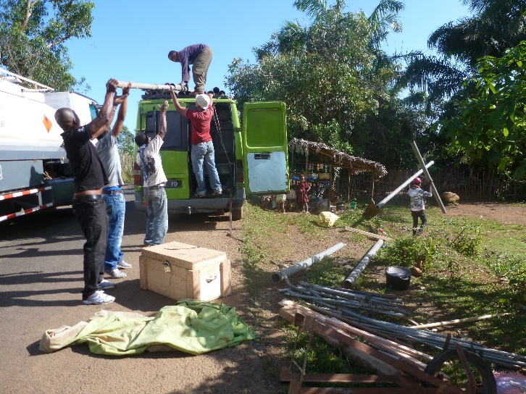 | 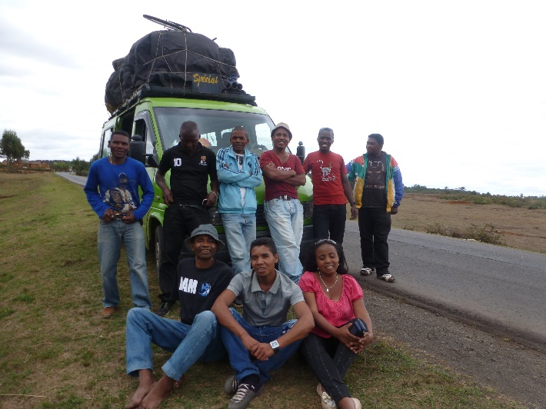
Travel to Vohipeno

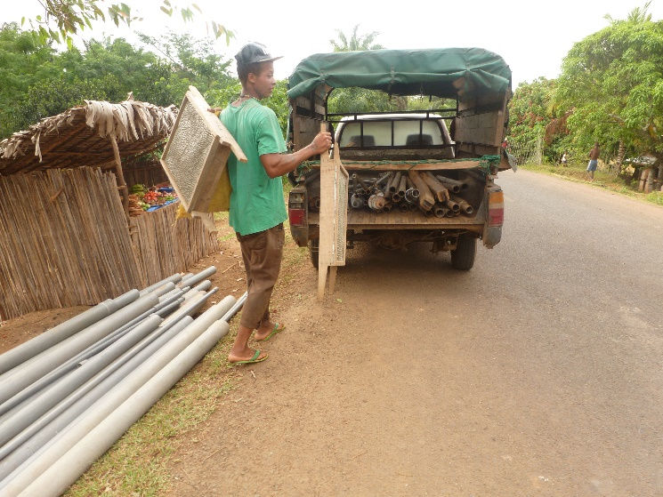
Beneficiaries transporting materials to Tanjomoha.

- BOREHOLE INSTALLATION
- Borehole Installation in Mangarivotra Centre

- Date: 7th - 27th November 2015, over 20 days
- The Team:
Drilling team 1: Abel, Aimé & Eric
Technicians: Brian & Rose

- Timeline of project activities in Mangarivotra Centre:
- Started drilling on the 7th of November with 3 drillers, 2 local maintenance technicians, 1 technician officer and 1 social-organisational officer.
- 7th-10th November: Drilling activities. The community fetched water daily to use for drilling and construction work.
- 11th -12th November: Some drillers prepared the PVC pipe for the borehole lining and others drillers helped the community find sand for the sand filter.
- 12th November 2015 : Installation of PVC well casings within the boreholes, placement of a sand filter pack in the open space surrounding the well casing and start of borehole development.
- 13th November: Borehole casing and development.
Visit of Bernard from ADSUM Fdn and representatives from FBM/Ny Tanintsika Fianarantsoa.
- 13th -16th November : Development of borehole with rope pump and drilling blow
- 18th November: Carrying out the first chlorination.
- 17th – 20th November: Start of building the surface structure: a concrete pedestal, sanitary apron, a soakaway (‘sump’) and a painted fence (with brick pillars as corners). The fence serves to prevent animals from entering the well area.
Heavy rain made completion of work difficult for the team, although community participation remained high at all times.
- 22th November: Carrying out the second chlorination.
- 20th - 26th November: Development of borehole using a Rope pump.
- 27th November: Installation of the Canzee hand-pump.

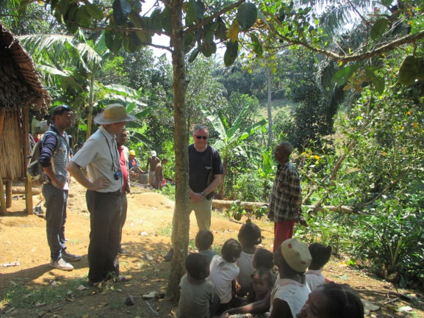
Visit to a borehole in Vohipeno with Bernard from Adsum Foundation

- Timeline of activities with the reparation of the India Mark Pump at Maromby Primary school with 2 drillers and beneficiaries:
- 17th September: Diagnostic of India Mark III problem: after dismantling the borehole, there was found to be a lot of sand in the hole and materiel missing.
- 20th November: Reparation of the India Mark III pump at Maromby Primary school.
- 21th November: Development using a rope pump and an electric submersible pump.
Identification of the problem: there is a part missing of the India mark hand-pump. The technician reinstalled the metal pipe in the borehole. The project bought the required material.
2nd Reparation
- 1st February 2016: Removing the pipe from the borehole for a second diagnosis.
- 2nd February 2016: Replacing the missing material (a cylinder) and mounting the India Mark III hand-pump.
- 3rd -4th February: Redevelopment of the borehole and finishing touches.
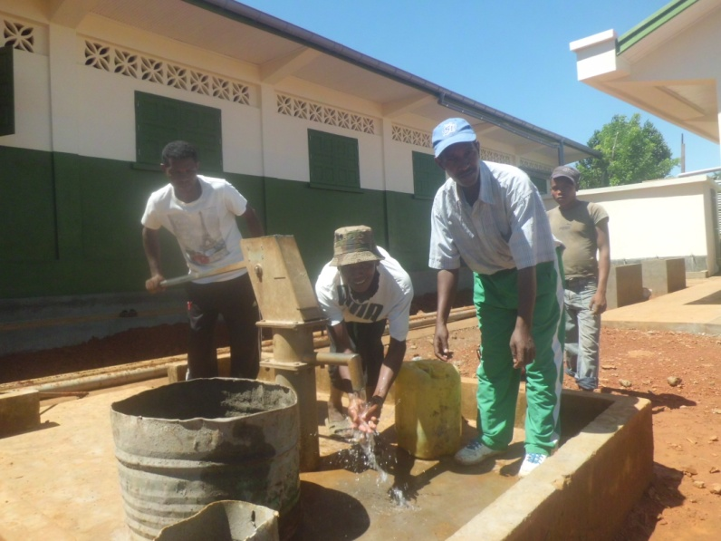
The India Mark pump repaired!
- Borehole Installation in Mangarivotra North East

- Date: 7th November to 4th December 2015, over 27 days
- The Team:
Drilling team 1: Ndria, Lova & Mamy
Technicians: Brian and Rose

- Timeline of project activities in Mangarivotra North East:
- Starting drilling on the 7th of November with 3 drillers, 2 local maintenance technicians, 1 technician officer and 1 social-organisational officer.
- 7th -10th November: drilling activities. The community fetched water daily to use for drilling and construction work.
- 11th -12th November: Some drillers prepared the PVC pipe for the borehole casing and others drillers helped the community find sand for the sand filter.
- 12th November 2015 : Installation of PVC well casings within the boreholes, placement of a sand filter pack in the open space surrounding the well casing and start of borehole development.
- 13th -21st November : Development with rope pump and drilling blow
- 22nd November: Carrying out the first chlorination.
- 17th– 21st November: Start of building the surface structure: a concrete pedestal, sanitary apron, a soakaway (‘sump’) and a painted fence (with brick pillars as corners). The fence serves to prevent animals from entering the well area.
Heavy rain made completion of work difficult for the team, although community participation remained high at all times.
- 18th November: Carrying out the second chlorination.
- 2nd -3rd December: Finish the fence and paint.
- 4th December: Installation of the Canzee pump hand-pump.
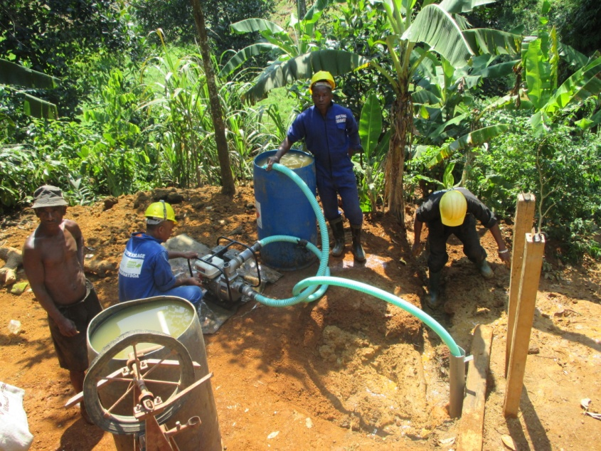
Borehole development in Tanjomoha Centre (using rota jetting technology)

- Boreholes activities at the Tanjomoha Centre.

a- Date: 23th November to 15th December 2015, over 23 days
b-The Team:
Drilling team 1: Ndria, Mamy and Lova
Technicians: Brian and Rose

C-Timeline Activities at the Tanjomoha Centre

- 23rd -24th November: Drilling activities with 3 drillers, 2 local maintenance technicians, 1 technician officer, 1 social-organisational officer and Technology Rota jetting.
- 24th November: An unsuccessful drilling attempt at the first hole: the team hit rock that they could not penetrate at a depth of 10.8 metres. So they moved to a second place to restart a new borehole.
- 25th - 26th November: Starting the second drilling attempt: the team hit rock that they could not penetrate at a depth of 13.8 metres. So they moved to the third place to restart a new borehole.
- 27th November: Testing the third hole, development with electric pump and drilling blow. The water flow rate was 1m³ and the total depth of the borehole is 13.80m.
- 27th -28th November: Some drillers prepared the PVC pipe for the borehole casing and other drillers helped the community find sand for the sand filter.
- 29th November -5th December 2015: Development with rope pump and drilling blow.
After development and drilling blow the water flow rate increased to 1.4m³ with the submergible electric pump.
- 5th December : They re-tested the 2nd hole drilled and the water flow rate was found to be satisfactory:
The water flow rate is 1.4m³ /hour but, because the Tanjomaha Centre needs to fill up 25m³ reservoirs every day, they require a flow rate of 2-3 m³/hour. Since the water flow rate was therefore insufficient for the centre, Père Emeric asked the team to make a fourth drilling attempt to try to have a better water flow rate.
- 7th December: Start of the fourth drilling attempt using the Rota jetting technology. The team dug to 13.80m.
- 7th -10th December: Drilling activities at the third hole to a depth of 13.8m
- 11th December: Preparation of the PVC pipe for the borehole casing.
The community helped drillers find sand for the sand filter.
- 12th December: Development of the borehole.
- 13th- 14th December: Development, plunging and starting building the surface structure.
- 14th December: Re-testing the borehole: the water flow rate was found to be satisfactory (more than 2m³ per hour).
- 15th December: Building the surface structure.
- 16th December: Technical acceptance of the borehole with the technicians, representatives of the neighbourhood and representatives of Vohipeno municipality.
- Borehole Installation in Vatomasina Sud East
- Date: 27th November to 18th December 2015, over 22 days
- The Team:
Drilling team 1: Able, Eric and Aimé
Technicians: Brian and Rose

- Timeline of project activities in Vatomasina Sud East:
- Started drilling on the 28th of November with 3 drillers, 2 local maintenance technicians, 1 technician officer, 1 social-organisational officer and using Rota sludge technology.
- 28th November-2nd December: Drilling activities. The community fetched water daily to use for drilling and construction work.
- 3rd December: Team meeting in Vohipeno, visit and monitoring of the borehole achieved in Vohipeno with the project officer.
- 3rd December: The drillers prepared the PVC pipe for the borehole casing and other drillers sieved the sand filter.
- 4th December : Installation of PVC well casings within the boreholes, placement of a sand filter pack in the open space surrounding the well casing and start of borehole development.
- 4th - 12th December: Development with rope pump and drilling blow
- 12th December: Carrying out the first chlorination.
- 12th - 14th December: Start of building the surface structure: a concrete pedestal, sanitary apron, a soakaway (‘sump’) and a painted fence (with brick pillars as corners). The fence serves to prevent animals from entering the well area.
Heavy rain made completion of work difficult for the team.
- 15th December: Carrying out the second chlorination.
- 15th December: Installation of the canzee pump hand-pump.
- 15-18th December: Development with Canzee hand-pump.
- 16th December: Technical acceptance ceremony with the Technicians, representatives of the neighbourhood (fokontany) and representatives of Vohipeno municipality.
Remark: The community in Vatomasina is not keen to participate in activities in Vatomasina; only 25% of their contributions have been realised.

- Borehole Installation in Maromby

- 31st January 2016: Travel to Vohipeno from Fianarantsoa
- 1st -2nd January 2016: preparation of the activities in Vohipeno with the community and the authorities.
- The Team:
Drilling team 1: Ndria, Lova and Mamy
Technicians: Funny, Rose and Vonjy

- Timeline of project activities in Maromby: 3rd February to 4th March 2016
- Starting drilling on the 3rd of February with 3 drillers, 2 local maintenance technicians, 1 technician officer, 1 social-organisational officer and Rota sludge technology.
The team hit rock that they could not penetrate at a depth of 2.5metres. So they moved to the second place to restart a new borehole.
- 4th - 8th February: Starting the second hole: the team hit rock that they could not penetrate at a depth of 17.3 metres. So they tested the hole and the water flow rate was under than 1m³. This was considered less than hoped so they moved to a third location.
- 9th -10th February: Starting the third hole: the team hit rock at a depth of 6.3 metres. On testing the water flow rate, this was even less.
11th February: The team decided to redevelop the second borehole.
- 12th -13th February: Some drillers prepared the PVC pipe for the borehole casing and others drillers helped the community find sand for the sand filter.
Installation of PVC well casings within the boreholes, placement of a sand filter pack in the open space surrounding the well casing and start of borehole development.
- 13th -21st February: Development with rope pump and drilling blow
- 13th February: Carrying out the first chlorination.
- 22nd -26th February: Building of the surface structure: a concrete pedestal, sanitary apron, a soakaway (‘sump’) and a painted fence (with brick pillars as corners). The fence serves to prevent animals from entering the well area.
Heavy rain made completion of work difficult for the team, although community participation remained high at all times.
- 20th February: Carrying out the second chlorination.
- 27th February: Installation of the canzee pump hand-pump.
- 28th February – 2nd March: Development using the Canzee hand pump.
- 3rd March: Provisional acceptance of works.

- Borehole Installation in Vatomasina North East

- 31st January 2016: Travel to Vohipeno From Fianarantsoa
- 1st -2nd January 2016: preparation of the activities in Vohipeno with the community and the authorities
- The Team:
Drilling team 1: Abel, Aimé and Eric
Technicians: Funny, Rose and Vonjy

- Timeline of project activities in Vatomasina North East: 3rd February to 4th March 2016
- Starting drilling on the 3rd of February with 3 drillers, 2 local maintenance technicians, 1 technician officer, 1 social-organisational officer and Rota sludge technology
The team hit rock that they could not penetrate at a depth of 2.5metres. So they moved to a second place to restart drilling.
- 4th - 8th February: Starting the second hole: the team hit rock that they could not penetrate at a depth of 17.3 metres. The water flow rate was under 1m³ so they moved to a third location.
- 9th -10th February: Starting the third hole: the team hit rock at a depth of 6.3 metres. The water flow rate was lower.
11th February: It was decided best to redevelop the second hole.
- 12th -13th February: Some drillers prepared the PVC pipe for the borehole casing and others drillers helped the community find sand for the sand filter.
Installation of PVC well casings within the boreholes, placement of a sand filter pack in the open space surrounding the well casing and start of borehole development.
- 13th -21st February: development with rope pump and drilling blow
- 13th February: Carrying out the first chlorination.
- 22nd-26th February: building of the surface structure: a concrete pedestal, sanitary apron, a soakaway (‘sump’) and a painted fence (with brick pillars as corners). The fence serves to prevent animals from entering the well area.
Heavy rain made completion of work difficult for the team, although community participation remained high at all times.
- 20th February: Carrying out the second chlorination.
- 27th February: Installation of the canzee pump hand-pump.
- 28th February – 2nd March: development with the canzee hand pump
- 3rd March: Provisional acceptance of works.

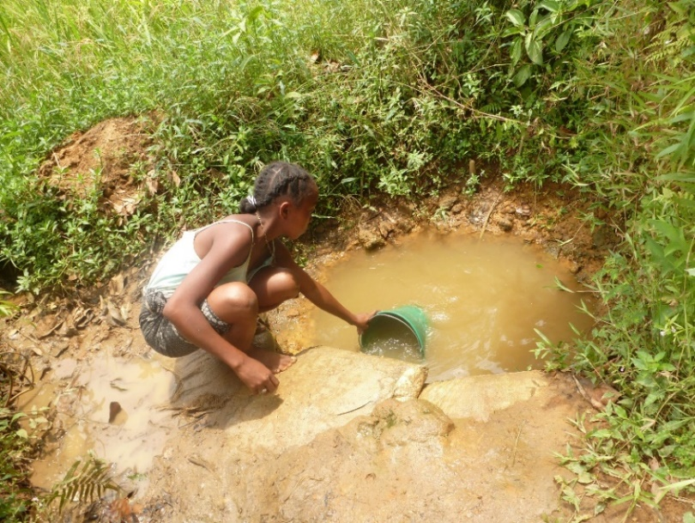  The previous water source | 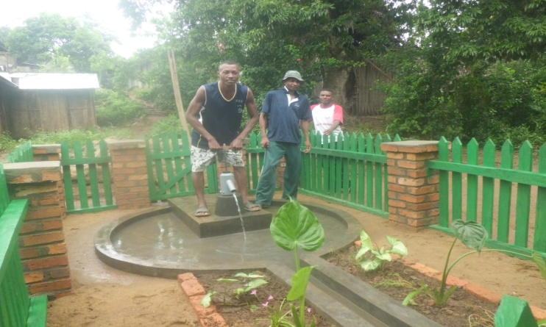  A new borehole in Vatomasina North East
- Borehole land agreement:

All of the boreholes installed are on private property with signed agreements given by landowners.

- POST-INSTALLATION PHASE

- Water management committee creation

A water management committee was created following this table:
Fokontany | Village | Achievement | Name of the management committee | Date of Training
Maromby | Mangarivotra Afovoany | 27/11/2012 | SOAFIADANA | 02-03 December 2015
 | Mangarivotra Est | 21/11/2015 | AINASOA | 02-03 December 2015
Vatomasina | Vatomasina Nord | 15/12/2015 | SAMBEZASOA | 12-13 December 2015
Maromby | Foyer Tanjomoha | 15/12/2015 | TSARARIVOTRA | 12-13 December 2015
Maromby | Village Maromby centre | 23/02/2016 | EZAKA | 24-25 February 2016
Vatomasy | Vatomasy Est | 23/02/2016 | TSIMIALONJAFY | 24-25 February 2016

- Training of the water management committee
- Training content:
- The reasoning for creating an association
- Leadership and communication
- The roles and responsibilities of the different members of the association
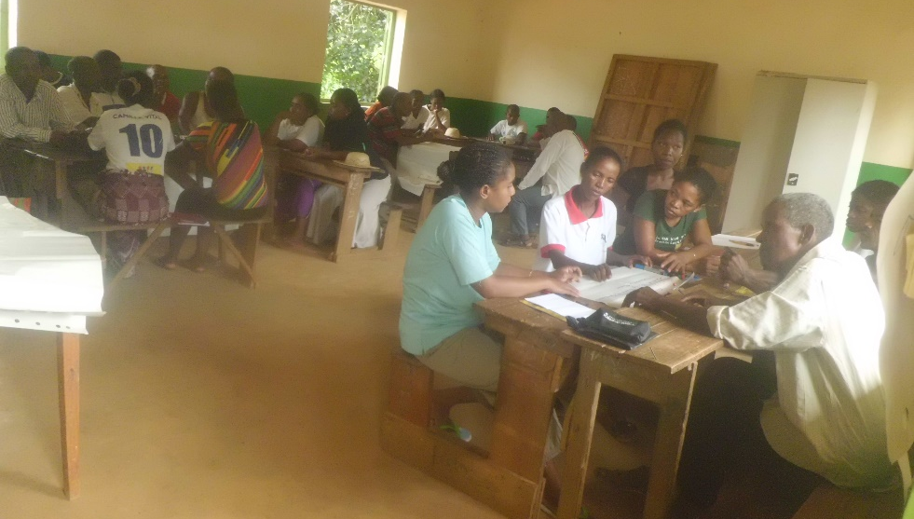
Management committee members in training

- Training of the local maintenance technicians

Village | NAME | Date of training
Mangarivotra North | CONSTANT Robert | December 2015
 | BOTO Mahavatotsara
Mangarivotra South | RANDRIANAMBININA Felix
Vatomasy North EAST | RAHERISON Jean Tokiniaina Albro | 07-08 April 2016
 | RAZAFITSARATSIRY Adamah
Foyer Tanjomoha | COSTANT ROBERT
 | GASIPARA
Maromby | RANDRIAMIRADO | 07-08 April 2016
 | RAMANANTENA Alfred
Vatomasy South East | TSIAFARANDAHY Martino
 | RANDRIAMAHEFA Nestor

Training was about borehole maintenance, reparation and chlorination.
Some tools were given to the local technicians in order for them to fulfil their role.
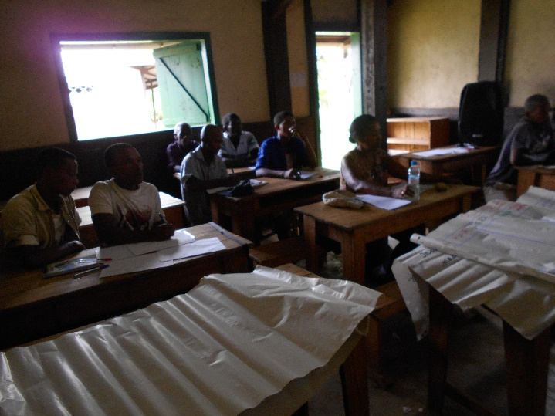
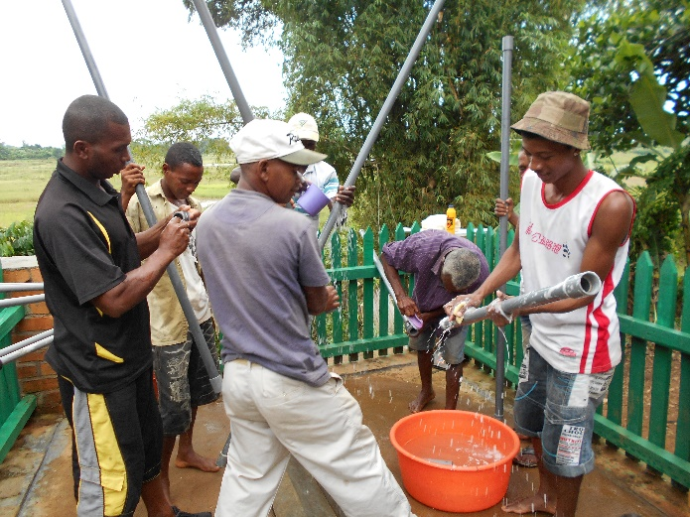
Follow-up training of the local maintenance technicians (theory & practical sessions).
THE TEAM

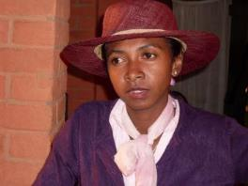 | 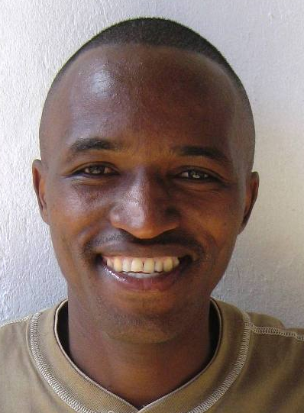 | 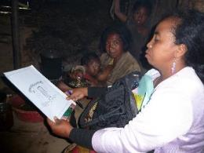
Sophie  Project Officer | Funny  Borehole Technician / Overseer of Drilling Team | Rose  Community Outreach Worker (Socio-Organisateur)
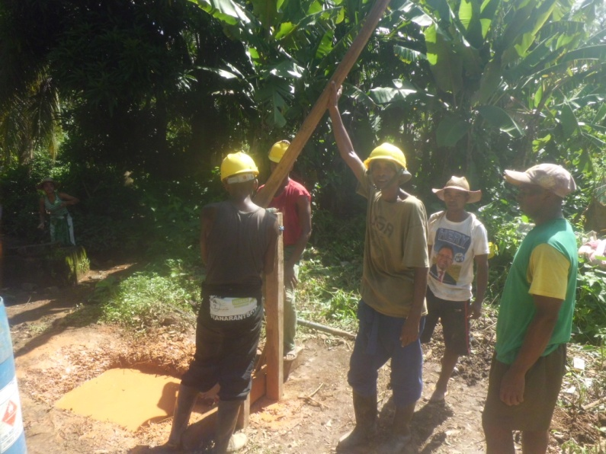
The drilling team: Aimé, Abel, Eric, 2 local Technicians in Mangarivotra centre

- TECHNICAL DETAILS OF BOREHOLE DRILLING AND PUMP INSTALLATION

NO | Fokontany | Village | Geographical coordinates |  |  | Duration of drilling (day) |  | Beneficiaries | Static level | Dynamic level | Total depth(m) | Water flow rate | Number of failed drilling attempts | Technology
 |  |  | X [E] | Y [S] | Z |  | Pump
REGION VATOVAVY FITO VINAGNY

1 | Maromby | Mangarivotra Afovoany | 47*50.815' | 22*20.546' | 14 | 20 | canzee | 146 | 4,5 | 7 | 18,9 | 1m3/h | 1 | Rotasludge
2 |  | Mangarivotra Nord Est | 47*50.879' | 22*20.454' | 14 | 27 | canzee | 130 | 4,3 | 9 | 13,3 | 1m3/h | 1 | Rotasludge
3 | Vatomasina | Vatomasina south East | 47*50.448' | 22*21625' | 10 | 22 | canzee | 123 | 4 | 10 | 21,3 | 1m3/h | 1 | Rotasludge
4 | Maromby | Foyer Tanjomoha | 47*50.991' | 22*20.630' | 9 | 23 | canzee | 393 | 3 | 17 | 20,3 | 2m3/h | 3 | Rotajetting and Rotasludge
5 | Maromby | Village Maromby centre |  |  |  | 21 | canzee |  |  |  |  | 1m3/h | 3 | Rotasludge
6 | Vatomasy | Vatomasy Est |  |  |  | 21 | canzee |  | 1,5 | 2 | 11,3 | 2m3/h | 1 | Rotasludge

- WATER TEST

DATE OF TESTING: 6/04/2016
TYPE: Water from manually-drilled borehole, Canzee hand-pump
ANALYSIS KIT: PORTABLE DELAGUA
 |  |  | ORGANOLEPTIC PARAMETER |  |  |  |  |  |  |  |  |  | PHYSICO-CHEMICAL PARAMETER |  |  | BACTERIOLOGICAL PARAMETER
No. | VILLAGE | Water management committee | TURBIDITY |  |  |  | COLOUR | ODOUR | TASTE |  |  |  | PH | RESIDUAL CHLORINE |  | E.COLI
1 | Vatomasina South East | SAMBEZASOA | <5NTU |  |  |  | Transparent | Odourless | A little salty |  |  |  | 6.9 | 0mg/l |  | 0/100ml
2 | Vatomasina North East | TSIMIALONJAFY | <5NTU |  |  |  | Transparent | Odourless | A little salty |  |  |  | 6 | 0mg/l |  | 0/100ml
3 | Maromby | EZAKA | <5NTU |  |  |  | Transparent | Odourless | Tasteless |  |  |  | 6.5 | 0mg/l |  | 0/100ml
4 | Foyer Tanjomoha | TSARARIVOTRA | <5NTU |  |  |  | Transparent | Odourless | Tasteless |  |  |  | 6.9 | 0mg/l |  | 08/100ml
5 | Mangarivotra centre | SOAFIADANA | <5NTU |  |  |  | Transparent | Odourless | Tasteless |  |  |  | 6.5 | 0mg/l |  | 0/100ml
6 | Mangarivotra North East | AINASOA | <5NTU |  |  |  | Transparent | Odourless | Tasteless |  |  |  | 6.5 | 0mg/l |  | 0/100ml

- DEFINITIVE ACCEPTANCE OF WORKS AND OFFICIAL CELEBRATION

The definitive acceptance of works was on the 14th April with the:
- Director of the regional department of the Ministry of Water, Sanitation and Hygiene for Vatovavy Fito Vinany Region,
- Mayor of Vohipeno Municipality
- Local Management technicians for each borehole
- 3 Representatives from FBM-Ny Tanintsika
- The TASC team (Stuart, Pat &Tojo)
We took the opportunity to raise awareness about the 3 key WASH messages amongst beneficiaries, and to give advice about using the boreholes.
In Vatomasina North east, one person built a latrine 10 metres from the borehole, just 21 days after the pump was put in place, and despite clear rules being set. The Mayor of Vohipeno ordered this latrine to be demolished within 3 days. Luckily, this latrine had not been used yet.
THANK YOU SO MUCH, TASC & THE ADSUM FOUNDATION FOR YOUR SUPPORT!! 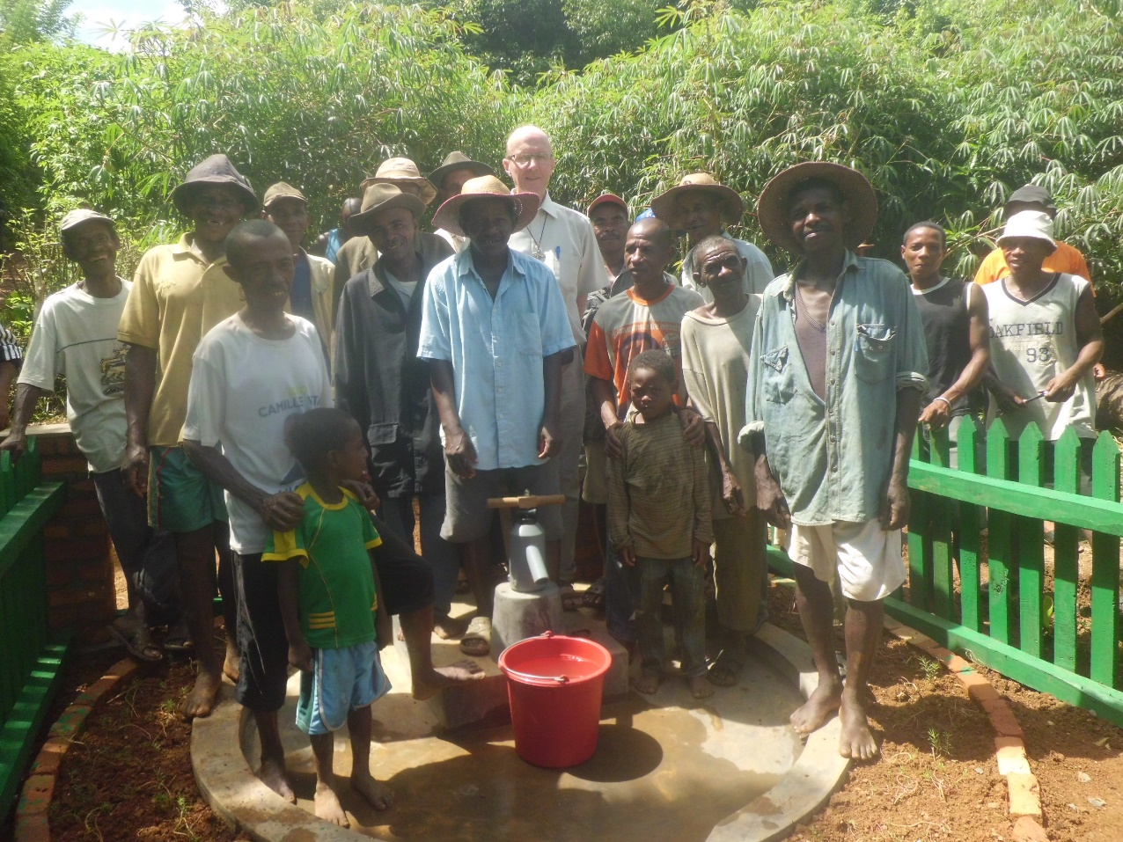

Final acceptance of works document: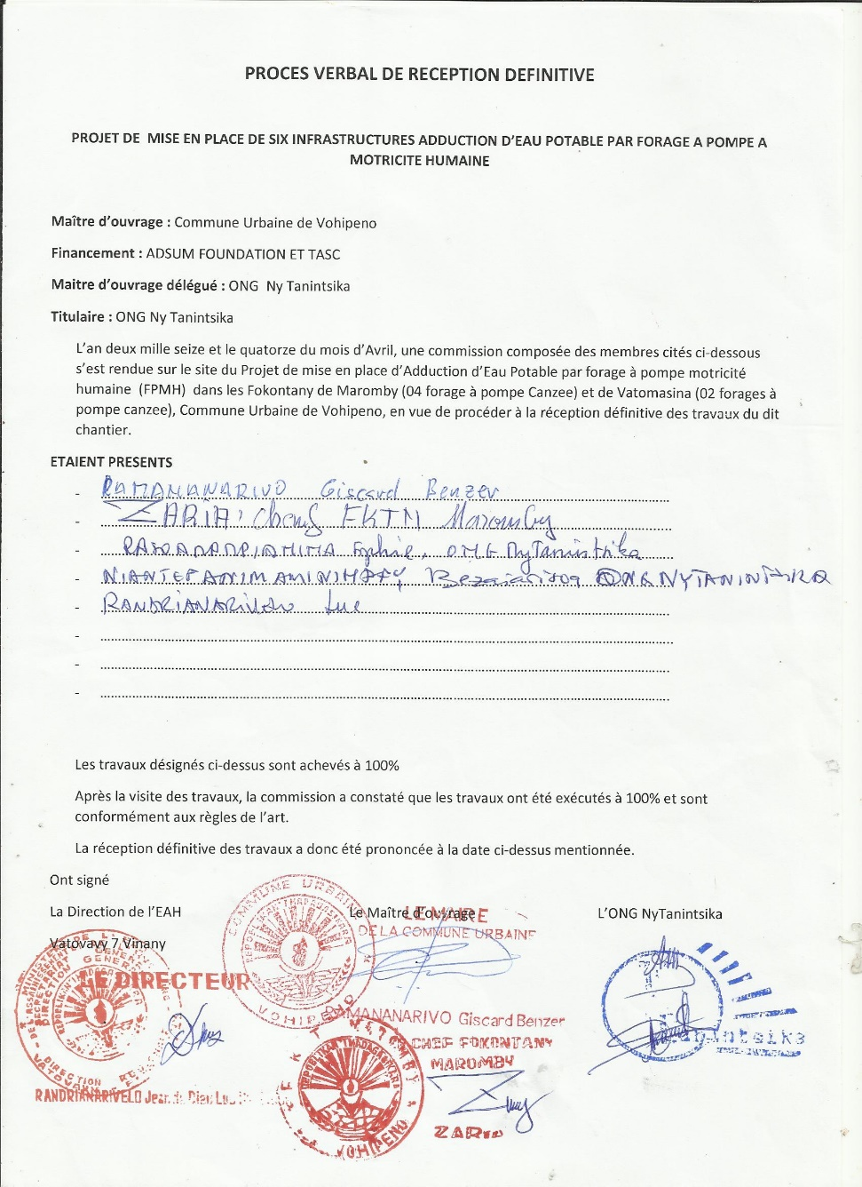

STRATIGRAPHIC PROFILES FOR EACH BOREHOLE:
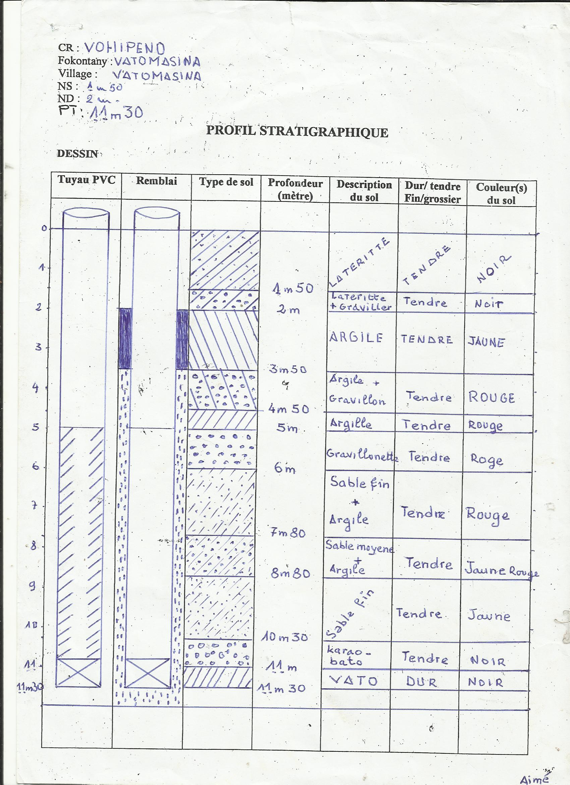

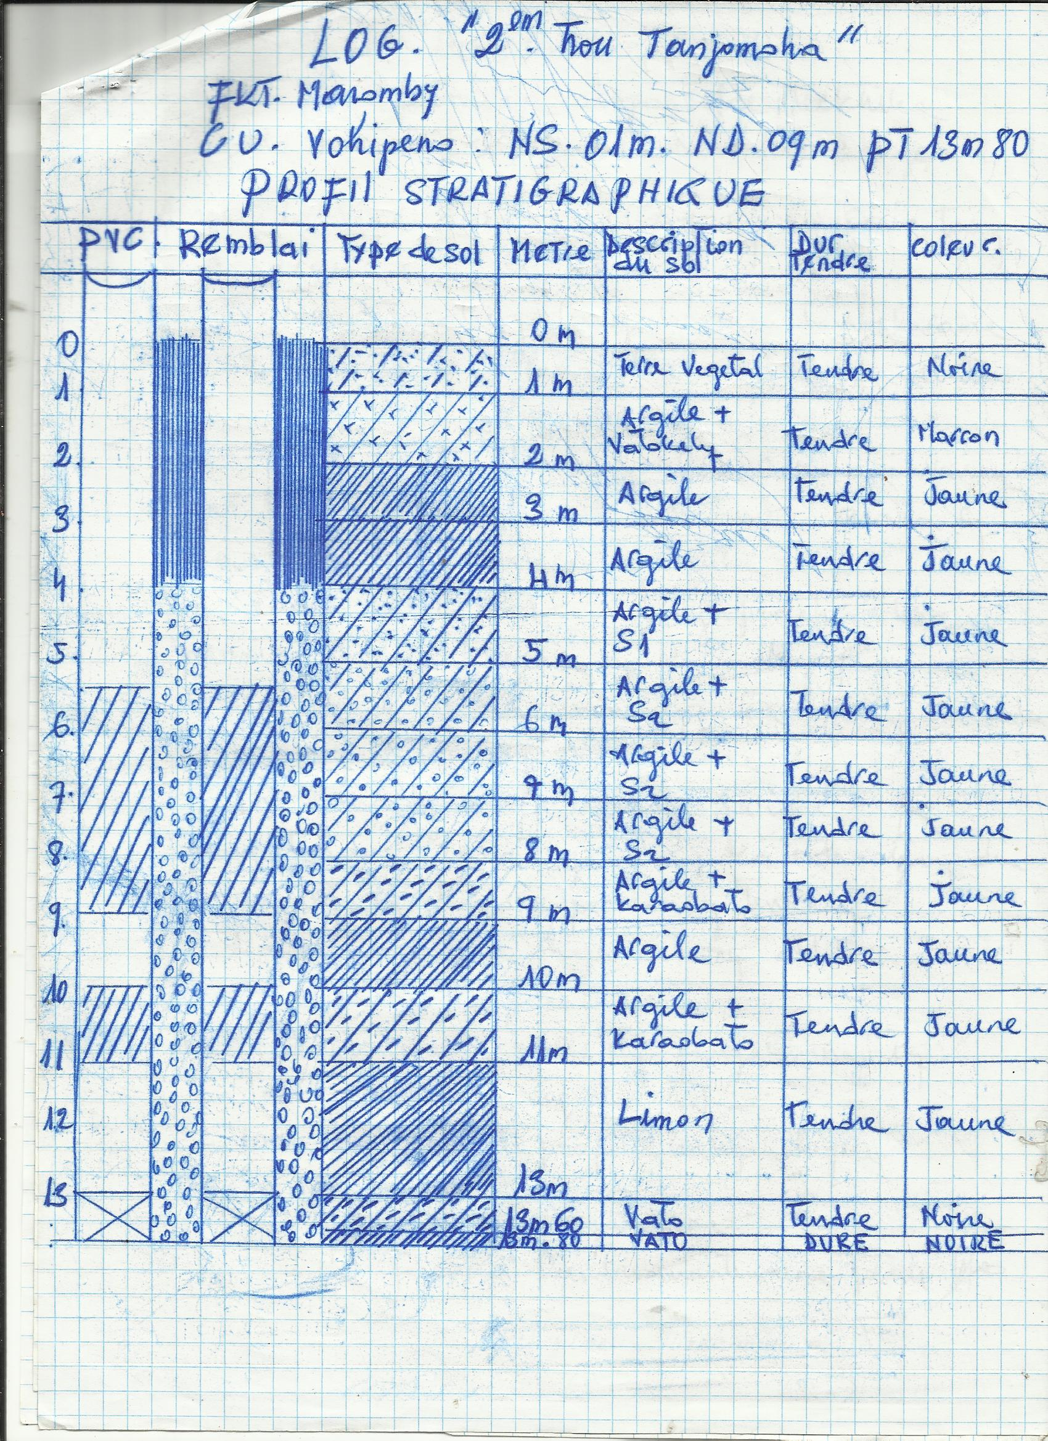
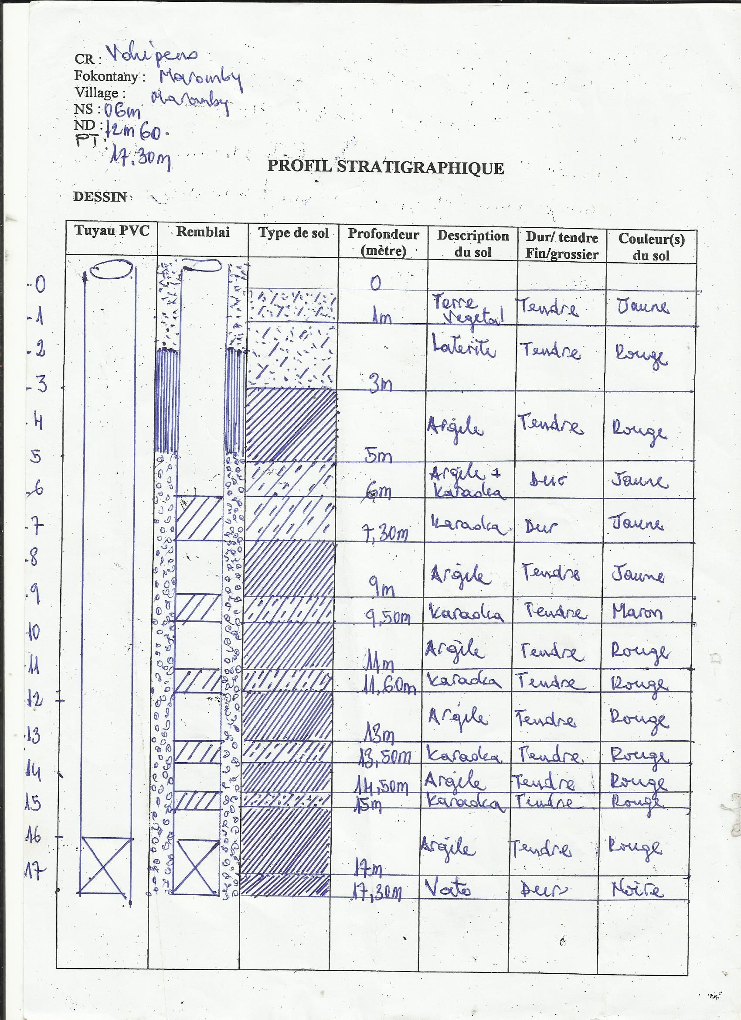

The document explaining the official transfer of responsibility for the borehole to the Mayor of Vohipeno municipality on 15th April 2016
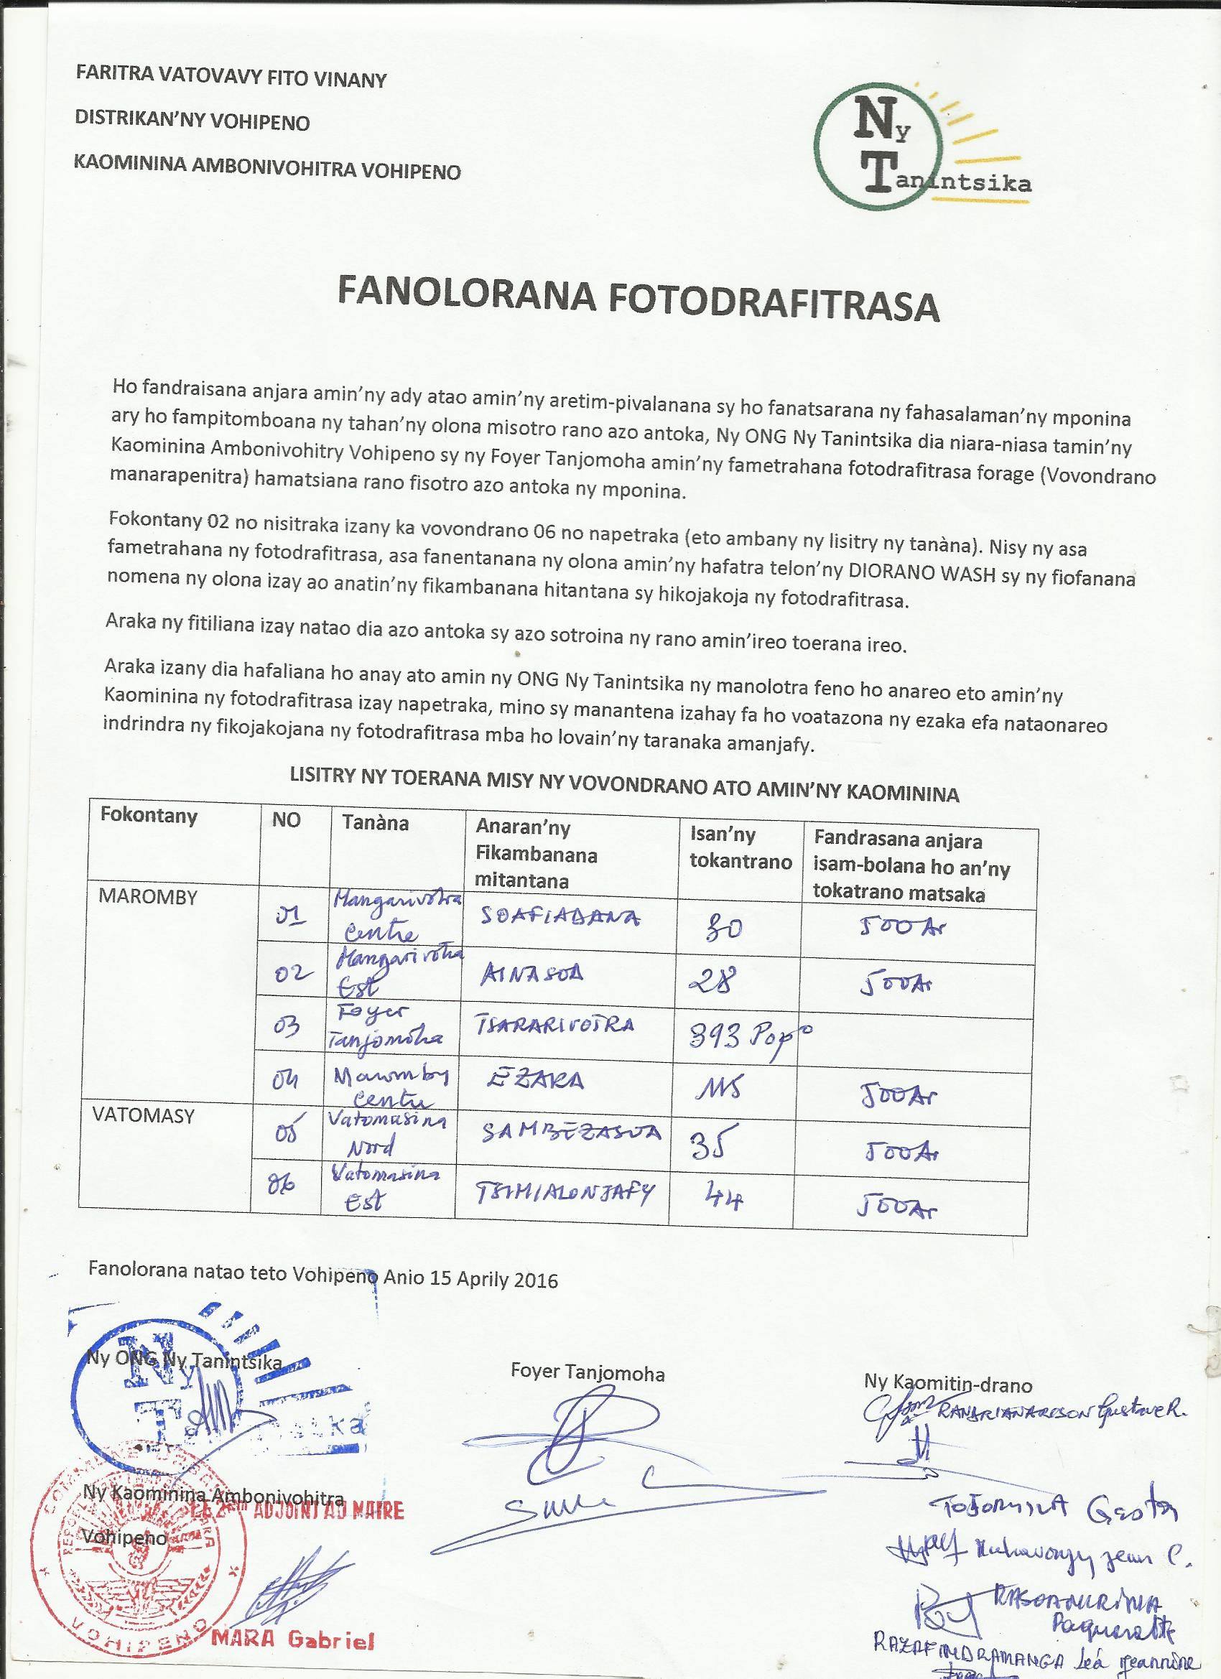

Thank-you letters from communities
The water management committee named ‘Tsimialonjafy’ in Vatomasina thank you for the gift of clean drinking water.
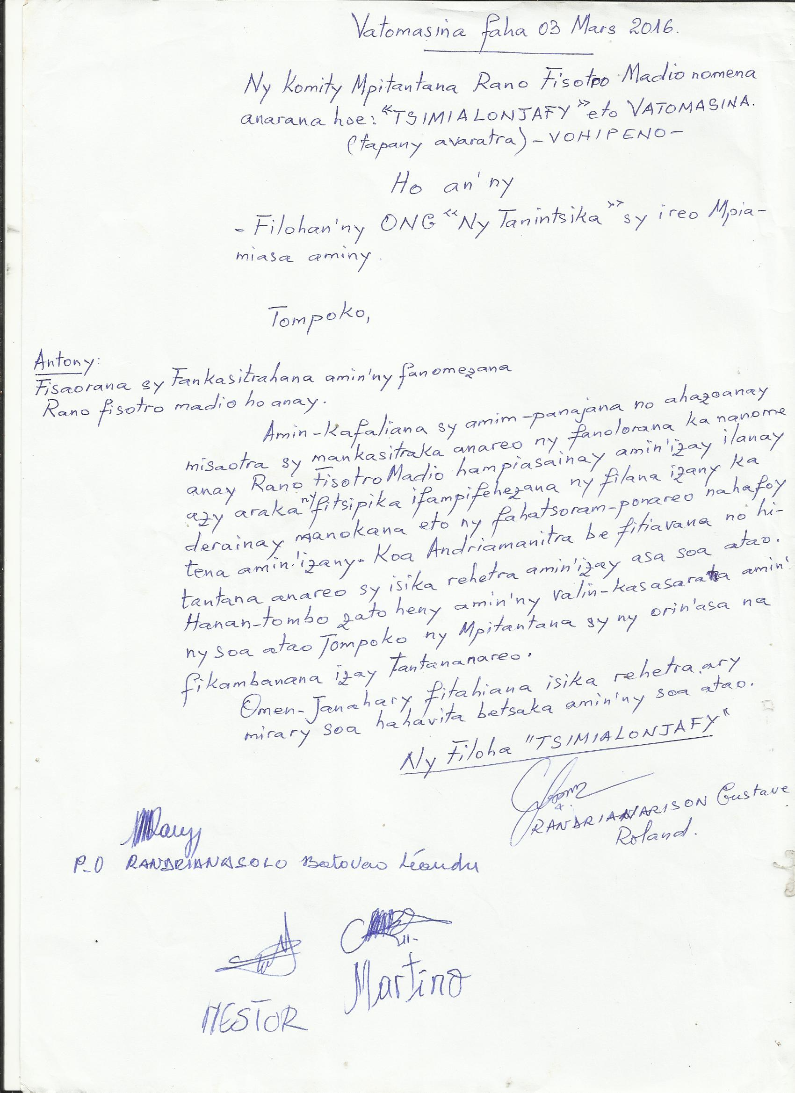

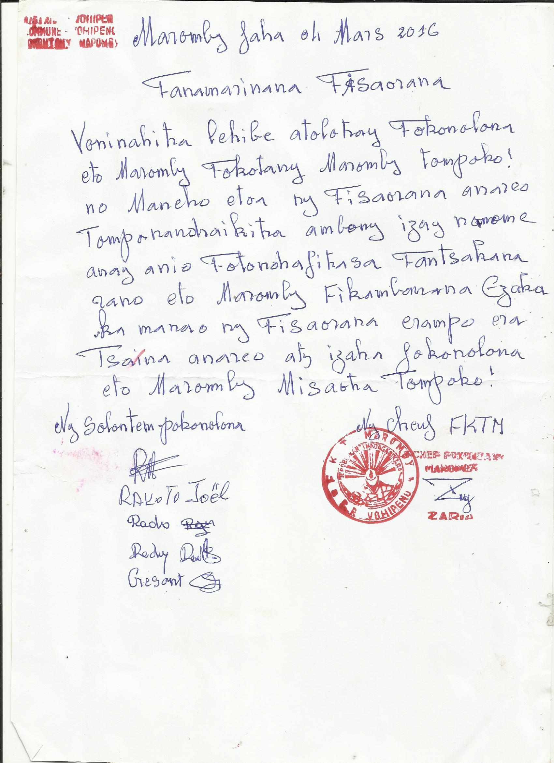

Photo of soil samples taken during drilling work:
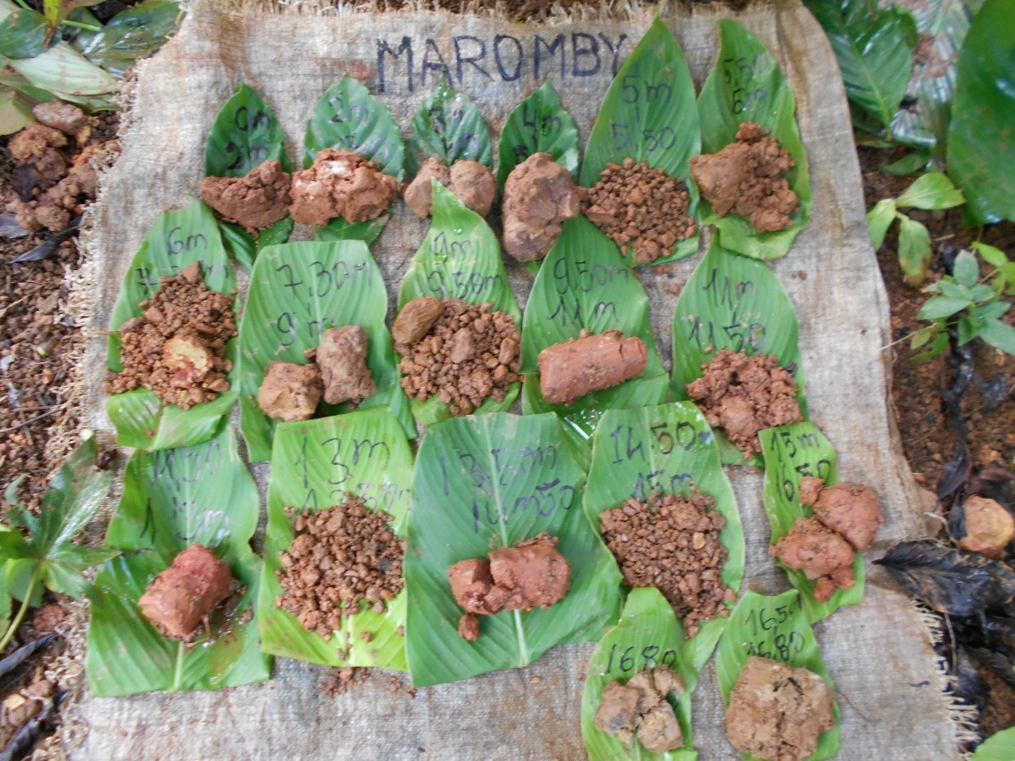

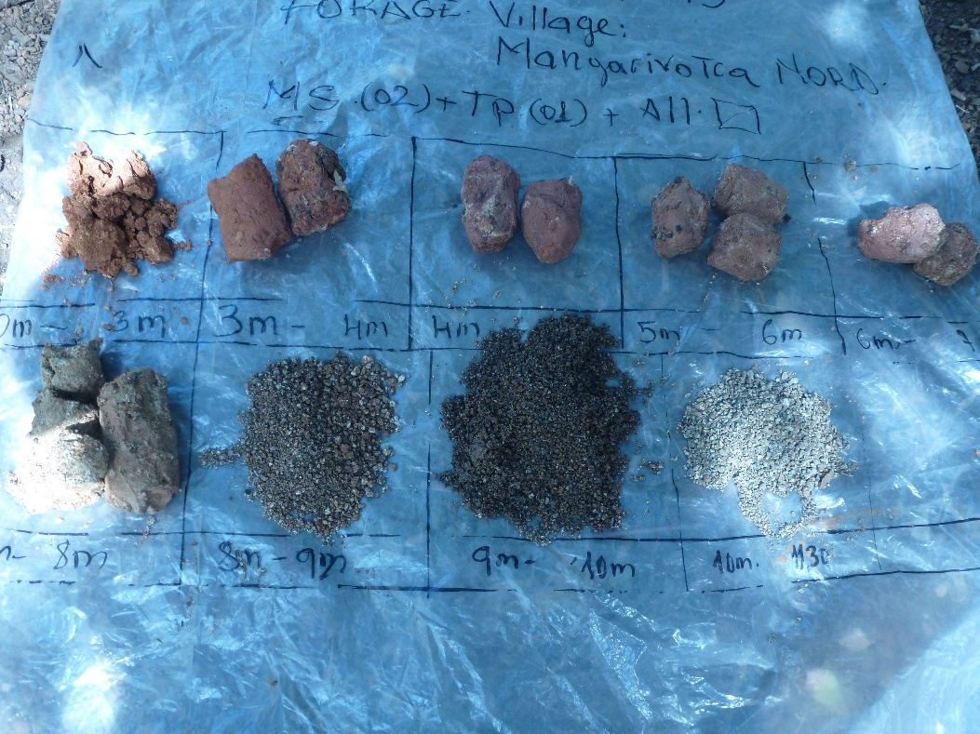
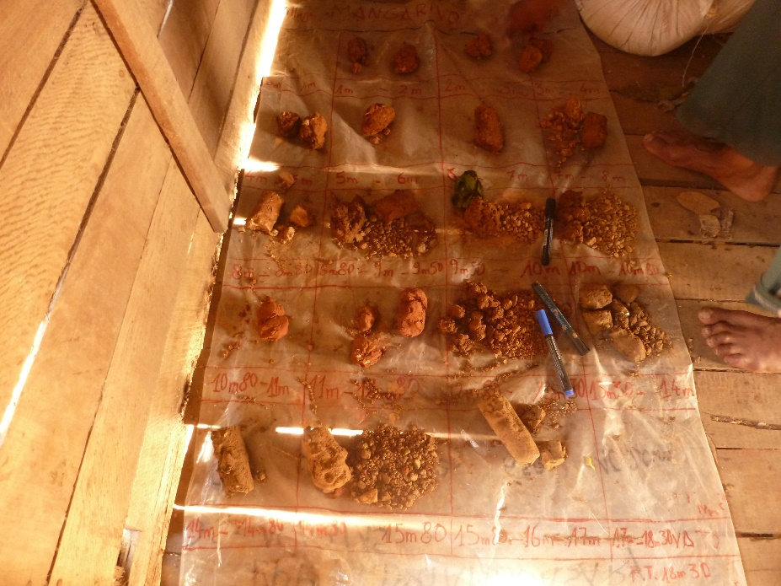
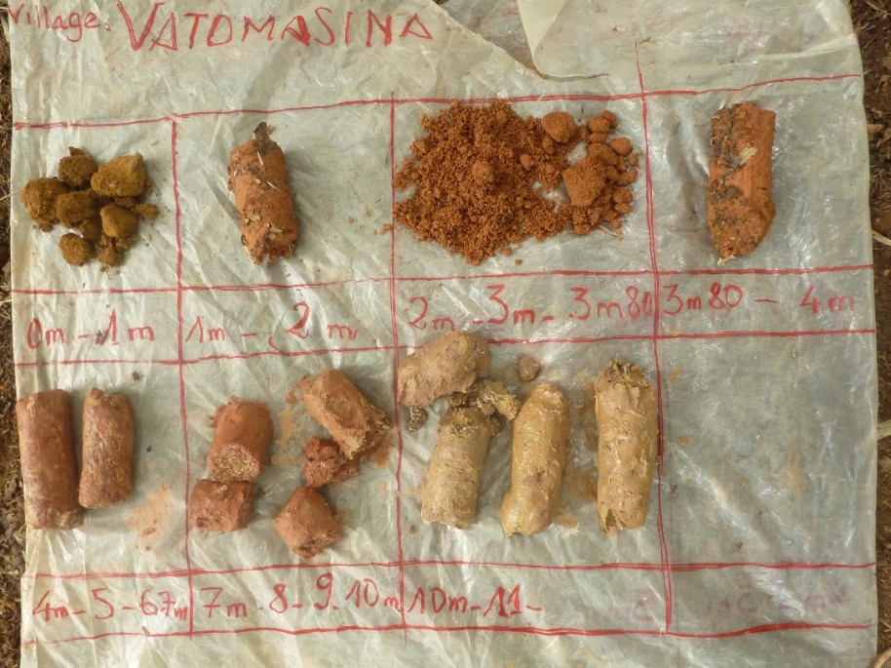
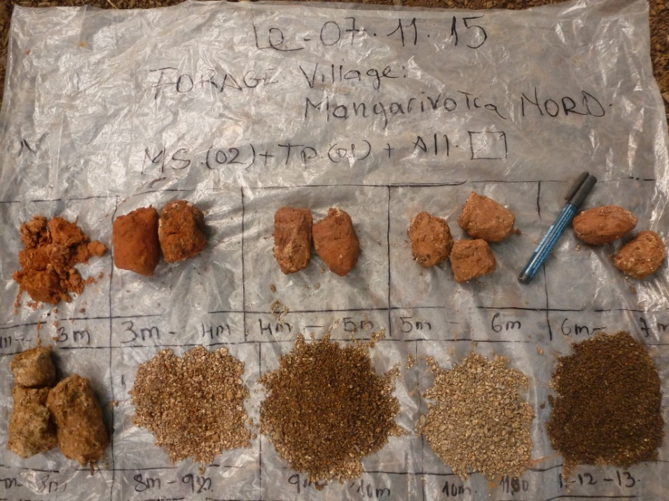
Photos taken at the inauguration ceremony:
