**Appendix 1.**

**Works history on Maromby School.**

**This is presented by local engineer Auguste Manasoa and P.J O’Brien in conjunction with**

**TASC Madagascar and ADSUM .**

The history shows the renovation of an existing building along with the design drawings, site management and completion of the detail concrete elements that allowed for the high quality finished seen in the completed works.

The school was completed to budget over a 1 year period and finished and officially opened in April 2016.

1. **Maromby**
   1. **OLD STATE OF MAROMBY SCHOOL**

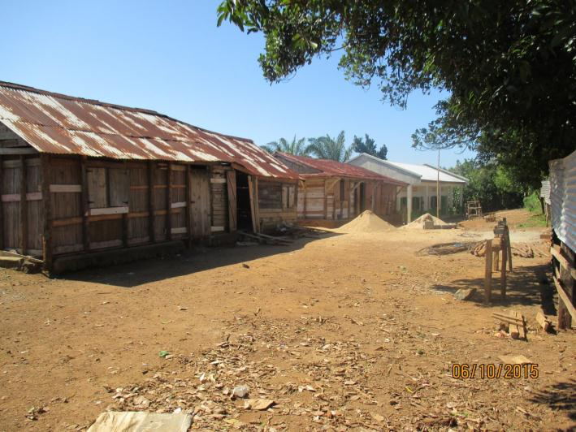 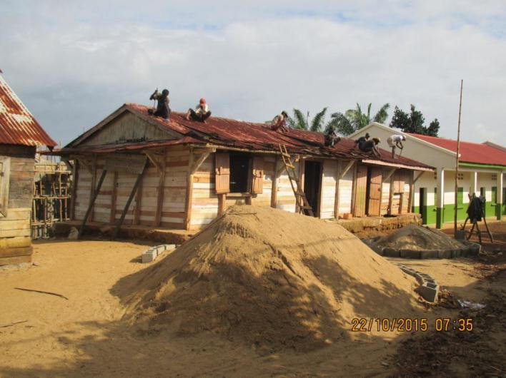

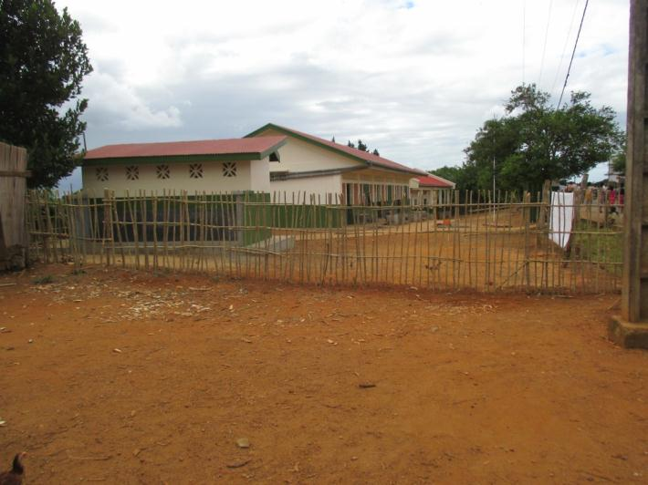 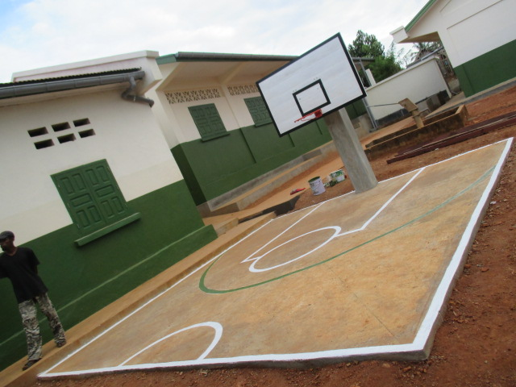

* 1. **RENOVATION**

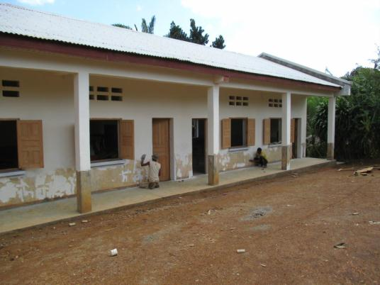 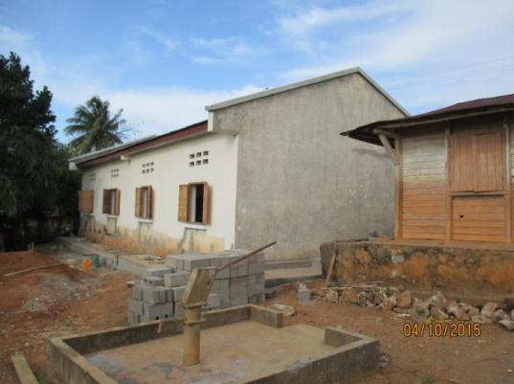 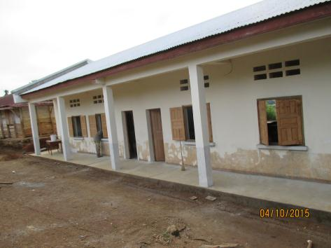

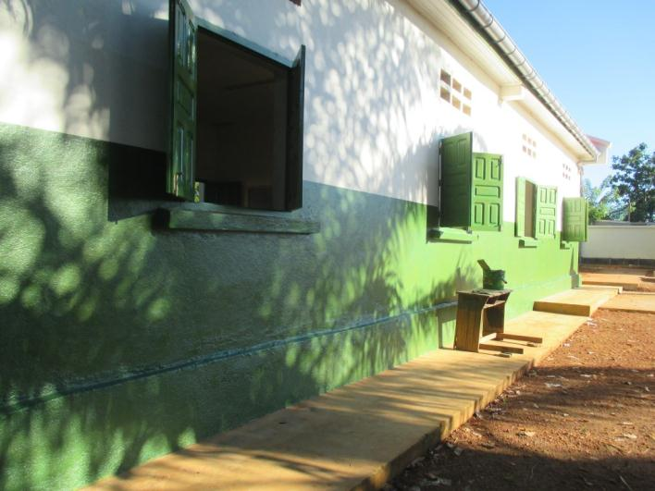 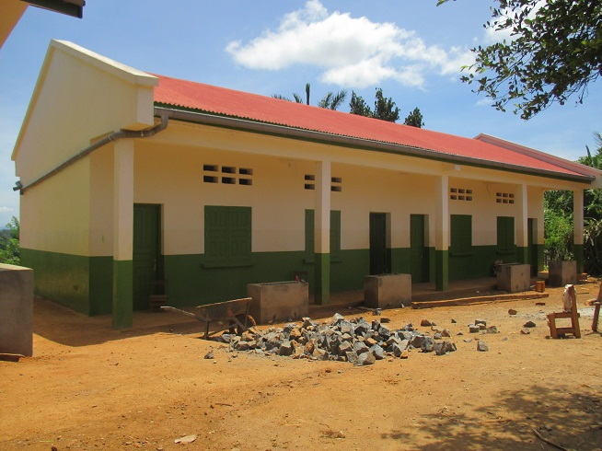

* 1. **SHUTTERING AND REINFORCEMENTS**
     1. **Reinforcement and shuttering to columns and beams**

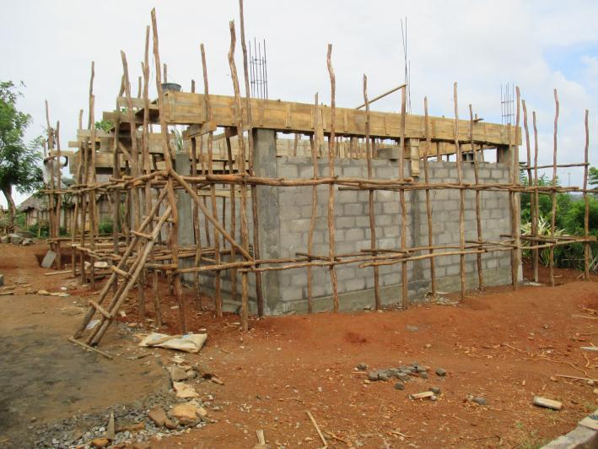 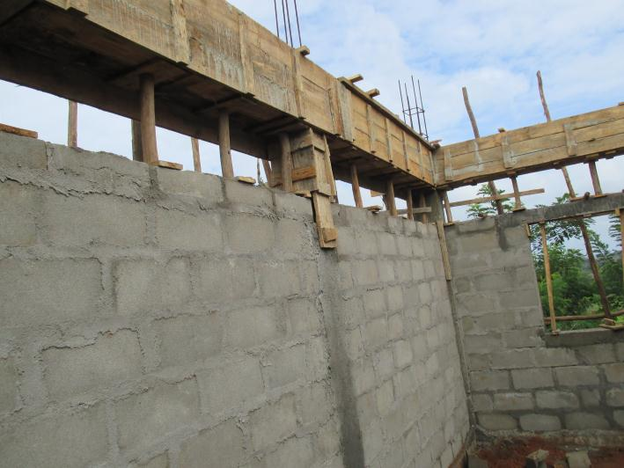

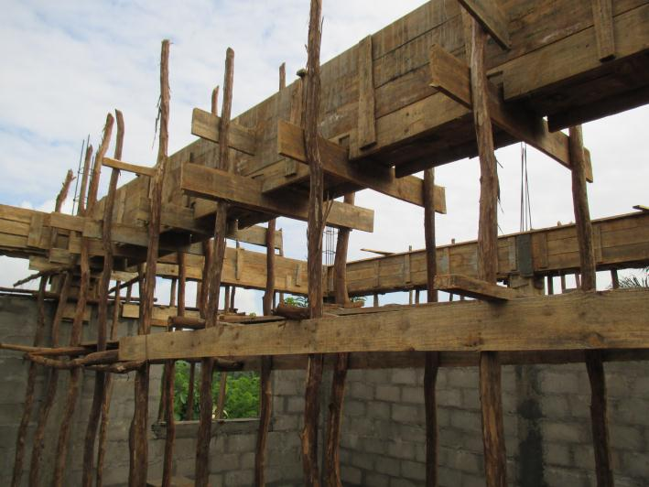 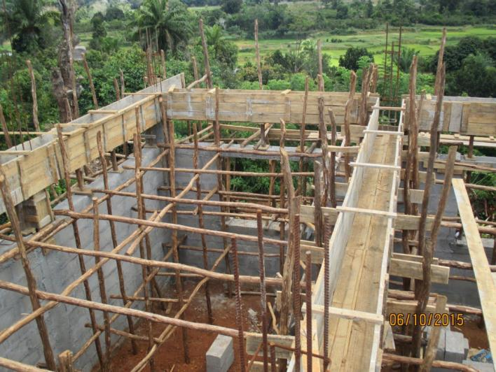

**Beam shuttering with supports and clean empty shutters for gable and intermediate beams.**

**Note.   
Shutters should be clean and dry and smooth and oiled ahead of pours with spacer blocks and links used on all reinforcement cages.**

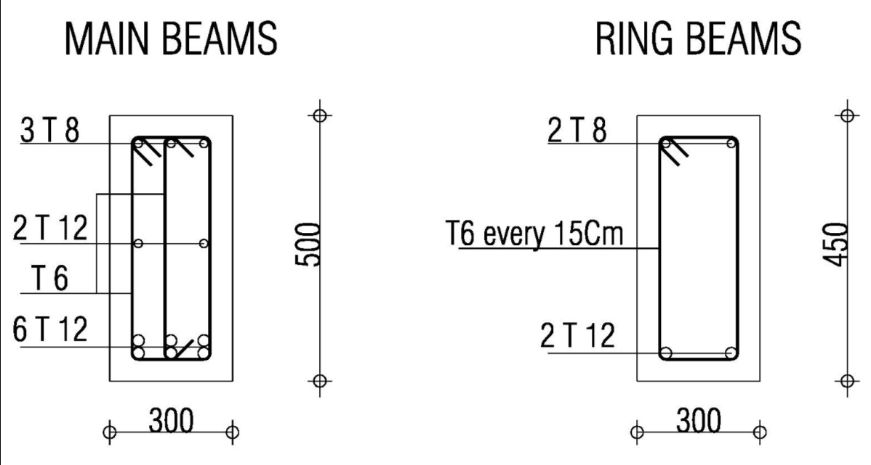

REINFORCEMENT OF RING BEAM AND MAIN BEAM

TENSION REINFORCEMENT OF MAIN BAIM

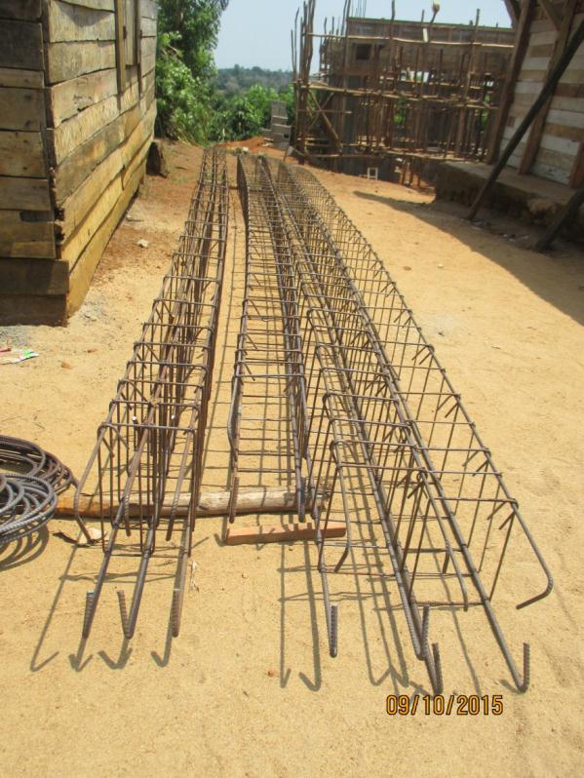 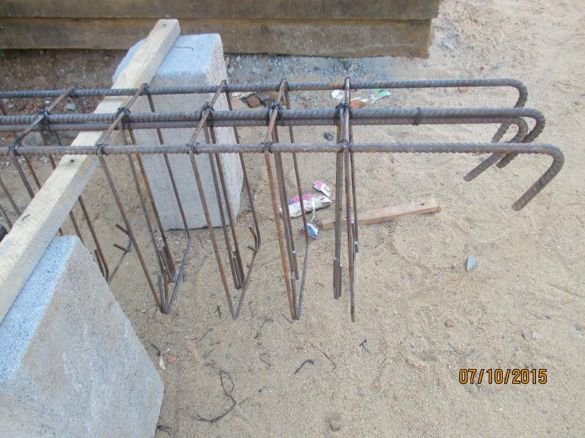

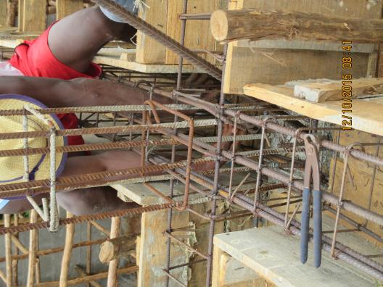

3 T8 Compression reinforcements

6 T 12 Main or tension reinforcements (All in 2 layers)

2 T12 Additional reinforcements (in the middle and at the edge)

SPACING : 5 + 2*10 + 4*15 + 3*20 , then every 30 till middle ( Hoop and stirrup )

* + 1. **RING BEAMS**

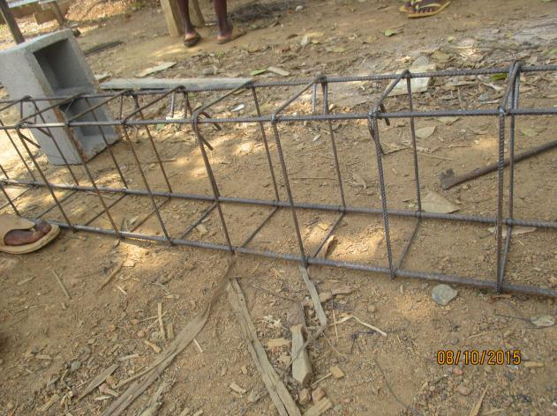 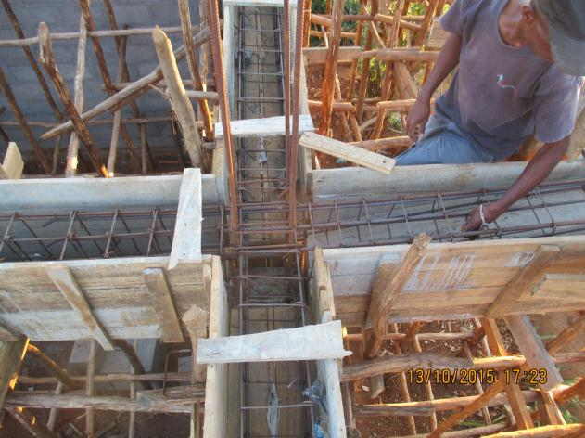

* + 1. **REINFORCEMENTS** 
       1. **CANTILEVERS AND CONCRETE ROOF GUTTERS**

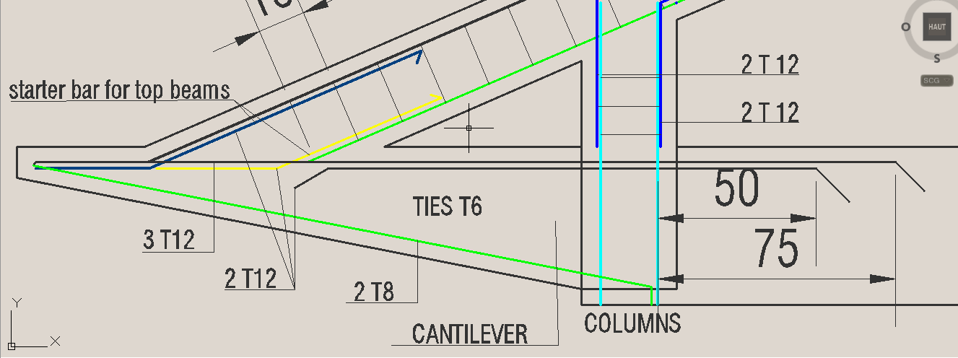

**Note . Only gable beams are required to this design and walkways and sloped porches can be built off separate columns for a more refined and cheaper design.**

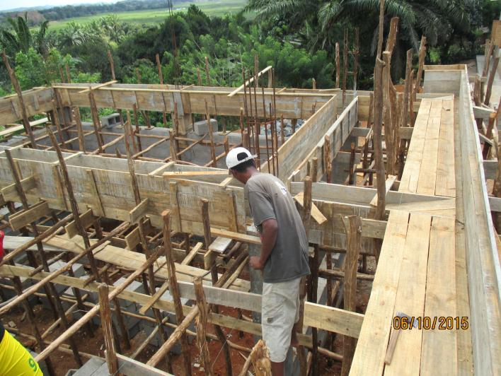 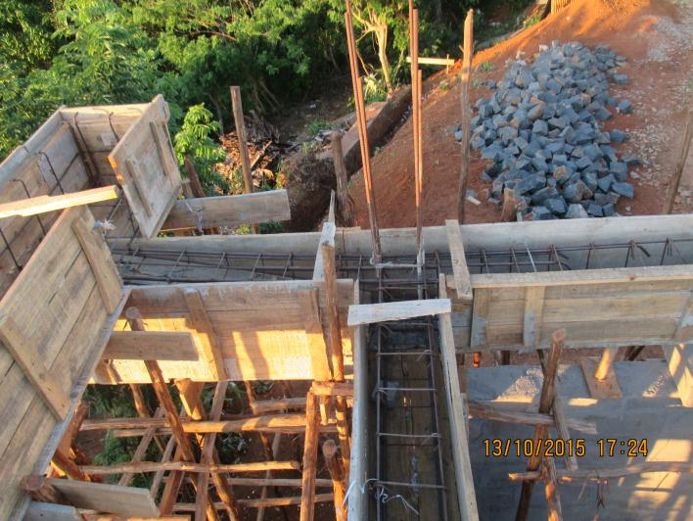

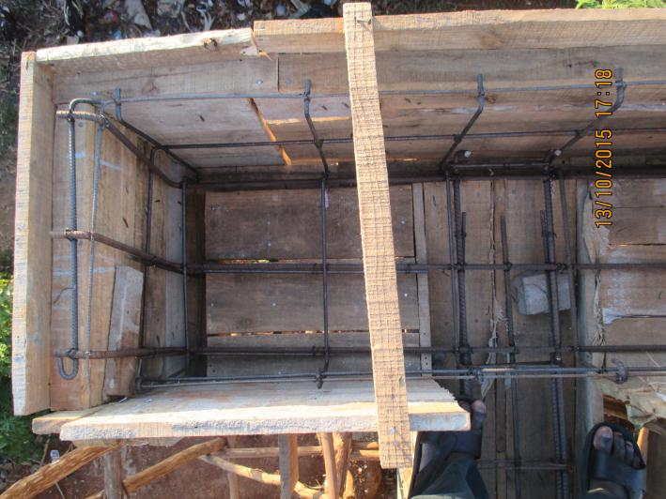 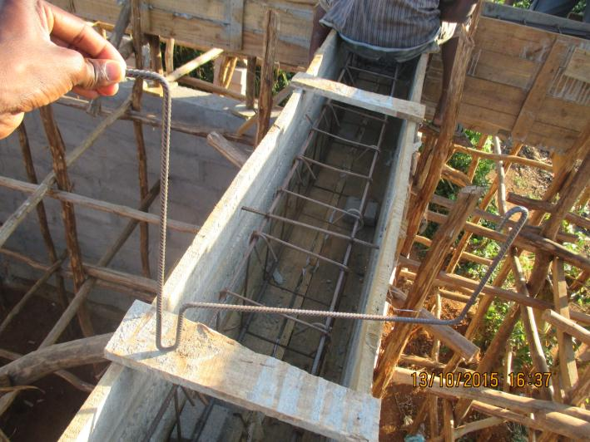

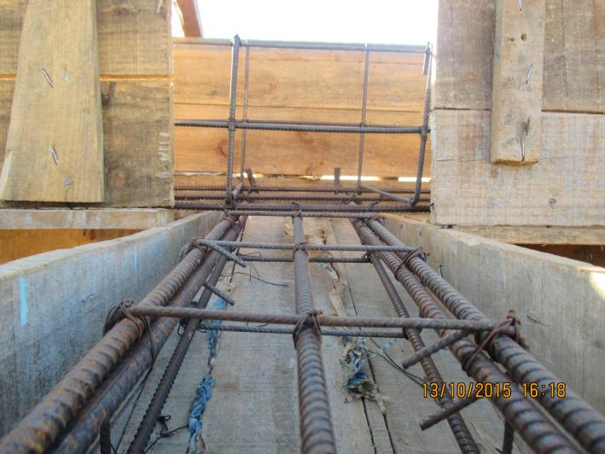 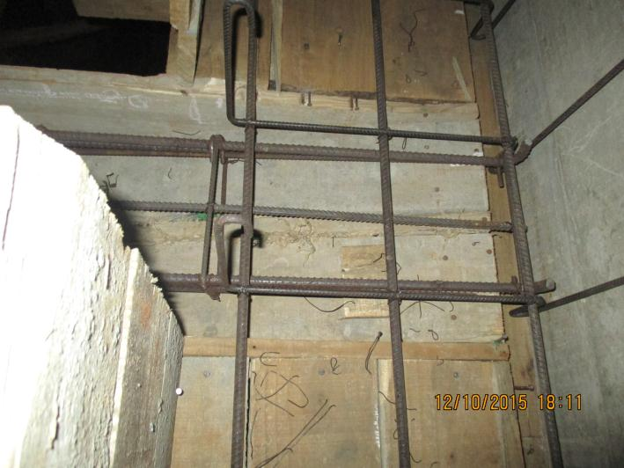

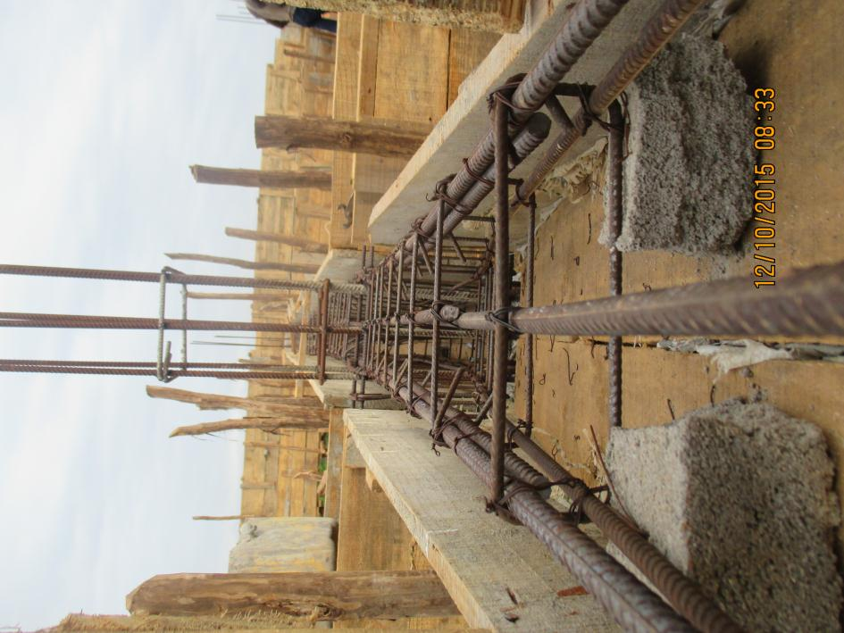 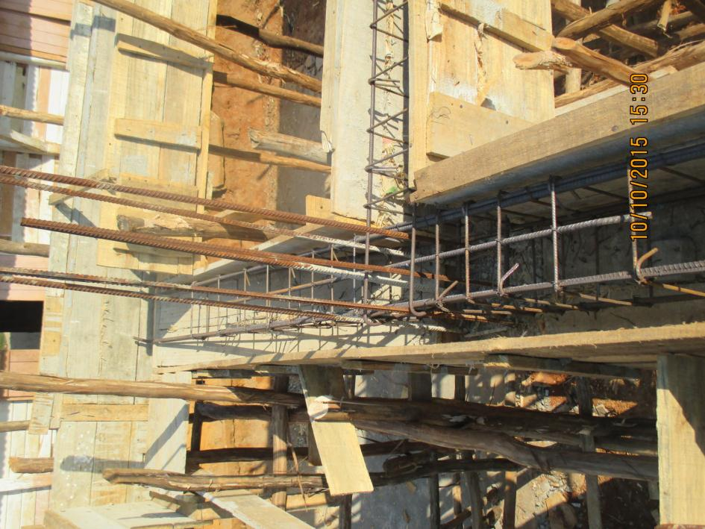

**Cantilever’s reinforcement**

* + - 1. **MAIN BAIM**

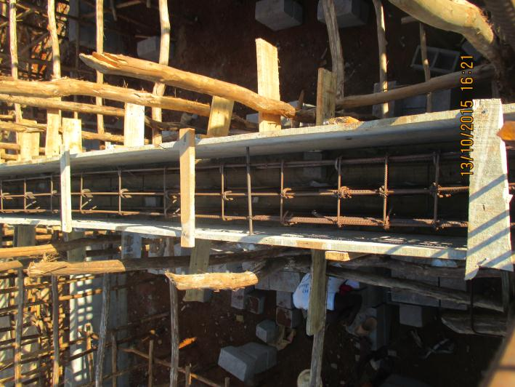 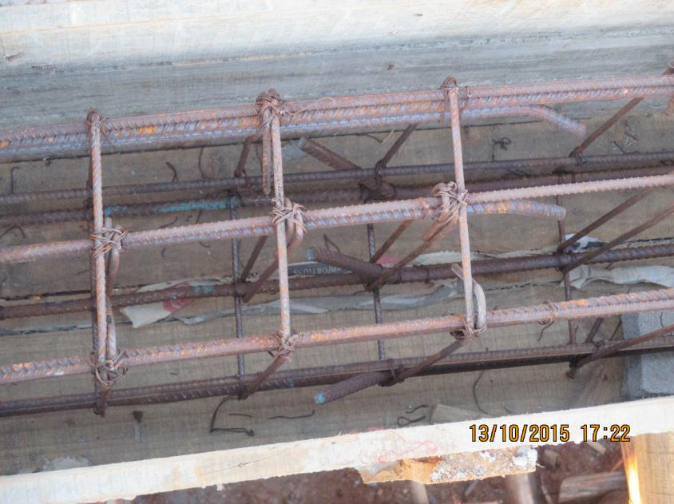

**Note. The shutters are clean and dry and spacer bars and links are accurate.**

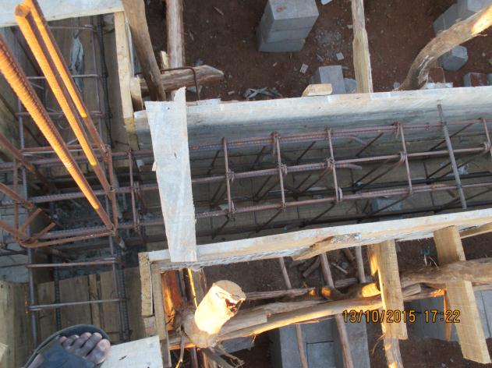 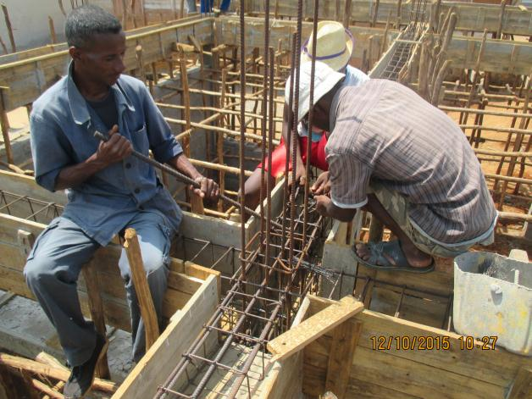

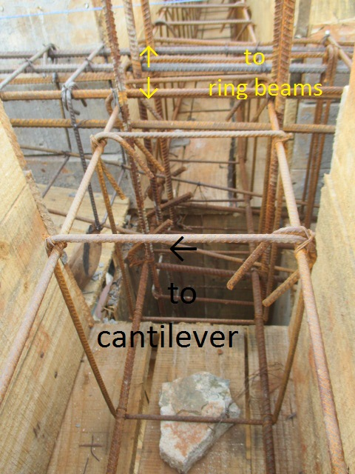 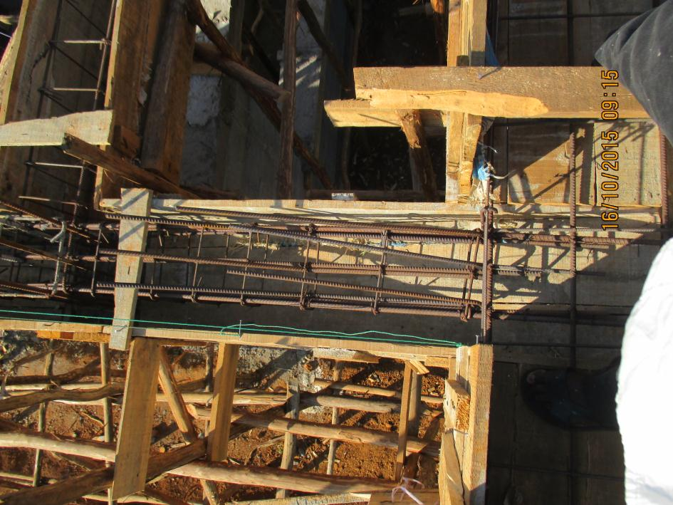

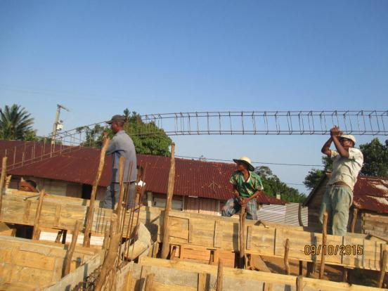 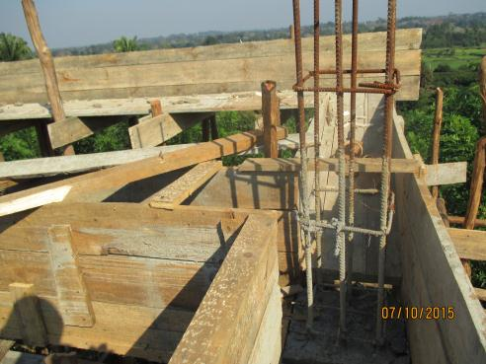 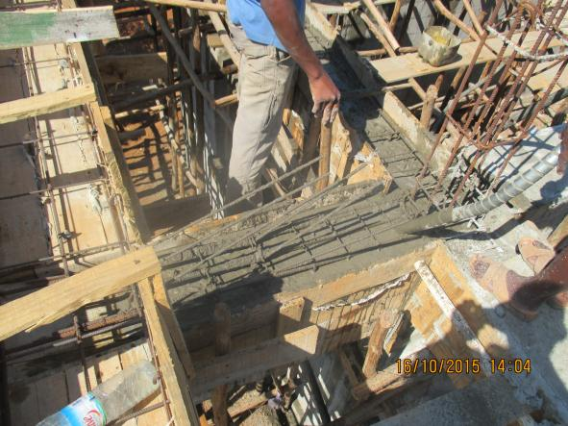

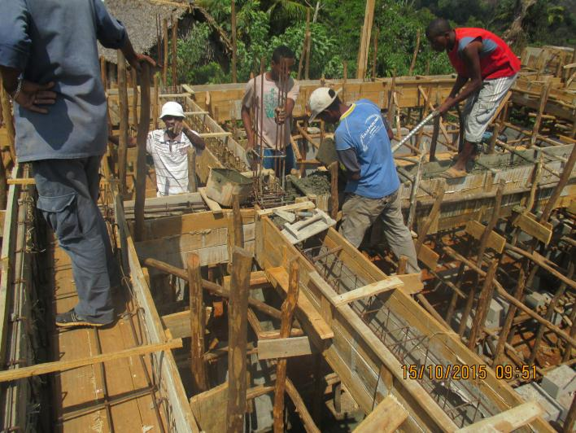 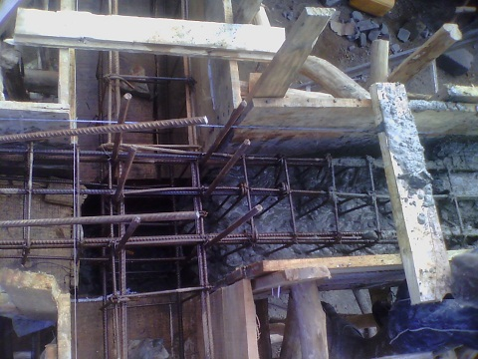

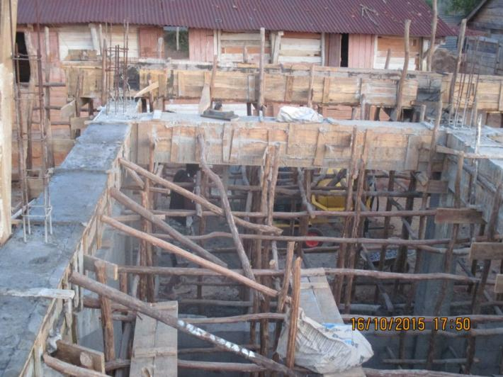 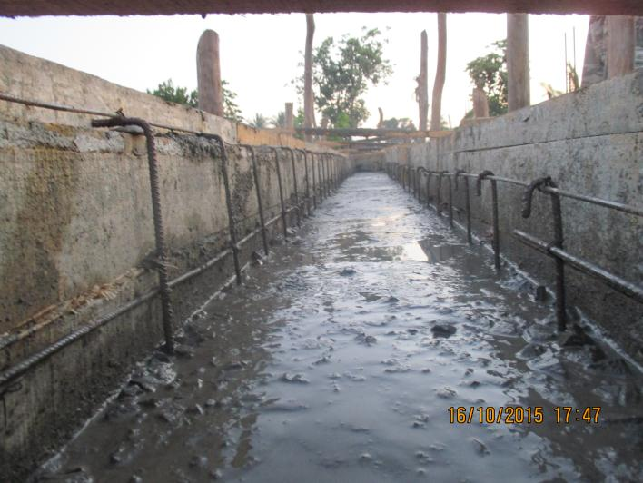

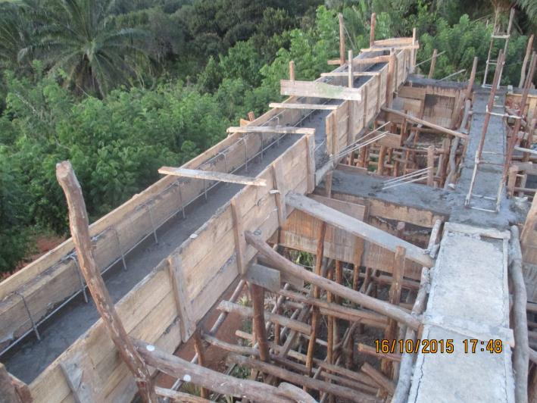 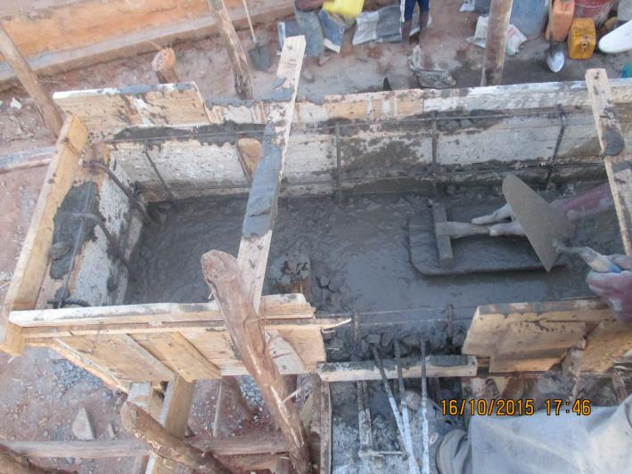

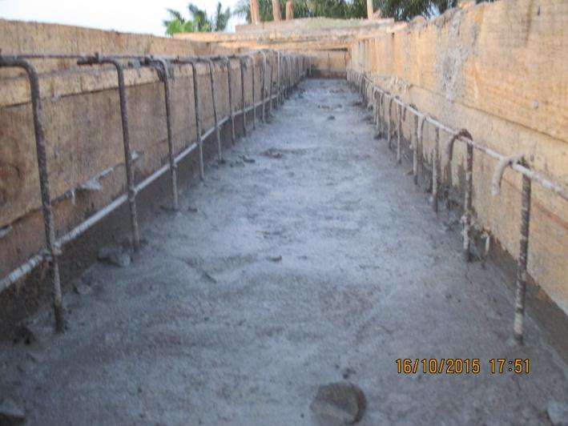 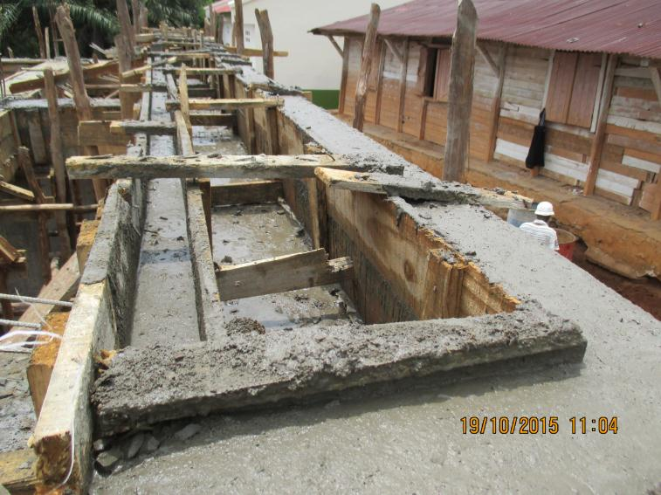

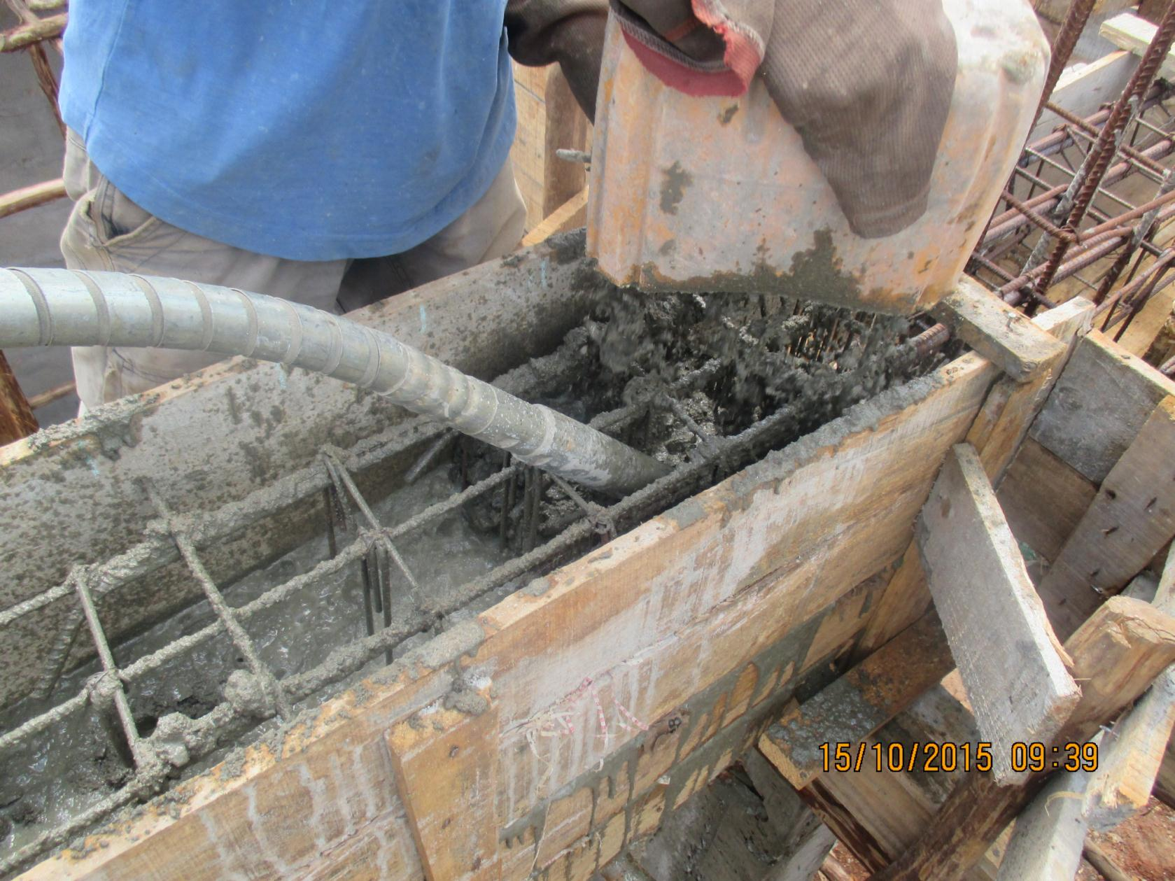

* + - 1. **TOP BEAMS**

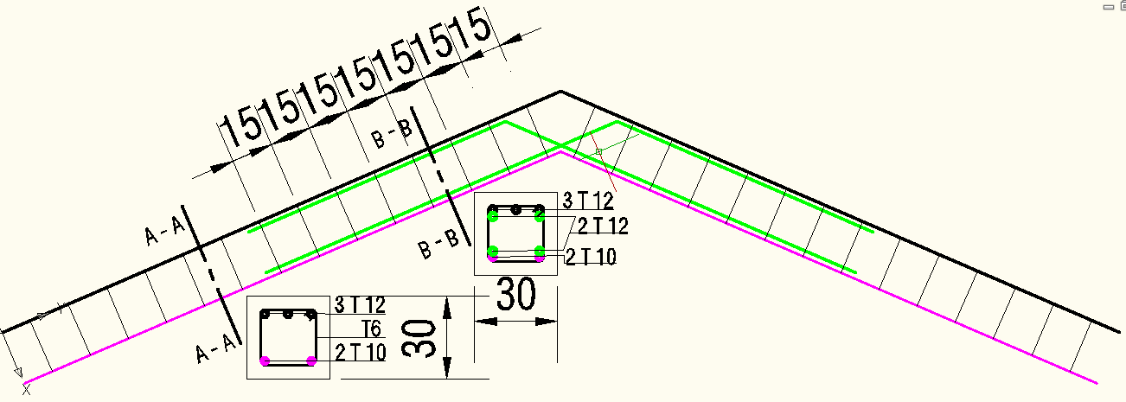

2 T8 Compression reinforcements 6 T 12 Main or tension reinforcements (All in 2 layers) 2 T12 Additional reinforcements (in the middle)

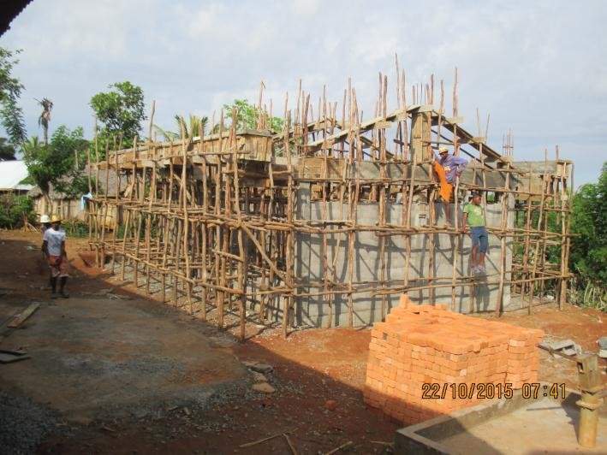 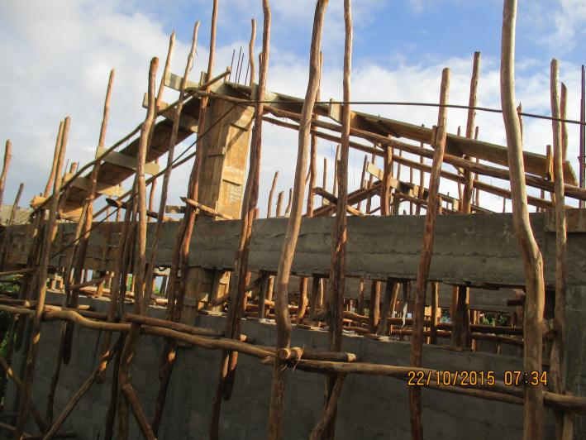

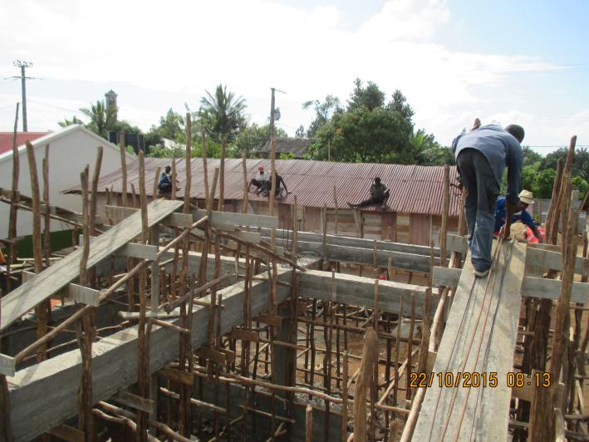 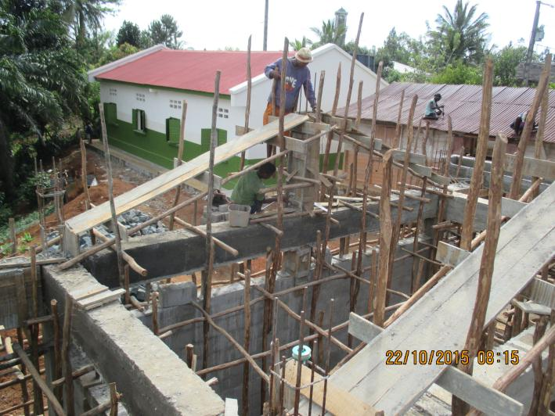

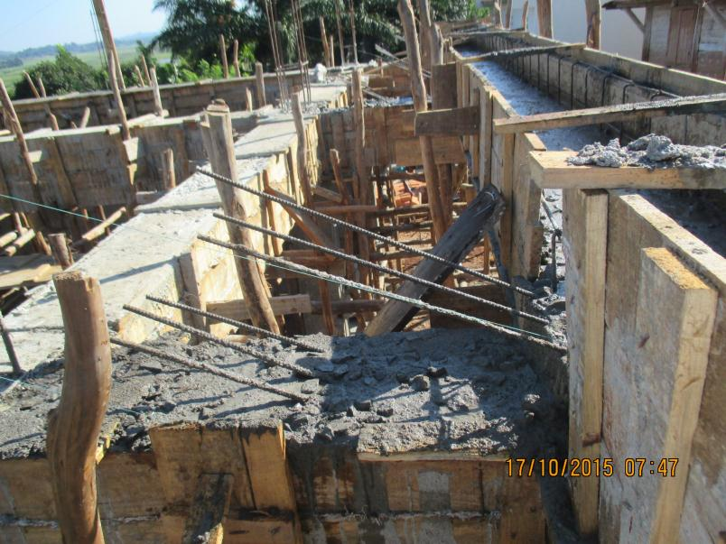

* + - 1. **TOP BEAM AND GABLES FINISHED**

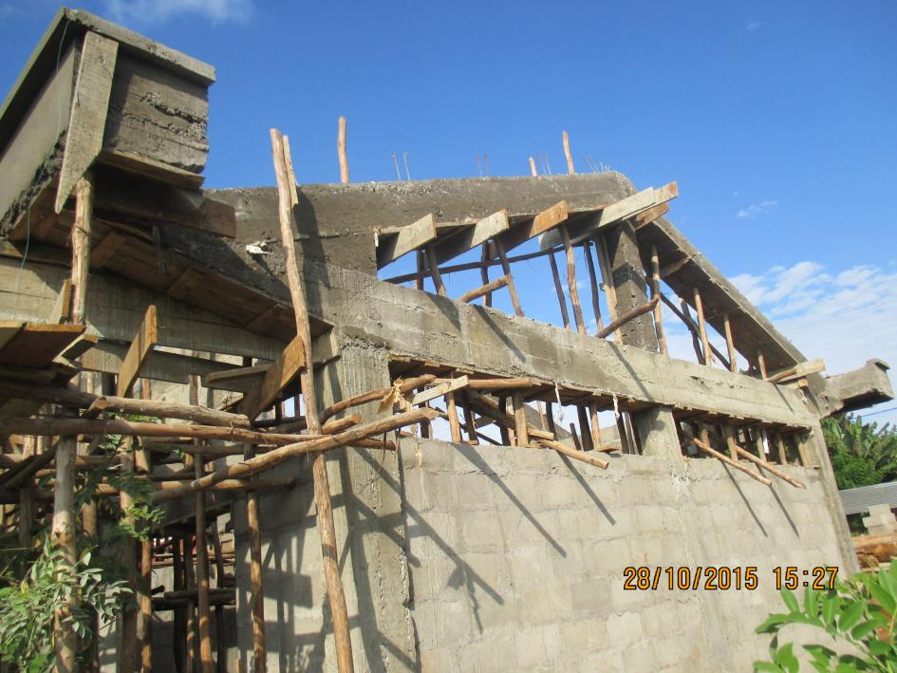

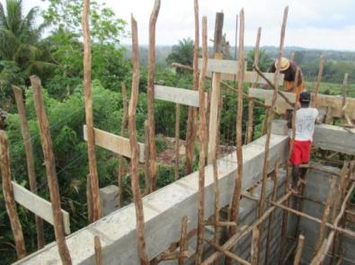

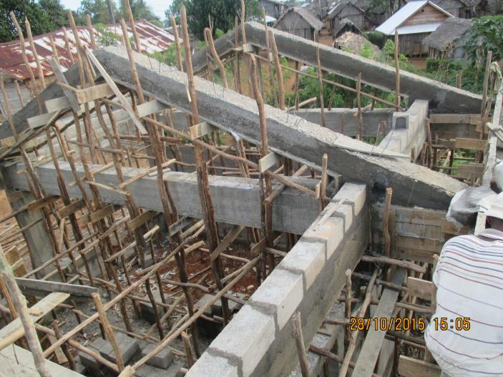

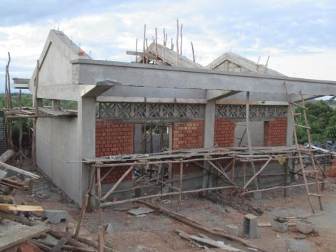 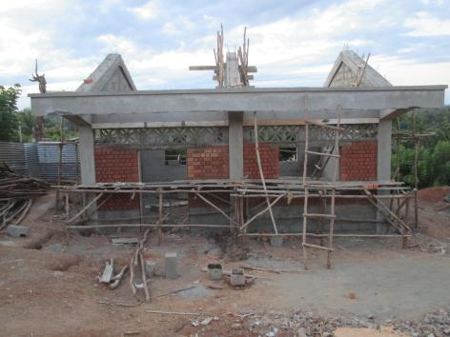 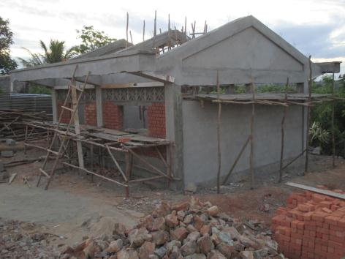

* + - 1. **SILL OF WINDOWS**

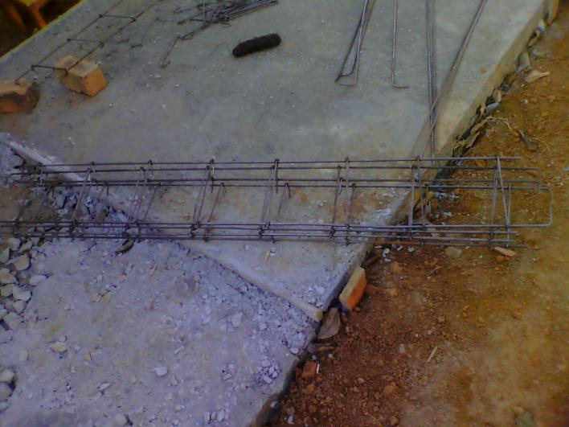 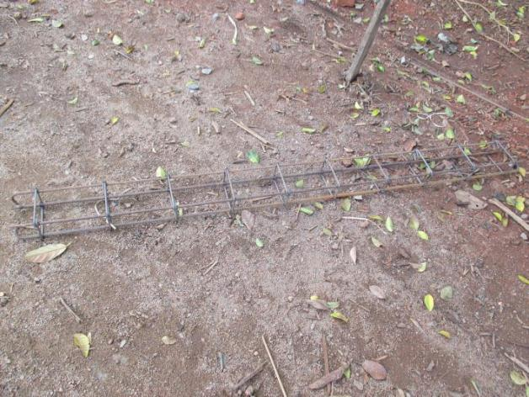

* + - 1. **LINTELS FOR WINDOWS AND DOORS**

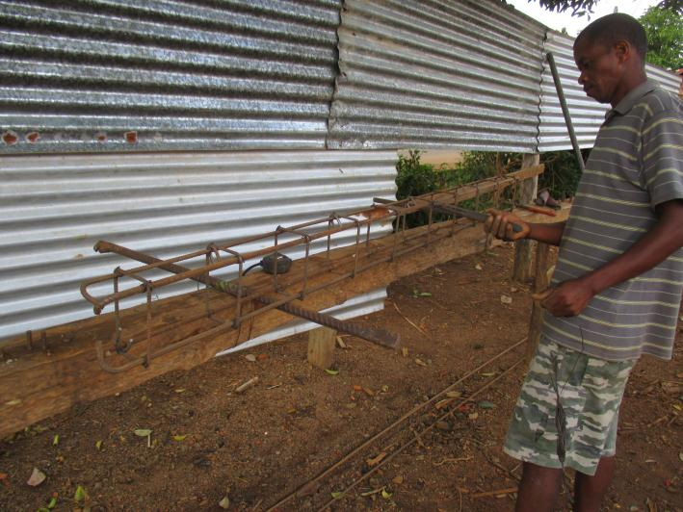

1. **LATRINES**
   1. **REINFORCED CONCRETE SLAB / RING BEAM / MAIN BAIN / COLLUMNS / HOLLOW BLOCKWORKS**

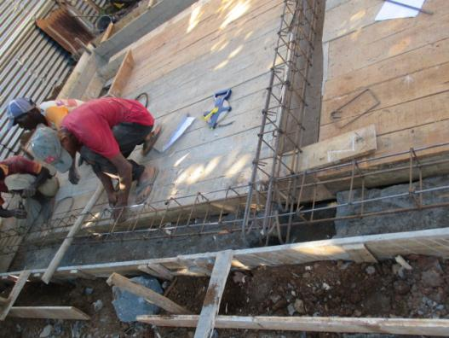 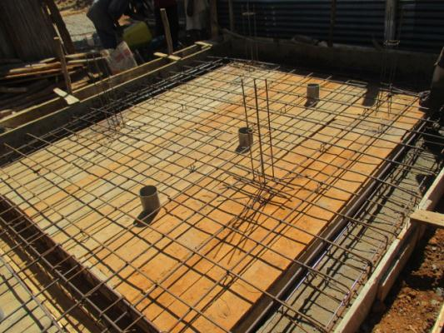 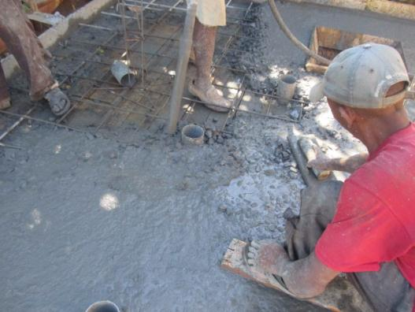

SHUTERING OF COLLUMNS AND LINTEL (RING BEAMS)

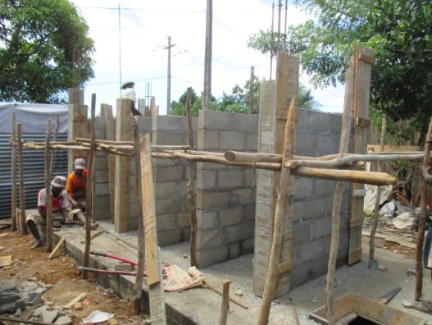 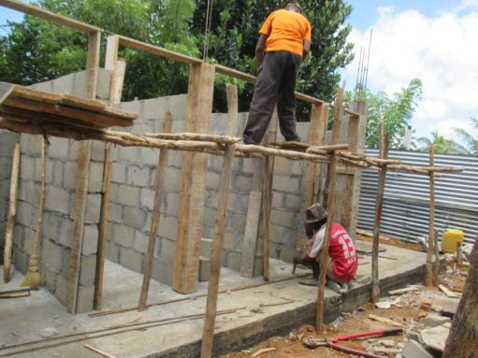 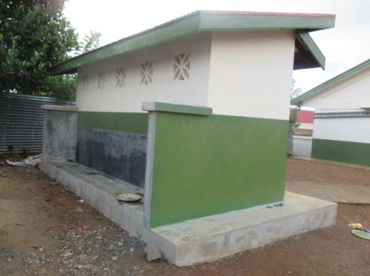

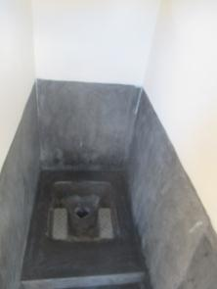 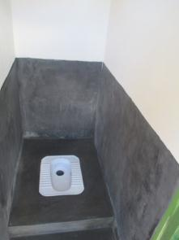 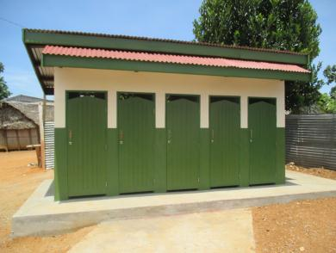 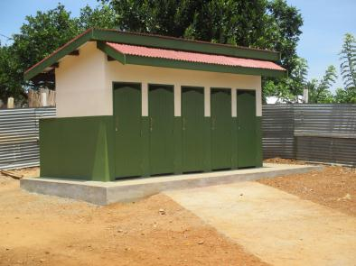

* There is one main beam in the middle of the slab
* Solid slab lay above ring beams (*above the is surrounded by ring beams*)
  + Solid beams (from external) :6,50m x 3,00m and 10cm of thickness
    - It’s reinforcement are all in T10, with spacing: every 200mm
  + Main beam (in the middle concrete slab) : 20 x 30Cm
    - 2 T10 Compression reinforcements
    - 2 * 2 T12 Strengthen reinforcement
    - 4 T 12 Main reinforcements
    - Hoop reinforcement in T6,spacing every 150mm
  + Ring beams : 30 x 20m
    - 2 T8 Compression reinforcements
    - 2 T 12 Main reinforcements
    - Hoop reinforcement in T6

1. **THREE CLASSROOMS**

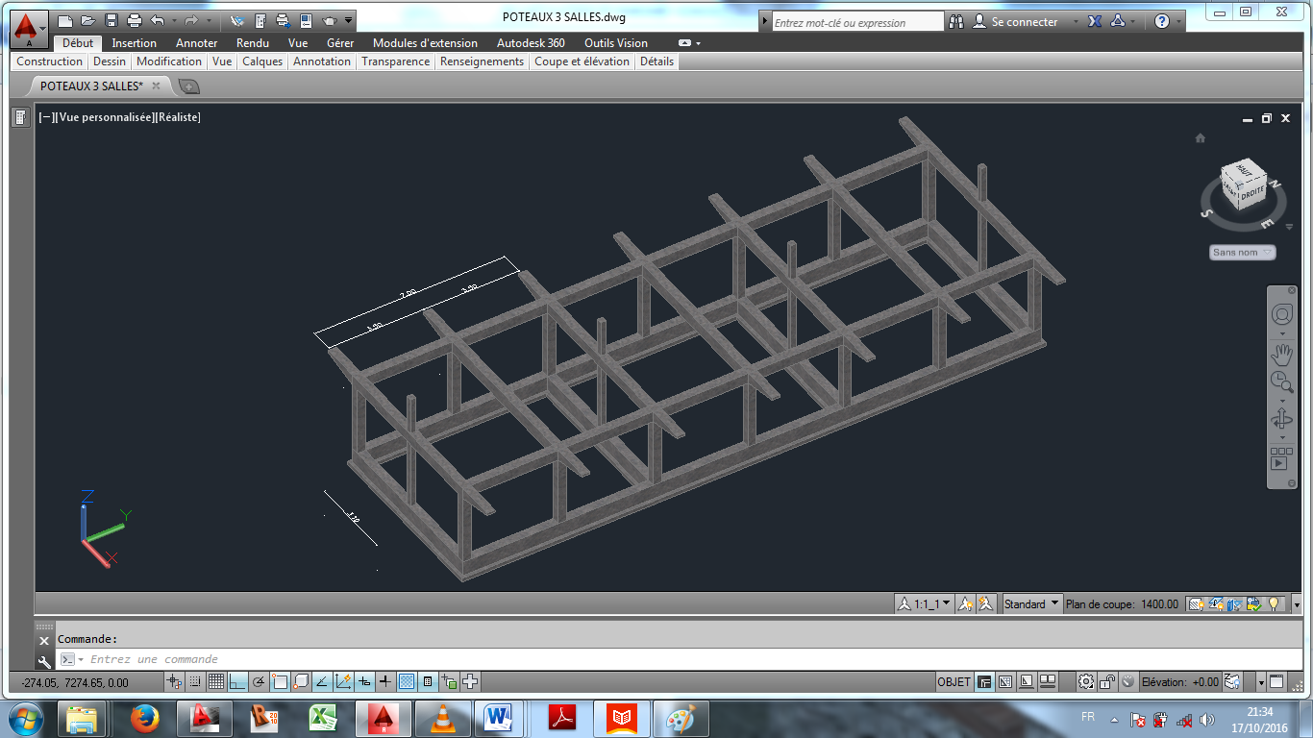

**Main frame of the building.**

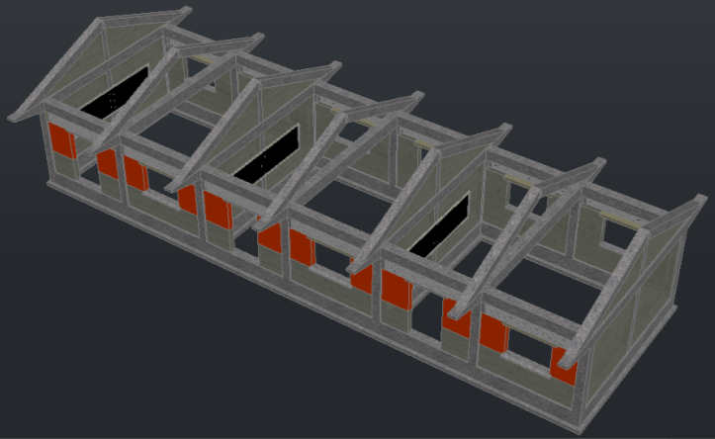

* 1. **Every second sloped beam can be dismissed here**