TASC Madagascar: 2013 Findings
Tanjomoha, Vohipeno: Pilot phase community-based forestry scheme
Tossing a Starfish Charity Madagascar, Registered Charity: 1130610

On-going key variables and project aims
  - Financial return: from harvested timbers, provide long term employment, strengthen biodiversity, support wildlife, and provide education and community empowerment.
  - Are there opportunities for payment for ecosystem services? REDD+, Plan Vivo etc.
  - How does the forestry scheme provide additional services/injections into the already sustainable community of Tanjomoha and the wider Vohipeno region?

What has happened since 2012?
  - On TASC’s last site visit 12 months previous, Pine was suffering from a 50% leakage/loss. After making adjustments to planting techniques by adding fertile manure and a longer germination period in the nurseries, leakage has dropped to an attractive 5% (nurseries begin October, planting begins January). Each sapling is planted into a 50/50/50cm plot with 2kg of manure, finished with topsoil.
  - An additional 8ha has been purchased bringing the total to 52ha. This is almost half of the intended site size (127ha), with 12 more hectares to be purchased in the next month.
  - Each hectare has a minimum of 1000, maximum 1200 trees. Having a good understanding of this allows for Carbon sink calculations to begin.
  - All documents and land tenure agreements have been received, with each purchased plot surrounded by a ‘living fence’ providing a multi-purpose boundary. This not only creates plot division it also creates bio-diversity and a micro-habitat for insects and small animals (bees, small reptiles etc.)
  - Both Eucalyptus and Rotra are growing at a promising rate. Voandelaka has a growth rate of 0.5ft/month, along with Acacia which also boasts extremely deep roots decreasing its vulnerability in drought seasons and heavily contributing to Carbon sinks. Pine has seen a mean growth rate of 4ft per year, with its increased strike rate of 95%. It currently holds a commercial value of 5000 Ar per 13ft plank.
For more details and latest news, visit our website: http://www.tascmadagascar.org/

What are the Socio-Economic drivers?
  - Abada Louise, now employed as a full-time forest manager, receives a wage of €50/month and is supported by 8 full time forest rangers. To ensure security of the young forest stock, a patrol ranger is also employed who receives a wage of rice and cash. This is to make bi-weekly transect walks of the forest boundary and produce bi-monthly reports on all problems such as; fires, damage, theft and boundary issues.
  - Total human capital costs to the forestry scheme, €2500/yr with an additional outlay of wages to the 120 temporary employees through the planting seasons.
  - The direct result of local employment from the forestry scheme provides a ‘win-win’ situation, incurring a local multiplier effect (trickledown effect). Not only are the 8 Forest Rangers, Abada Louise, Patrol Ranger and the 120 temporary employees financially benefiting from the work of TASC, but their families and the wider community as well. From a sociological view, the forestry scheme is also providing community empowerment, engagement and education to the benefits of reforestation. Moreover there is a growing pool of knowledge surrounding different planting techniques and the broader community acceptance of sustainable natural resource management.

Recommendations
  - Begin developing a strategy and action plan for the first harvest in 8 years’ time.
  - Call upon the research by Oliver Stewart and his ideas of internalising the milling process; is there the scope for this in Tanjomoha?
  - Look to expand employment structure as additional land is purchased.
  - Continue with the newly developed planting techniques, and longer germination periods.
  - Explore the opportunity of integrating the local agricultural college into aspects of forest management and conservation techniques to drive local interest and technical knowledge.
  - Continue to pursue all opportunities under the umbrella of ‘payments for ecosystem services’: REDD+ ( http://www.un-redd.org/) or Plan Vivo (http://www.planvivo.org/)

Funding requirements summary
  - Funding issued in July 2013 by TASC to support the remaining work for 2013: €2500. Allocated to planting new 12ha plot, wages, nurseries and general forest maintenance.
  - For 2014: projected/forecasted cost for salaries, temporary employment wages, general forest maintenance: €2000 (Tanjomoha contribute additional funding)
  - New lands: 20ha plus planting of 22,000 saplings (inclusive of germination period): €3000

The total funding required for 2014 is €5000.

Conclusion
The overall joy, commitment and enthusiasm towards the longevity of the forestry scheme by Abada Louise and Pere Emeric appears to of answered the fears of TASC in the aftermath of Theo’s departure. It seems with the continued support of generous donations, well managed staff, sensible and realistic forest management plans and the security of lands, there is no reason to suggest that the Tanjomoha forestry scheme cannot continue to flourish. Moreover, it’s beginning to lend itself as a flagship example to the long term solutions of poverty, environmental degradation and more generally sustainable development in one of the country’s poorest regions.

Key images from the forest: 5km N/E of Tanjomoha, Vohipeno.

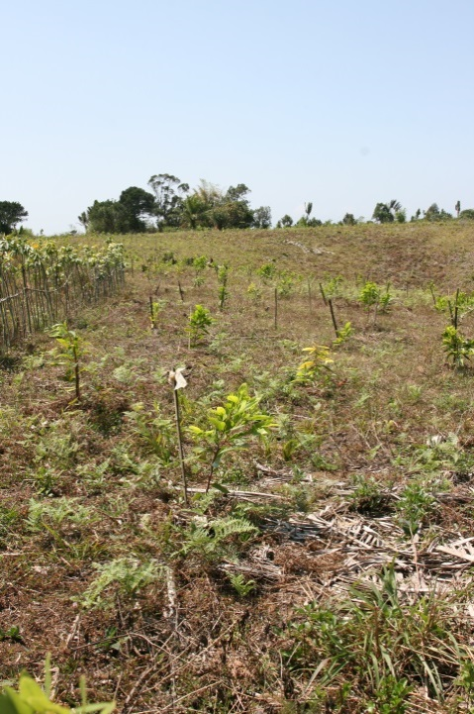

Fig 1. Acacia saplings with ‘living fence’

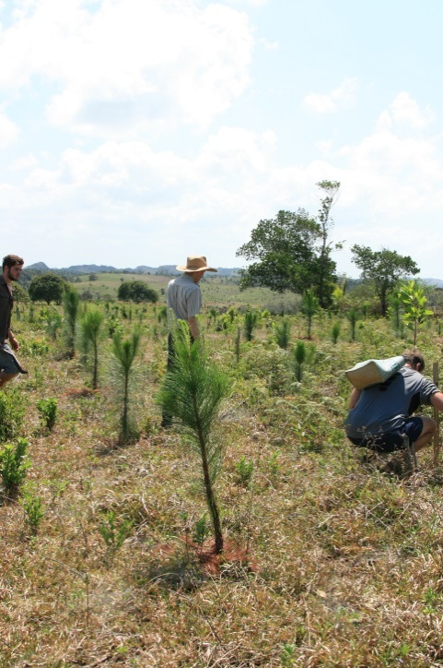

Fig 2. Maturing Pine plot, strengthened by longer germination period

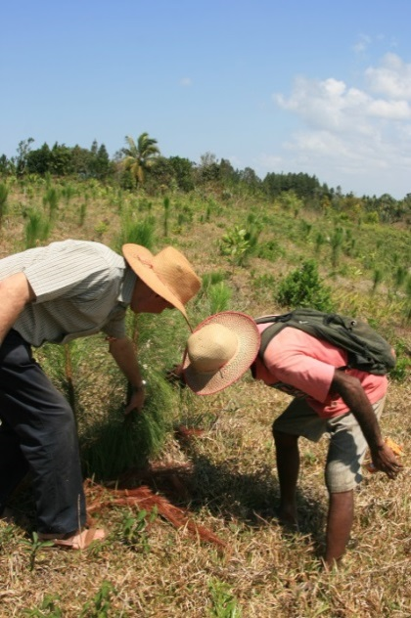 | 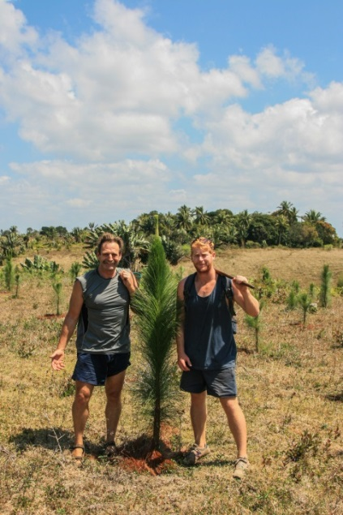
Fig 3. Pere Emeric and Abada Louise inspecting Pine saplings | Fig 4. Strong, maturing 16 month Pine at a promising height of 6ft

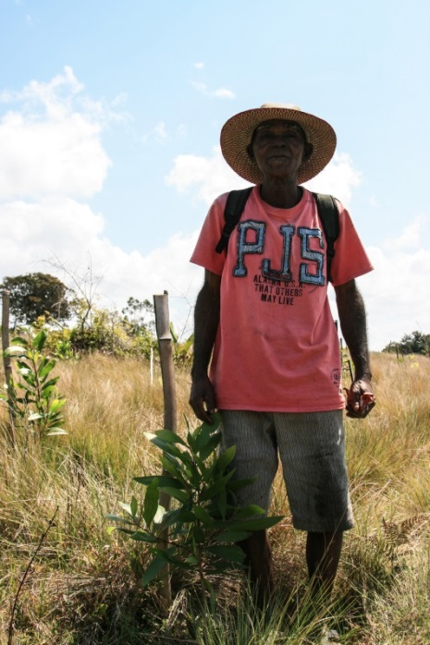 | 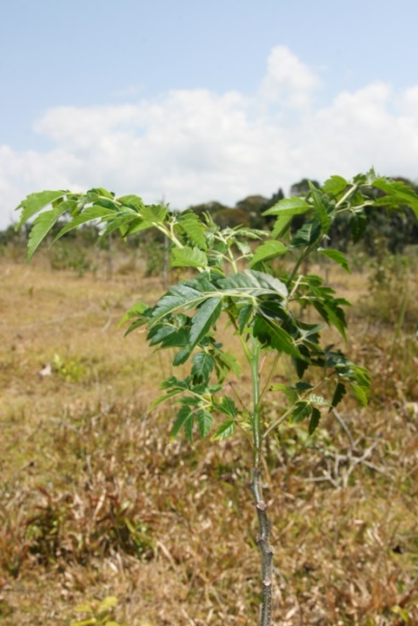
Fig 5. Abada Louise with his Acacia saplings | Fig 6. Voandelaka saplings

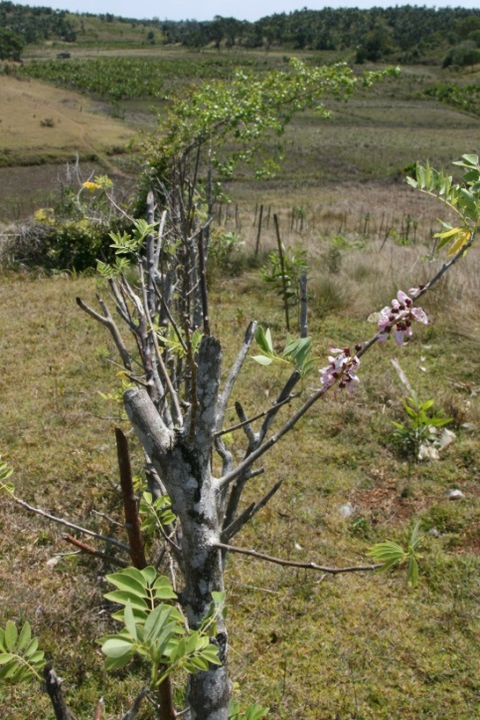 | 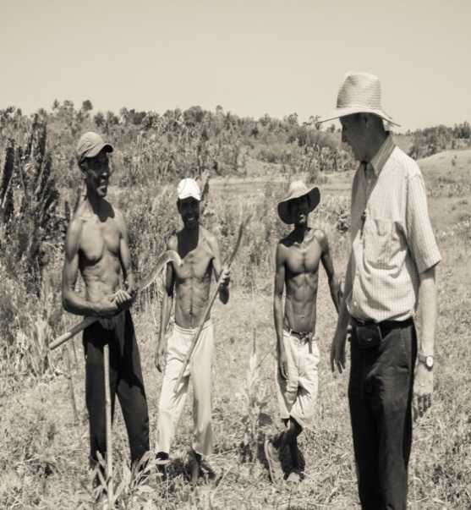
Fig 7. Up close with the ‘living fence’ | Fig 8. Pere Emeric with three forest ranger.

If you would like to use these photographs, or require any additional information regarding the forestry scheme, please do not hesitate to contact me: garyobrien4689@gmail.com

Gareth J. O’Brien
23 October 2013

