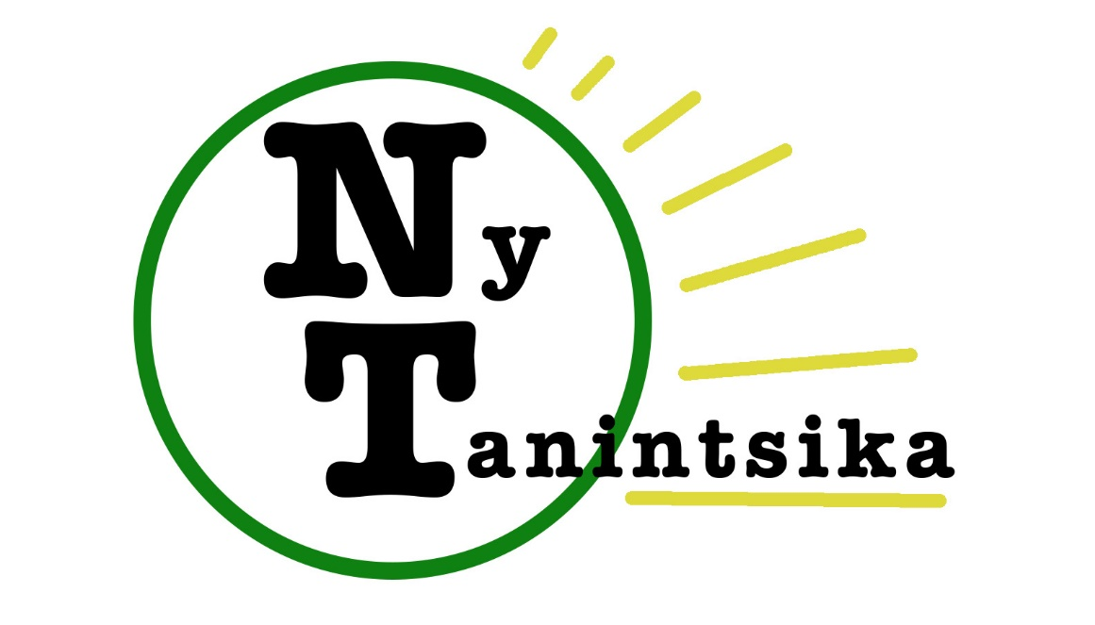

Feedback Madagascar – Ny Tanintsika – TASC
Report 1 and Action Plan
“MIVOATSE” Project:
“Multi-Initiatives for the Vulnerable Of Ampasambazaha Towards Sustainable Employment”
27-7-2016
Introduction
The ‘MIVOATSE’ project works towards the autonomy or independence of the target group (initially people of the Star compound, but potentially expanding to other nearby areas where homeless people are concentrated once surveys are completed), so that they are empowered and capable of improving their own lives (including leaving the compound). This ultimately involves catalysing a change in their attitudes and behaviour, alongside skills training and other actions. The name ‘MIVOATSE’ was chosen for the project because it is a Malagasy word meaning a positive change or evolution, which is inspiring in itself.
This report covers the period from the project launch in April, until late July 2016.

Specific initial objectives:

- Improve the health of the people of the Star compound through education, facilitating access to services and provision of medical treatment where possible.
- Ensure access to clean and potable water so that waterborne disease is not continuing to be spread. (ie. through filter initially until negotiations are carried out with the landowner).
- Start a number of skills courses and information sessions so that they become independent and able to fend for themselves, and provide key start-up support to committed households.
- Look at the immediate schooling needs of the children and get them the resources, books, etc to go to school.

As from the 20th June, rumours abounded in the Star compound that the homeless were to be evicted from the site after the Independence Day celebrations had come to an end. This was confirmed by STAR, who placed security agents in the compound to survey the situation. They plan to develop the site in the future, and are keen to work together to ensure that the homeless find alternative places to live as well as to improve livelihoods. Since July, efforts have been intensified to find solutions to house the people of the Star compound and the Catholic congregation of nuns ‘Soeurs Filles de Charité Tambohobe’ offered to house families in their Ampopoka site. Five households have since moved there and have expressed their readiness to start a new life.
Overall, despite the various obstacles encountered, headway has been made with regard to the psychological preparation of beneficiaries for project support, and the development of action plans for numerous families in need of help – the first round of which can be found at the end of this report.
Achievements in relation to planned activities:
Planned activity | Achievement | Observation / action plan
Sending Brilliante ‘Olga’ (homeless lady) to Tanjomoha for treatment | Olga was sent to Vohipeno, initially accompanied by Auguste, with Voahangy (another project beneficiary) who followed a couple of days later (the 2nd May) in order to take care of her. After medical diagnosis, they returned to Fianarantsoa the 19th May, due various concerns Olga had. Olga and Voahangy were once again taken to Vohipeno with Victor and the FBM car on the 4th June in time for the planned operation.  Operation was not carried out. | At the last moment, Olga refused to be operated on as she was afraid of dying. It appears that nothing can be done to change her mind, and so no further action has been taken.  Olga is one of the few people of the Star compound who is refusing to leave, and even her closest friends have somewhat given up on changing her mind.
Meeting with mayor of Fianarantsoa to discuss ideas and find out about situation of the land ('Star compound') | Meetings held in May, June and July.  Although the municipality were unable to assist with regard to negotiating the ‘Star’ land, they have expressed the potential of collaboration in two other areas of town (development of sanitation infrastructure /playground). | Plans were made regarding organising the meeting with different stakeholders working with the homeless, and discussions were made with regard to the land situation.
Meeting with regional land director to discuss about the situation of the land | Meeting held in May, in which information was obtained on procedures to follow.
Request and obtaining of certificate declaring legal situation of the land. | Carried out in May. Certificate received confirming the land is owned by the company ‘Star’.
Negotiation with STAR | A meeting was held with the Regional Director of STAR Fianarantsoa on the 28th June after initial contact with the head of zone the 22nd June. STAR will not negotiate about removal of the homeless people from their land, which they plan to build on, but they are open to collaboration to assist this process. | Star invited us to submit a proposal which they could consider for funding (action that help remove the homeless from their land or re-establish them elsewhere).
Medical consultation of target group (voluntary session) | Two opportunities for free medical consultations were offered to the target population in May 2016, with volunteer British Doctor Meriel Raymond. 10 consultations were held initially, plus a further four in the 2nd session. | Common problems identified were respiratory diseases, tuberculosis, and anaemia. Case of suspected neuro cysticercose.  And previous case of leprosy.
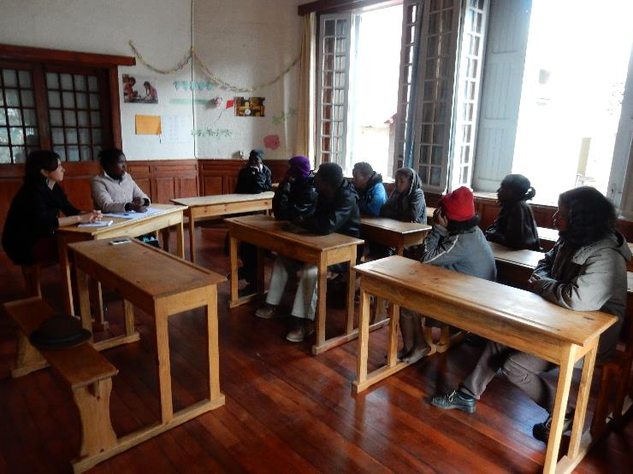
Motivational session with beneficiaries on the 2nd July.
Educational & motivational sessions (twice weekly, 1.5 hour sessions) to build self-esteem & motivation to change | Development of a plan for these sessions, including contacting relevant key people who could contribute.  Negotiation of room hire with the nuns in Ambalapaiso (4-5.30pm Wednesdays and Saturdays).  An initial session was held on Saturday 2nd July with 8 people present. | Delays to the start of sessions due to perturbations with the Independence Day celebrations and then the disruptions related to the eviction of people from the Star compound.
Continuation of quantitative data collection on target group:  - those without birth certificates / national identity cards  - those without vaccination  - schooling of children | Data has been collected on the family situation of each beneficiary household as well as details on these points (included in action plan below). | Action plan to ensure that everyone has a birth certificate and national identity card, in order for them to benefit from full citizen rights.
Discussion with Regional Education authorities (DREN) concerning options for schooling children from the target group | Discussion carried out at the meeting on the 13th July. | The DREN are ready to ensure that all children get schooling.
Strengthening partnerships and collecting information. | Continuation of contacting relevant stakeholders working in the field e.g. Omeo Bonbon, BAS, Rotary Club, religious communities, the Ministry of Population… | Some stakeholders appear to be not very favourable to collaboration, such as BAS and Omeo Bonbon.
Collect weight & measure height of children in target group | Not yet carried out.
Individual interviews with homeless people identified as being priority & feasible to help | Carried out on Wednesday 6th and 20th July. More were planned for Saturday 9th July and Saturday 23rd July but they did not show up.  11 interviews held with 18 people present. | Development of action plans and budgeting. Action plans and budgets for those families considered priority (most ready to make an effort to change their situation for the better) are included in annexe.
Setting individual objectives & action plans, & signing of contracts/ commitment letters | Action plans annexed to this report. | Drawing-up of contracts / commitment letters for beneficiaries.
Training as required (as per individual action plan) | Not yet carried out. | Included as part of action plan.
Provision of equipment as required (as per individual action plan) | Provision of 20,000 Ariary to Ramerina in order for him to purchase new shoes. With this, he bought 3 new second-hand pairs of shoes. | We left Ramerina to purchase his own shoes which he considered to best suit his needs.
Development of an action plan for schooling children from target group | Negotiation underway with partners ‘Lapan’ny Ankizy’ Ambalapaiso.
Support and monitoring of progress | Victor has been making regular visits to the beneficiary group.
Survey of homelessness in other parts of Ambatomena | Survey started in the ‘Complexe’ area of Ambatomena, near the Ministry of Youth & Sport.
Health initiatives:  - Monthly health clinic service  - 6 monthly deworming  - Provision of daily multivitamins to all target population.  - Provision of nutritional supplements for children under 5 e.g. peanut butter.  - Obtain health books for children to plot on growth charts, & ask for vaccination history – if unclear, devise a re-vaccination programme.  - For any sex workers, recommend regular sexual health checks – particularly for HIV, and condom distribution. | Yet to be started. | We plan to distribute the multivitamins at each educational session for project beneficiaries.
Meeting with local authorities & stakeholders to officially launch project and request collaboration. | Meeting held on Wednesday 13th July. Invitations to all relevant stakeholders were sent out, signed by the Mayor of Fianarantsoa. There were 20 participants from 12 different institutions. | Due to time constraints, it was decided that there should be a further meeting to define a clear action plan to help the homeless. This was an opportunity to share information and present activities.

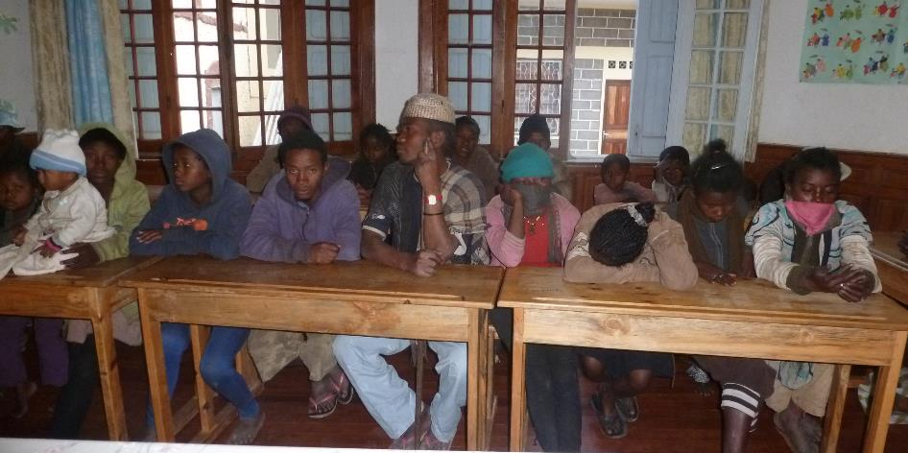
Beneficiaries at a meeting and with new T-shirts distributed via FBM/NT.
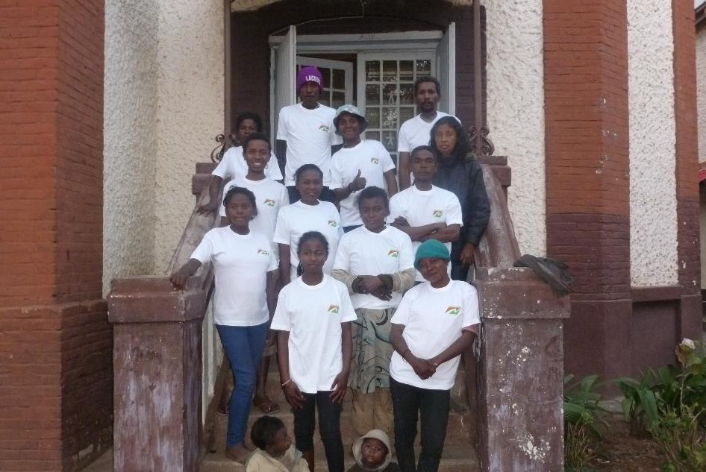
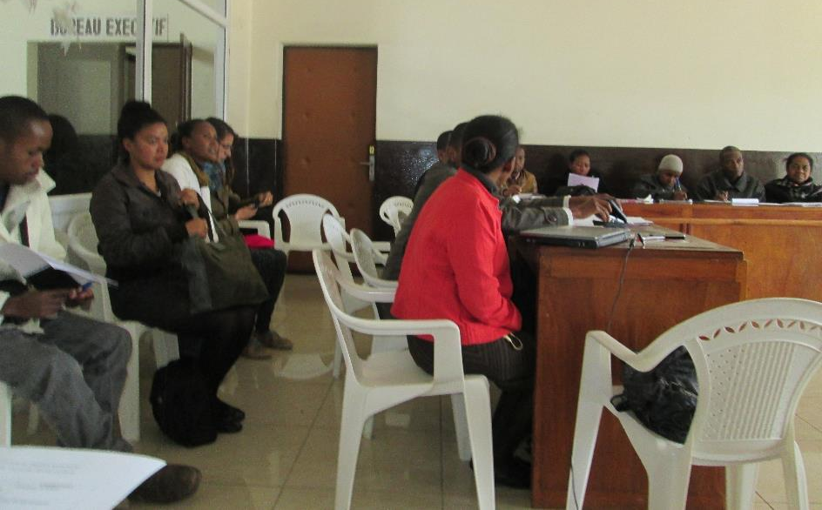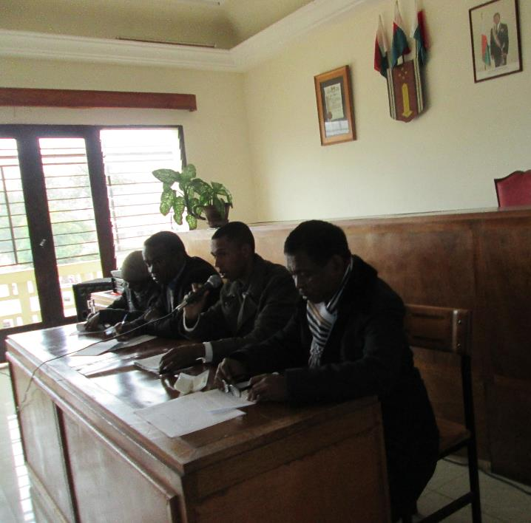
Stakeholder meeting on 13th July at the Fianarantsoa Municipality Office.
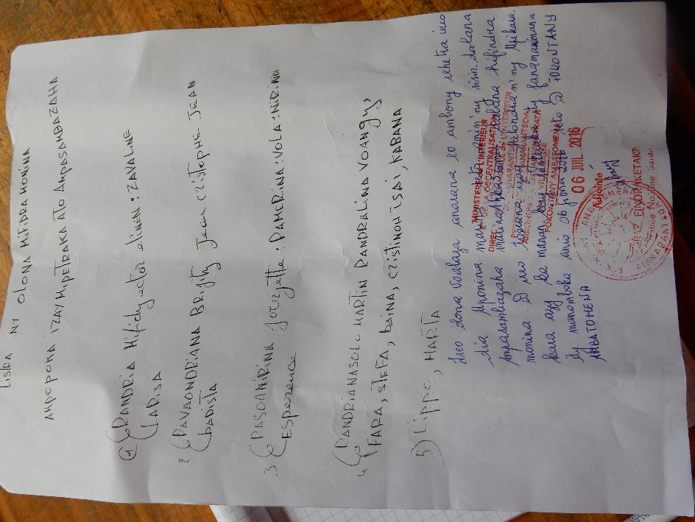
Document listing the families ready to move from the Star compound to the nun’s housing in Ampopoka.
ACTION PLAN PER BENEFICIARY FOR THE 1st ROUND OF SUPPORT
Beneficiary 1: Voahangy Lalao
 | NAME | AGE | SEX |  | Identity card |  | Birth certificate |  | Remarks
 |  |  | M | F | Y | N | Y | N
FATHER
MOTHER | RASOANIRINA Voahangy Lalao Soaritiana Bernadette | 46 |  | X |  | X |  | X | Identity card lost with no declaration of loss.
CHILD 1 | RANDRIANAMBININA Tina Fago (“Ralipo”) | 22 | X |  |  | X |  | X | Worked as driver’s aid before.
CHILD 2 | RAMIARIZAKANIRINA Sitrakiniaina Nico Alfredo | 13 | X |  |  |  |  | X | Illiterate, no schooling.
CHILD 3 | SEHENONIAINA Sylvie Valerie | 14 |  | X |  |  |  | X | Lost birth certificate. Studies at LP Ambalapaiso.
CHILD 4 | SOAFARANIRINA Philipine | 11 |  | X |  |  |  | X
CHILD 5 | TSIRINIRINA Balsamina | 16 |  | X |  |  |  | X | Lost birth certficate.

Voahangy Lalao claims to have worked in mining before, when tourmaline boomed in the south. After bankruptcy, the family became homeless. Although Voahangy Lalao is keen to return to her home in Ambalavato, Fianarantsoa, where her mother lives, and to farm her land, she claims to be unable to work due to the metal rod inserted in her left arm after it was fractured. She is unable to do any physical work like clothes-washing or farming. She is keen to have this operated on to remove it. Depending on progress post-operation, support for her farming activities could be considered.
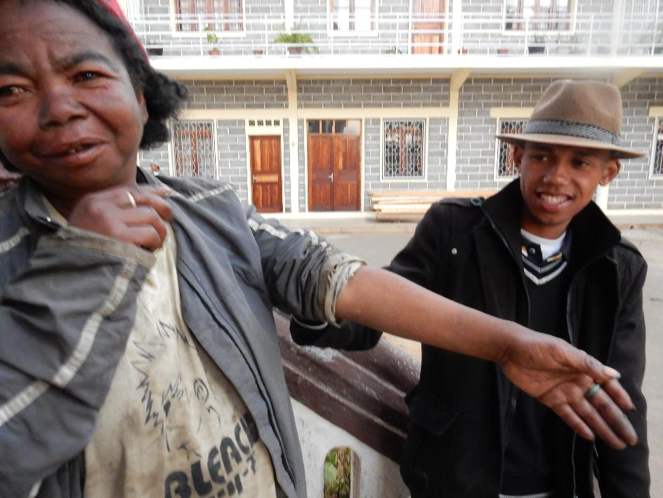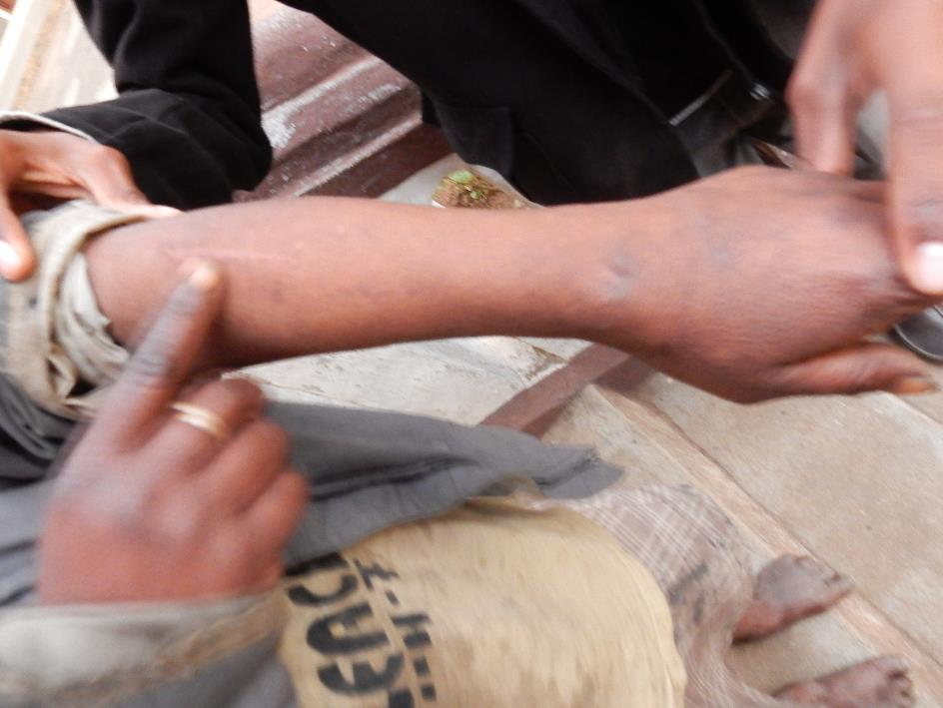
Victor with Voahangy Lalao, showing where the metal rod is in her arm.
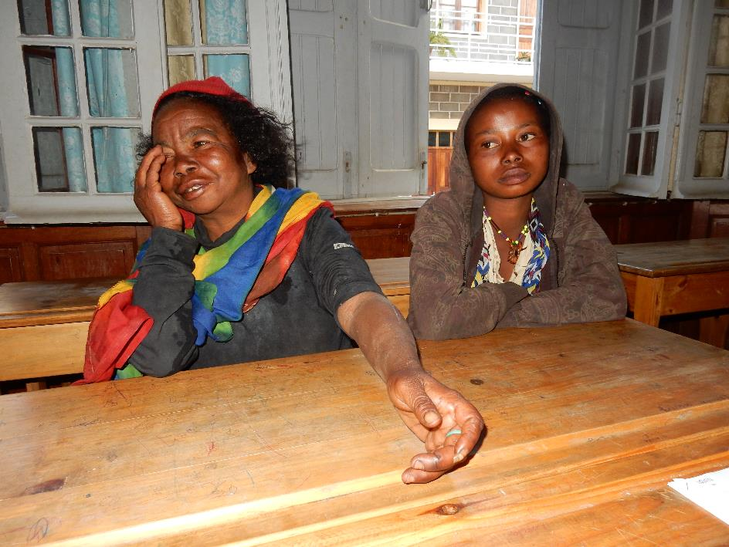
Voahangy Lalao with her niece, Marie Clarisse, at her interview.

The estimated budget for her operation is as follows (the Doctor responsible for her 1st operation refused to give an exact cost):
 | Item | Cost (Ariary)
1 | Operation fee | 150,000
2 | Medical treatment | 180,000
 | Total | 330,000

Beneficiary 2: Etienne
Etienne was the President of the Star complex. He is originally from Lokomby, Manakara, but used to work in Ambositra as a builder. He was imprisoned for 3 years and, since leaving prison, he has been homeless and his life upturned. He developed tuberculosis, which was treated. But since this health problem, he has found it difficult to work. He largely relied on gambling for income. He, with his wife and daughter, is one of the families who have recently moved to a house in Ampopoka provided by the nuns. He is keen to start a new life as a farmer; in the Star compound he had enjoyed looking after the vegetable gardens. He wants to plant rice, cassava, potatoes, beans and vegetables. However, he appears to have re-contracted tuberculosis and this needs to be treated first before he can start doing much physical work; a test is planned (for him and his family) for the 1st August. If the result is positive, as expected, they will be required to stay in hospital for the first 2 months of treatment.
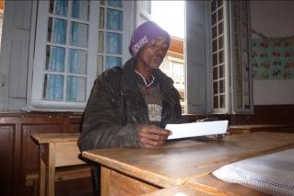

Etienne at the interview
 | NAME | AGE | SEX |  | Identity card |  | Birth certificate |  | Remarks  M
 |  |  | M | F | Y | N | O | N
FATHER | RANDRIAMIFIDY Hector Etienne | 39 | X |  |  | X | X |  | Identity card lost: he carried out a declaration of loss.
MOTHER | ZAVALINA | 29 |  | X |  | X | X |  | Never had an identity card.
CHILD 1 | HANITRINIAINA Marie Larissa |  |  | X |  |  |  | X

Estimated budget:
 | ITEM | Total (Ar)
A | Hospital meals for 2 months for his family during TB treatment | 480,000
B | Tools | 287,500
C | Initial preparation/labouring of the land | 70,000
D | Seed | 100,000
 | TOTAL: | 937,500

Beneficiary 3: Laurent
Laurent and Clara still live in the Star compound but are currently looking for somewhere else to work. Laurent recently started working with ‘Le Relais’ every morning, sorting rubbish on the rubbish tip next to the compound - for which he earns 50,000 Ariary / month. He says that this will be sufficient to cover rent. But he would like to have a ‘varamba’ (wooden cart to transport materials) in order to provide for his family. One of his principal problems in finding work has been his lack of identity card.
 | NAME | AGE | SEX |  | Identity card |  | Birth certificate |  | Remarks
 |  |  | M | F | Y | N | Y | N
FATHER | RAZAFIMANDIMBY Laurent | 24 | X |  |  | X | X
MOTHER | RAOLIARISOA Marie Clara | 25 |  | X |  | X |  | X | Washes clothes with Chinese shop-owner.
CHILD 1 | NIRINA Nomenjanahary Harisoa Marie Lauréat | 4 |  | X |  |  |  | X

Estimated budget:
200,000 Ariary to buy a ‘varamba’.
Beneficiary 4: Ramerina & Georgette
Ramerina and Georgette have three children together. Ramerina had to give up past work as a watchman when they had family problems and he had to look after his child. Since then they were unable to pay rent. He works as a cobbler in the Talatamaty area of Fianarantsoa, but suffers from a foot deformity and infections since he contracted leprosy years ago – therefore finding it difficult to walk. He would like assistance to improve his activities, to enable him to have a revolving fund for materials, in order to feed his family and ensure their education. They recently moved from the Star compound to housing in Ampopoka provided by the nuns.
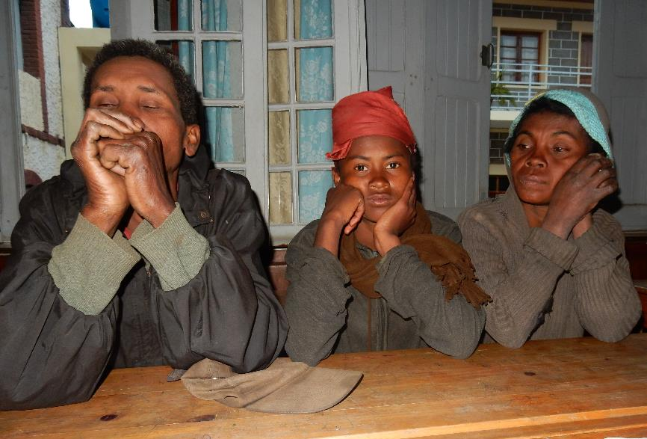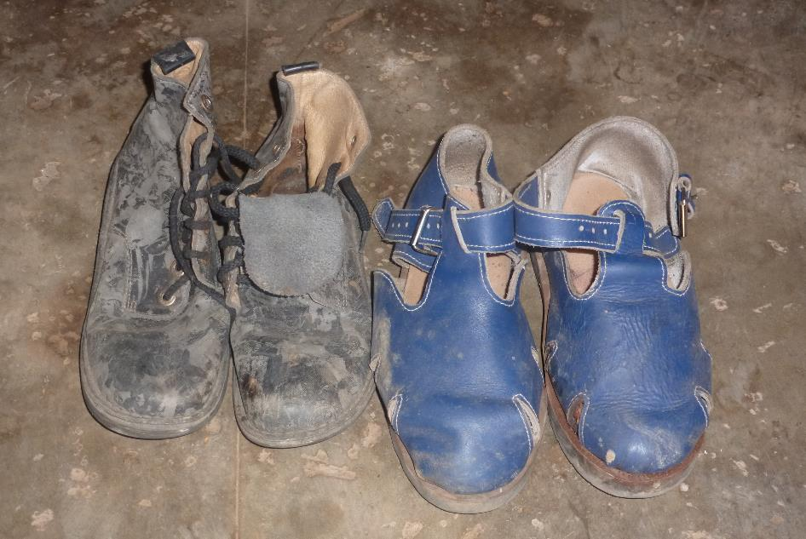
Ramerina, Vola (daughter) and Georgette (wife) at their interview (left) & 2 ‘new’ pairs of shoes (right).
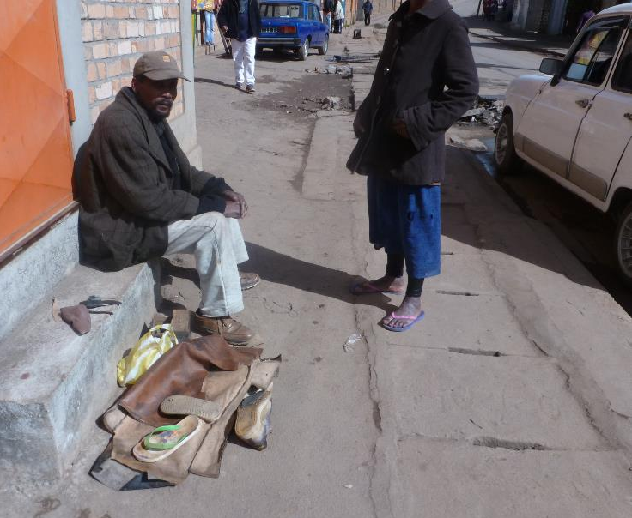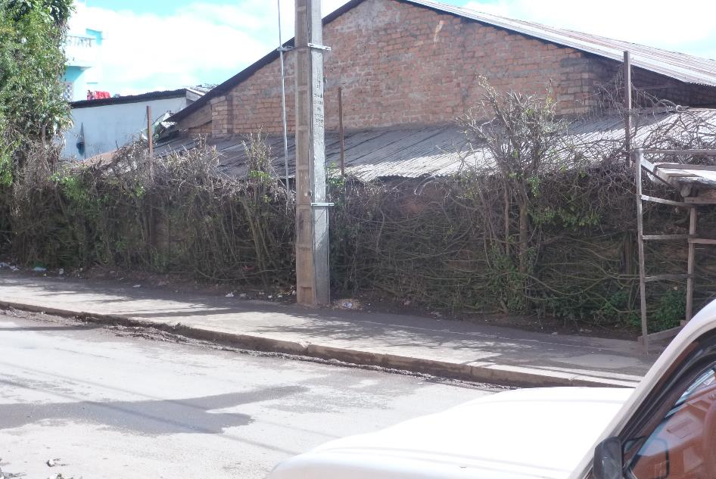
Ramerina at work in Talatamaty (left) and (right) where he hopes to set-up a kiosk.
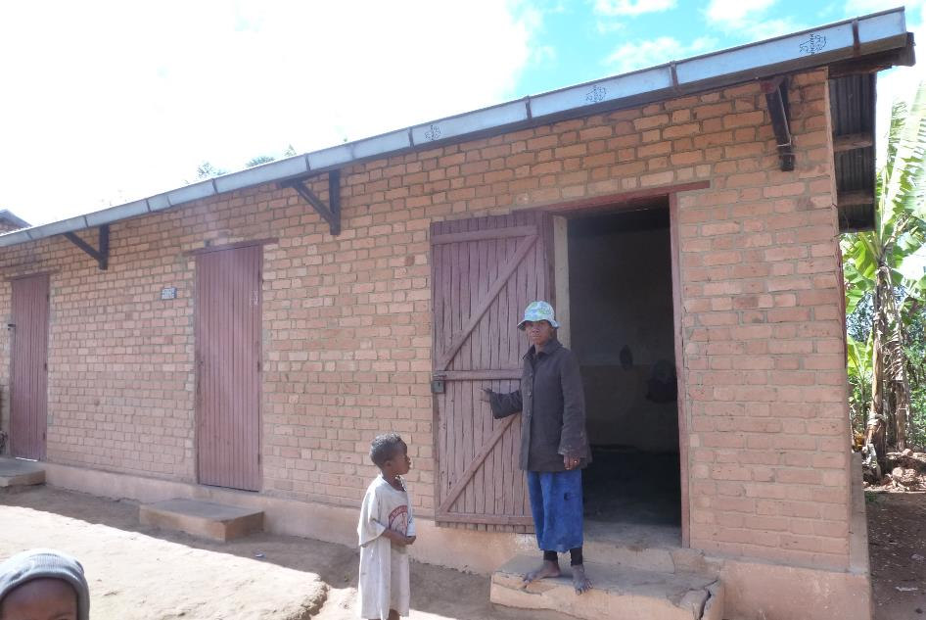
Georgette outside their new home in Ampopoka.
 | NAME | AGE | SEX |  | Identity card |  | Birth certificate |  | Remarks
 |  |  | M | F | Y | N | Y | N
FATHER | RAMERINA | 53 | X |  |  | X |  | X | Identity card lost; declaration not carried out.
MOTHER | RASOANIRINA Georgette | 42 |  | X |  | X |  | X | She has never had a birth certificate or identity card.
CHILD 1 | RAHERINIAINA Berthine | 14 |  | X |  |  |  | X | Studies at the Lapan'ny ankizy Ambalapaiso.
CHILD 2 | RAVOLANDRAMANGA | 16 |  | X |  |  |  | X | Lost birth certificate: left school at level of T5 class.
CHILD 3 | ESPERANCE | 1.6 |  | X |  |  |  | X | Little girl used for begging at Total station.

Estimated budget:
DESIGNATION | Total (Ar)
Shoe repairs supplies | 172,000
Building a kiosk | 237,000
Sub-total Ramerina: | 409,000
Start-up funds for poultry-selling (Georgette) | 174,000
Total (Ramerina & Georgette): | 583,000

Beneficiary 5: Martin (« Dadah »)
Dadah comes from Talata Ampano, and is the partner of Voahangy (who accompanied Olga to Vohipeno). They both looked after the ‘grandmother’ who lived outside the Victoria Hotel. He currently works as a porter, carrying materials particularly on market day. Martin used to sell household supplies (pens, torches, glue, batteries, etc.), and is keen to re-start doing this as a mobile seller. He is one of the people who have moved to housing offered by the nuns in Ampopoka. He requires 308,000 Ariary as start-up funds to start this work.
Beneficiary 6: RANDRIANAMBININA Tinah Fabio « Philippe”
Philippe has lived in the Star compound since 2006. He is the brother-in-law of Voahangy Lalao and his mother, Marthe, lives in Ambalavato. His birth certificate was lost by his previous boss when he worked as a cook, and he has been without papers since. He has learnt informally about mechanics and worked as a driver’s aid in Tulear before. However, he has not got a driver’s license nor any formal qualification. He currently works as a porter, and sometimes sells second hand clothes. He would really like to become a driver-mechanic. For this training, the expected budget is 804,200 Ariary.
 | NAME | AGE | SEX |  | Identity card |  | Birth certificate |  | Remarks
 |  |  | M | F | Y | N | Y | N
FATHER
MOTHER | RAZAIRIVELO Marthe | 63 |  | X | X |  | X |  | Housework and clothes-washing
CHILD 1 | SITRAKINIAINA Mamy Florien | 17 | X |  |  |  | X |  | Uneducated
CHILD 2 | LOVAOSANIRINA | 22 |  | X | X |  | X |  | Unemployed, uneducated.
CHILD 3 | RASOLONIAINA Claudia | 19 |  | X | X |  | X |  | Unemployed, uneducated.
CHILD 4 | RANDRIANAMBININA Tinah Fabio | 24 | X |  | X |  | X |  | Docker.
CHILD 5 | TOKINIAINA | 18 | X |  | X |  | X |  | Tout

Beneficiary 7: David & Harilalao
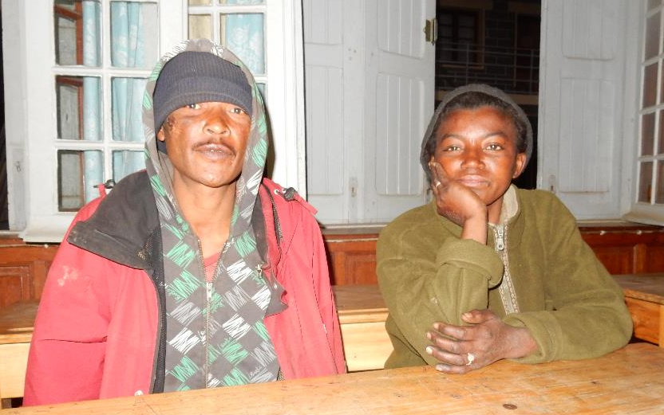
After 8 years of being homeless, David and Ihary recently moved from the Star compound to housing provided by the nuns in Ampopoka. They have three children (8, 5 and 3 years old). Ihary works sorting rubbish, selling bottles and cans. David works as a porter. The children beg. They used to sell everyday household items but stopped since they had financial problems when his mother died. They would like to start doing this again and require start-up funds – an estimated budget of 497,000 Ariary. They are ready to make an effort to improve their lives.

MIVOATSE Project
Budget Summary 28-7-16
 | No. | Cost / person | Total (Ar)
Birth certificates | 23 | 80,000 | 1,840,000
National Identity Card | 10 | 28,000 | 280,000
Tuberculosis tests | 20 | 10,000 | 200,000
Opening savings accounts for each beneficiary of livelihoods support | 8 | 5,000 | 40,000
1- Voahangy Lalao |  |  | 330,000
2- Etienne |  |  | 937,500
3- Laurent |  |  | 200,000
4- Ramerina & Georgette |  |  | 583,000
5- Martin |  |  | 308,000
6- Philippe |  |  | 804,200
7- David & Harilalao |  |  | 497,000
Subtotal |  |  | 6,019,700
Overheads |  |  | 601,970
TOTAL (Ar): |  |  | 6,621,670
ESTIMATED TOTAL (£): |  |  | 1,655.42

