Madagascar Rural School and Community Reforestation Project.
Pilot Program.
Position Paper for review.

Salohy School and Reforestation Area. 15 KM from Tanjomoha. Vohipeno.

From. P.J.O’Brien TASC
To. S Martin MBE. B Ellis. Dr J O’Brien . TASC
G Lonergan. ADSUM

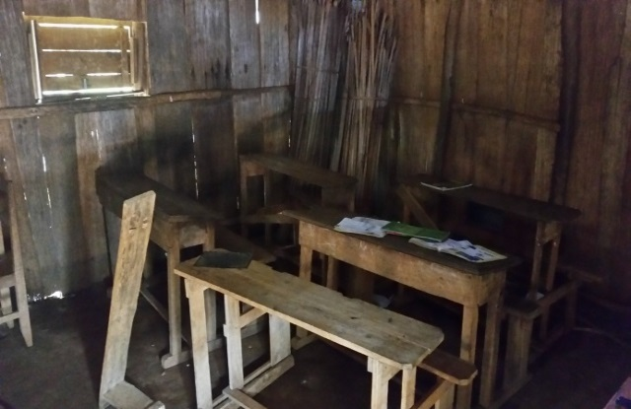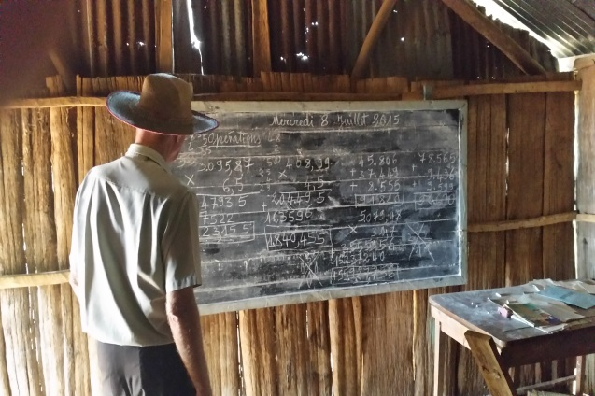

Existing Classroom with broken desks Pere at blackboard. No teacher for 4 days.
Note :
The school has the worst results in Vohipeno Region.
Sparse intermittent and poor quality teaching.
The King’s 17 year old son- no schooling
-----------------------------------------------------------------------------------------------------------------------------
External of the existing school

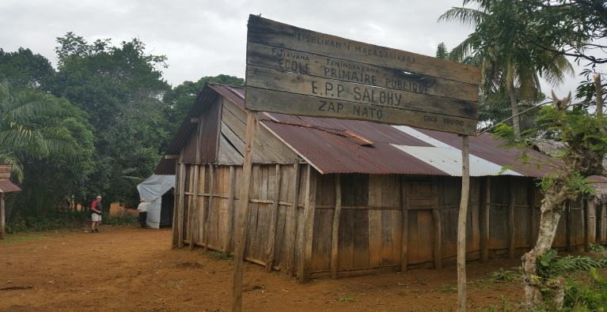
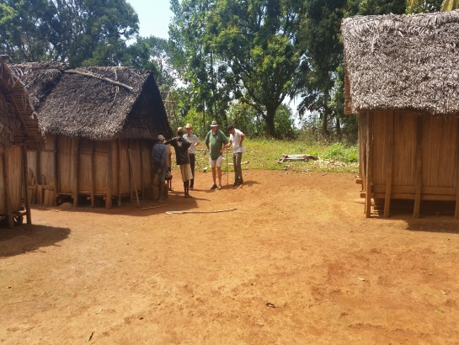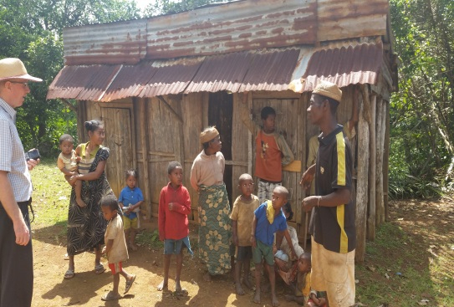

Remote Village at Salohy Villagers at Salohy and old small classroom
--------------------------------------------------------------------------------------------------------------------------

Proposed type of new rural school
and community centre / clinic Typical elevation.
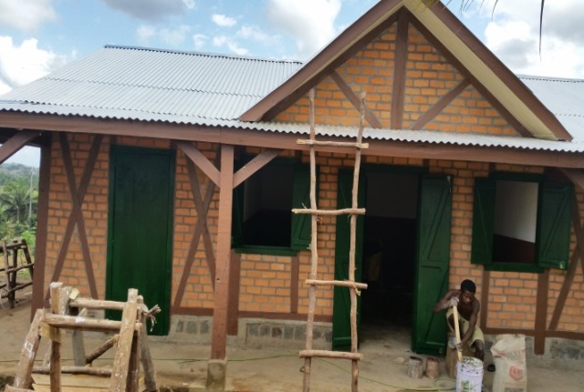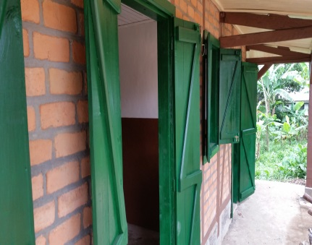

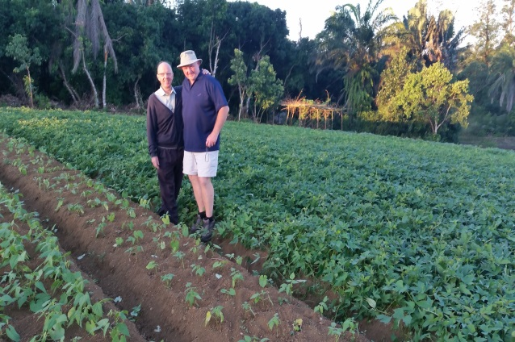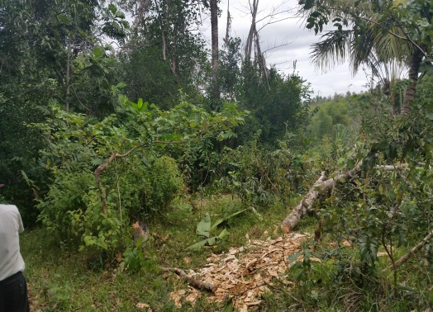

Example from Tanjomoha of new
Vegetable farming New lands at Salohy. 78 Hectares

Overview and Proposal

The school and village of Salohy is approximately 6 km off the main Manakara to Vohipeno road down a dirt track which is 5 KM north of Vohipeno.
The area is hilly with a lot of wild brush and some trees but with almost no agriculture or farming.
The area seems very poor with bare subsistence living and other than a large UNICEF temporary tent there seems to be no external support for the village.
TASC and Tanjomoha want to help and have recently ( June – Sept 2015) bought 37 Hectares of land for reforestation and possible farming.
TASC and partners are also considering rebuilding and supporting the rural school in an overall community based scheme and have met with the King of Salohy and the elders who are anxious for the help.
TASC will work through Tanjomoha and the local Education Ministry CISCO to establish the actual population and teaching needs and will budget and fund the project if possible.
TASC have also committed to clearing the land in stages ( 12 Hectares per year ) and to plant a variety of Trees ( 18,000 per Year) for the next 3 years to establish the forest as a support for Tanjomoha.
TASC are also proposing a rural communitity based scheme as a means of support for the local community through work for food programs ( Kotchumbra) to clear plots for families, building houses for families and allowing the families to cultivate the low areas for rice and home plots for vegetables , fruit and other local crops.
TASC and Tanjomoha have used a similar scheme in Nohona and it is working very well.
In payment for the land and houses the local villagers would be asked to help with pruning and clearing so as to minimize the maintenance costs of the plantation but also with the long term view of future work in forestry management, tree felling and planking.
Aligned with this scheme the proposal envisages education for all children in the new school in all the basic subjects but also with an element of education around forestry management, carpentry and embroidery or other crafts.
It is hoped that a 4 classroom school will be built with a small community hall attached.
The hall would be used for community based activities and adult education as well as local and school celebrations, graduations etc.
The hall would also have a small room / area that could be used as a mediacal clinic for a visiting nurse.

Details.

Education.
The existing 2 room school is in a total state of disrepair with rotting side walls
and main timbers, open leaks and rusted roof sheets and broken desks and walls.

There are no permanent teachers being paid at present and the exisiting teacher only shows up on a part time basis.

There are approximately 80 school age children living in the rural area aging from 5 years to 18 years and they are getting g sparse and very little education.

The school results that are accounted are very poor and are the worst in the Vohipeno area.
The proposal is to build 4 No classrooms of 5m by 10 m to accommodate four separate school years with 20 to 30 children in each.
TASC would support CISCO in paying for 2 teachers for 5 years with the locals then having to fund any shortfall in teachers pay from future income.

Sanitation.
As with the school at Maromby, TASC would hope to use Feedback Madagascar to install at least one community well and to also provide the education for sanitation to children and adults with a maintenace crew assigned to manage the well.

Land and Houses
The proposal is to adopt a “ Food for Work “ model to clear the land as we have done at Nohona and then to invite 10-12 families per 12 Hectare plot to build small holdings on high ground with the lower wet areas available for rice.
TASC would set up an education program with Tanjomoha and Fiahonanna Agricultural school to teach cultivation of vegetables, fruit, coffee and other crops so that the community of families live in and around the reforestation area.
TASC Tanjomoha would provide seeds as required to start the farms.

Work.
It will be expected as part of the plan that families who are given land and houses will attend to the forest for maintenance but could also assist with paid work in some of the forestation management, living fence, securtiy etc.
In time it is hoped that the families would also get work when trees are harvested and as a follow up may be able to use the lumber in carpentry work, crafts etc.

Next Steps.

- Tanjomoha have agreed to speak to the local CISCO representative regarding the school and numbers and ages of potential and present students.
- TASC will then budget and propose an agreement with CISCO to get permission to rebuild the school in a similar agreement as with Maromby.
- CISCO would have to commit to funding teachers on a full time basis.
- TASC- Tanjomoha would establish a BOQ for the build and obtain quotes as before with a local builder or with direct labour from Tanjomoha.
- TASC ADSUM Feedback would need to commission a feasibility study for a well.
- TASC ADSUM would have to commit to funding the school and teachers for 5 years.
- TASC Tanjomoha would need to get support for crops, education, building of houses etc.
- TASC ADSUM to agree funding for tree planting for 2016.

Patrick J. O’Brien
October 2015

